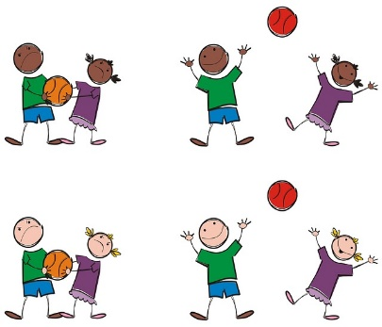
Get
Do lots of painting, drawing and making all kinds of models relating to families and homes.
Look at families and how they can be similar and different. We will learn about likes and dislikes and different feelings we have.

Settle in to school and get to know one another. We begin to become familiar with school routines and expectations.

Enjoy P.E. sessions focusing on travel and movement. Develop our fine motor skills in lots of ways.

.

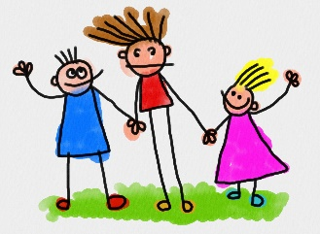

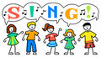

This half term we will …
Develop our number work including counting and number recognition and ordering numbers correctly. We will also work on ordering objects by size.

Develop our speaking and listening skills. We will also work on learning songs in singing sessions. Sharing our thoughts and consider the views of others.

Develop our writing and phonic skills in lots of ways. Enjoy lots of stories including Anna Hibiscus and The Little Red Hen.

Think about Harvest time and healthy eating and try lots of different fruit and vegetables. We will also be working in the garden planting bulbs and looking closely for the signs of Autumn approaching.

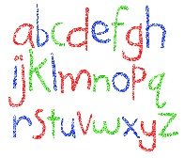

Think about what and where we enjoy doing or visiting including Stokesley Show and Fair.

Use technology such as the ipad or photocopier to help us with our learning.




