Why did WWII start?
What items were rationed during WWII?
Holocaust
Should Britain have entered WWII?

Which were the main countries involved in the war?
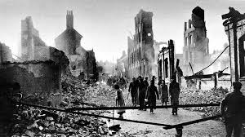
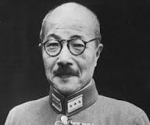
Books to Read:
- My Secret War Diary - Flossie Albright
- Goodnight Mister Tom – Michelle Magorian
- The Diary of Anne Frank
- War Boy - Michael Foreman
Things to Do:
- Write a fact-file about one of the world leaders during WWII
- Draw a picture of a WWII vehicle
- Find out the meanings of the Key Words on this sheet
D-Day
Evacuation – how would you have felt?
What was the land army? Who joined the land army?
Who was Hideki Tojo?
There is nothing to fear but fear itself.
Propaganda
Allies
Treaty

