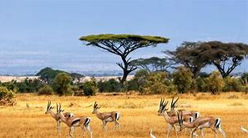

**What is a carnivore? Can you think of any African animals that are carnivores?**

**Carnivore**

**African Adventure**

**Continent**

**What are the names of the 7 continents? Can you find them on a world map?**

**Would you like to visit Africa? What would you like to see and do?**

**What do you know about Africa? Do you know the names of animals that live there?**

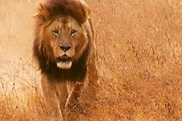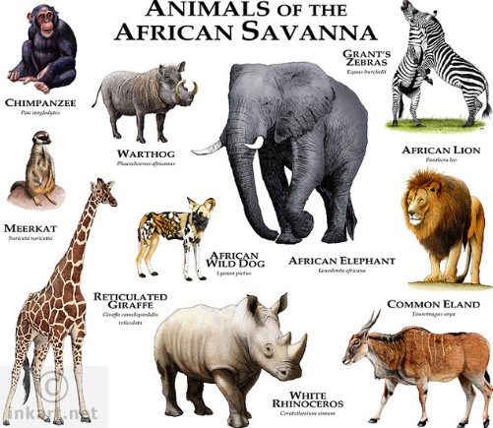

**classification**

**Do you know the names of any groups of animals? Which group do humans belong to?**

**Adventure**

**Savannah**

**What is the Savannah? What is it like to be there? What would you see, hear and feel?**

**Africa**

**Things you could do:**

Go to the library and borrow a book. Have a look at maps and Atlases.

Explore: https://www.bbc.co.uk/programmes/p011smwc

**Books to Explore:**

One Night, Far From Here by Julia Wauters

Bringing the Rain to the Kapiti Plain by Verna Aardema

Afican Animal Tales Collection by Mwende Hadithi

A is for Africa by Ifeoma Onyefulu