**Could you live like an ancient Egyptian?**

How did ancient Egyptians spend their free time?

What were ancient Egyptian houses built from?

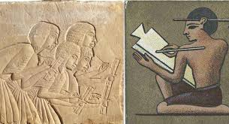

**papyrus**

**Senet**

Did ancient Egyptian children go to school?

What was the most popular ancient Egyptian pet?

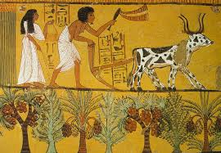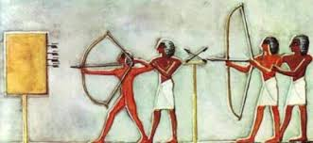

**Books and Websites to Explore:**

Awesome Egyptians – Terry Deary

So you think you’ve got it bad? A kid’s life in Ancient Egypt – Chae Strathie

Egyptian Things to Make and Do - Emily Bone <https://www.bbc.com/bitesize/topics/zg87xnb> <https://www.ducksters.com/history/ancient_egypt.php>

<https://egypt.mrdonn.org/trivia.html>

**tournaments**

Did ancient Egyptians enjoy sports?

**priest**

**seasons**

What did ancient Egyptian farming involve?

**sacred**

**Things you could do:**

Visit the library and/or borrow some non-fiction books about our topic.

Create an information poster about ancient Egyptian houses, schools, farming, leisure animals or sports.