**Could you be an archaeologist?**

Why were cats so important during this period of history?

Who were The Ancient Egyptians?

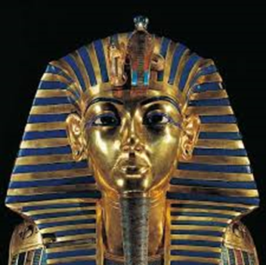

**River Nile**

**Pyramids**

Why was The River Nile so important to the Ancient Egyptians?

What was a day in the life of a Pharaoh like?

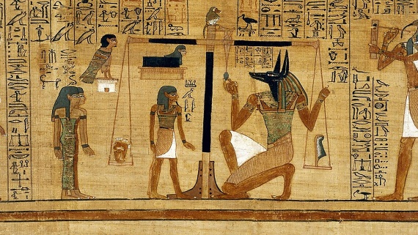

**Books and Websites to Explore:**

Awesome Egyptians – Terry Deary

So you think you’ve got it bad? A kid’s life in Ancient Egypt – Chae Strathie

Egyptian Things to Make and Do - Emily Bone <https://www.bbc.com/bitesize/topics/zg87xnb> <https://www.ducksters.com/history/ancient_egypt.php>

**Canopic Jars**

What can you find out about Hatshepsut?

**The Afterlife**

**Hieroglyphics**

What did the Ancient Egyptians like to eat?

**Mummification**

**Things you could do:**

Visit the library and do some research about The Ancient Egyptians

Take a trip to The Oriental Museum, Durham University

Collect a travel brochure to see what Egypt is like now