
Dear Parent/Carer
We are in the process of setting up our home learning platform for after the Easter holidays. We will be using Class Dojo. This can be accessed on a computer, IOS or android device.
As a school we will be using ClassDojo to message you, post announcements, send work and provide feedback and support to children and parents. Your child will be able to send photos, videos and journal entries on their own digital portfolio. This portfolio can only be seen by your child, you and the child’s class teacher. Your child will also be able to view their feedback and customise their ClassDojo monster. As your child is under 13, we need your consent to create your child’s student account on their behalf.
If you give permission for the class teacher to create a student and parent account for your child, allowing them to use ClassDojo, please send an email with your email address to contact@stokesleypa.org.uk Please state ClassDojo in the email subject. We also need to know your child’s name and year group they are in.
You can learn more about ClassDojo at www.classdojo.com/learnmore and see their privacy policy at www.classdojo.com/privacy
Thank you for your continued support and we hope to see all you soon in our virtual learning classrooms.
Yours faithfully
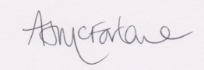
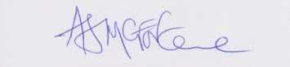
Mr McFarlane Mrs Graham
Principal Deputy Principal

