**Continents**

**Investigate**

**Which materials will float?**

**Planet Extinction or Planet Life?**

**Can you name all the continents?**

**Can you name a wild animal from each one?**

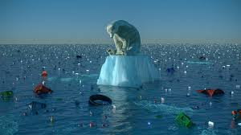

**What is extinction?**

**How does this effect the planet?**

**Poachers**

**Why are poachers a big threat to wild animals?**

**Things you could do:**

**F**ollow a route on a map or draw your own map of a journey you have taken.

Draw or paint a picture of an endangered animal.

Test some different materials in your bath, see which will float and which will sink. Record your results. Explain if the materials changed as they got wet.

Make something that you think could help the planet. Look at items you can recycle. Write what it does and how to use it.

Write about the words above or create a poem about an endangered animal.

**Don’t forget to bring your work in to show us in January.**

**Navigation**

**Can you read a map?**

**Would you be able to make a map with a key to help others get from one place to another?**

**Extinction**

**Climate Change**

**What is climate change?**

**What kind of effect is this having on our planet? What could you do to help?**

**Books to Explore, why not borrow one from the library:**

* Our beautiful earth, saving the earth piece by piece
* The lonely polar bear
* What is climate change