**Year 2 Spring 2 2022**

**The Great Fire of London**

**Where is London? Can you write 10 facts about our capital city?**

**Who was Samuel Pepys? What is he famous for?**

**London**

**Pepys**

**How did the Fire affect London?**

**How did they fight the fire in 1666? How does it compare to today?**

**What were the houses made out of? Can you make or draw one? material?**

**Firefighting**

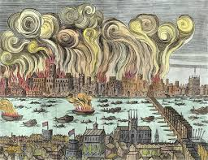

**Houses**

**Tell me what you know about the Fire of London**

**Can you sing a Fire song or make up a poem?**

**Fire! Fire!**

**Fun Facts**

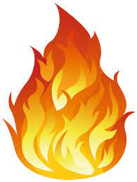

**Books to Explore:**

Fire Cat by Pippa Goodhart

Toby and the Great Fie of London by Margaret Nash

You wouldn’t want to be in the Great Fire of London by Jim Pipe

Vlad and the Great Fire of London by Kate Cunningham

**Non-fiction:**

Samuel Pepys by Paul Harrison

**Things that you could do:**

Write a poem about fire, how it moves, looks and smells.

Bake some bread, write or draw pictures to show what you did.

Draw or paint a picture of the fire of London.

Make a simple map of London- can you add some of the famous landmarks?