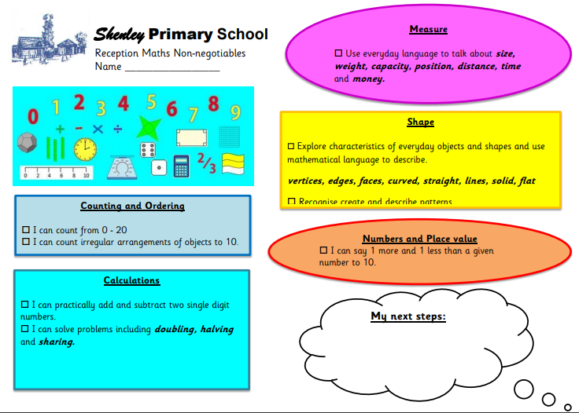

**Reception Maths**

**Non-negotiables**

