**What is special about Mount Erebus?**

**What do you think you would need to survive in Antarctica?**

Expedition

**Antarctic Exploration – Do or Die?**

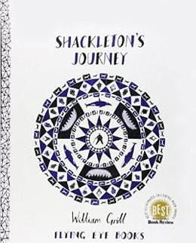

Crows Nest

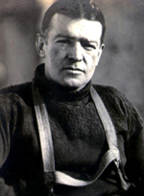

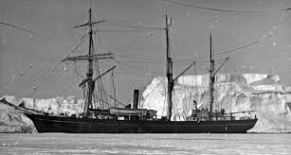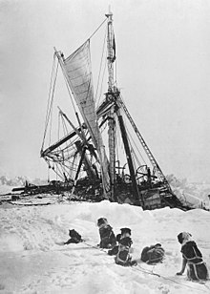

**What is unique about the sun in Antarctica?**

**Who was Ernest Shackleton?**

**What is the weather like in Antarctica?**

**Where is the Weddell Sea?**

Crew

Antarctica

Pack Ice

*Books to Read:*

* *Who was Ernest Shackleton? – James Buckley*
* *You Wouldn’t Want to be on Shackleton’s Polar Expedition – Jen Green*

*Things to Do:*

* *Get a book about Shackleton from the library*
* *Sketch a picture of an animal found in Antarctica*
* *Find out the meanings of the* ***Key******Words*** *on this sheet*