

**Astronaut**

**Who was the first person in space? Who was the first man on the moon?**

**Moon Zoom!**

**What are rockets and space ships made from?**

**Material**

**Would you like to work in space?**

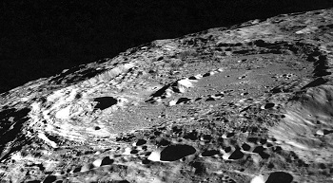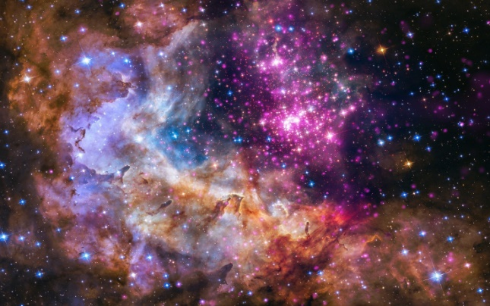

**Things you could do:**

Go to the library and borrow a book. Star gazing on an evening.

Explore: https://www.bbc.co.uk/cbeebies/shows/stargazing

<https://www.nasa.gov/kidsclub/index.html>

**crater**

**Planet**

**Alien**

**What is in ‘Space’? What can you see in the night sky?**

**What is a crater? How do you think they are made?**

**What is an alien? Do you think there are aliens in space?**

**Adventure**

**Books to Explore:**

Dr Xargles book if Earthlings – Jeanne Wills

Beegu – Alexis Deacon

Toys in Space – Mini Grey

The way back home – Oliver Jeffers