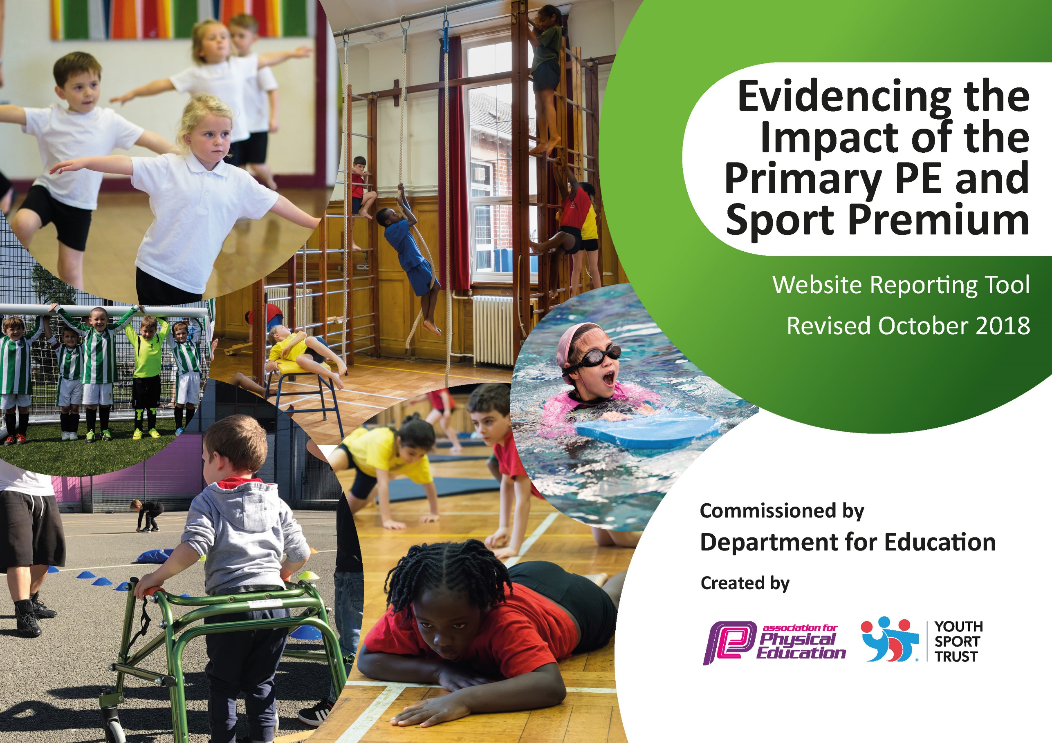
ce
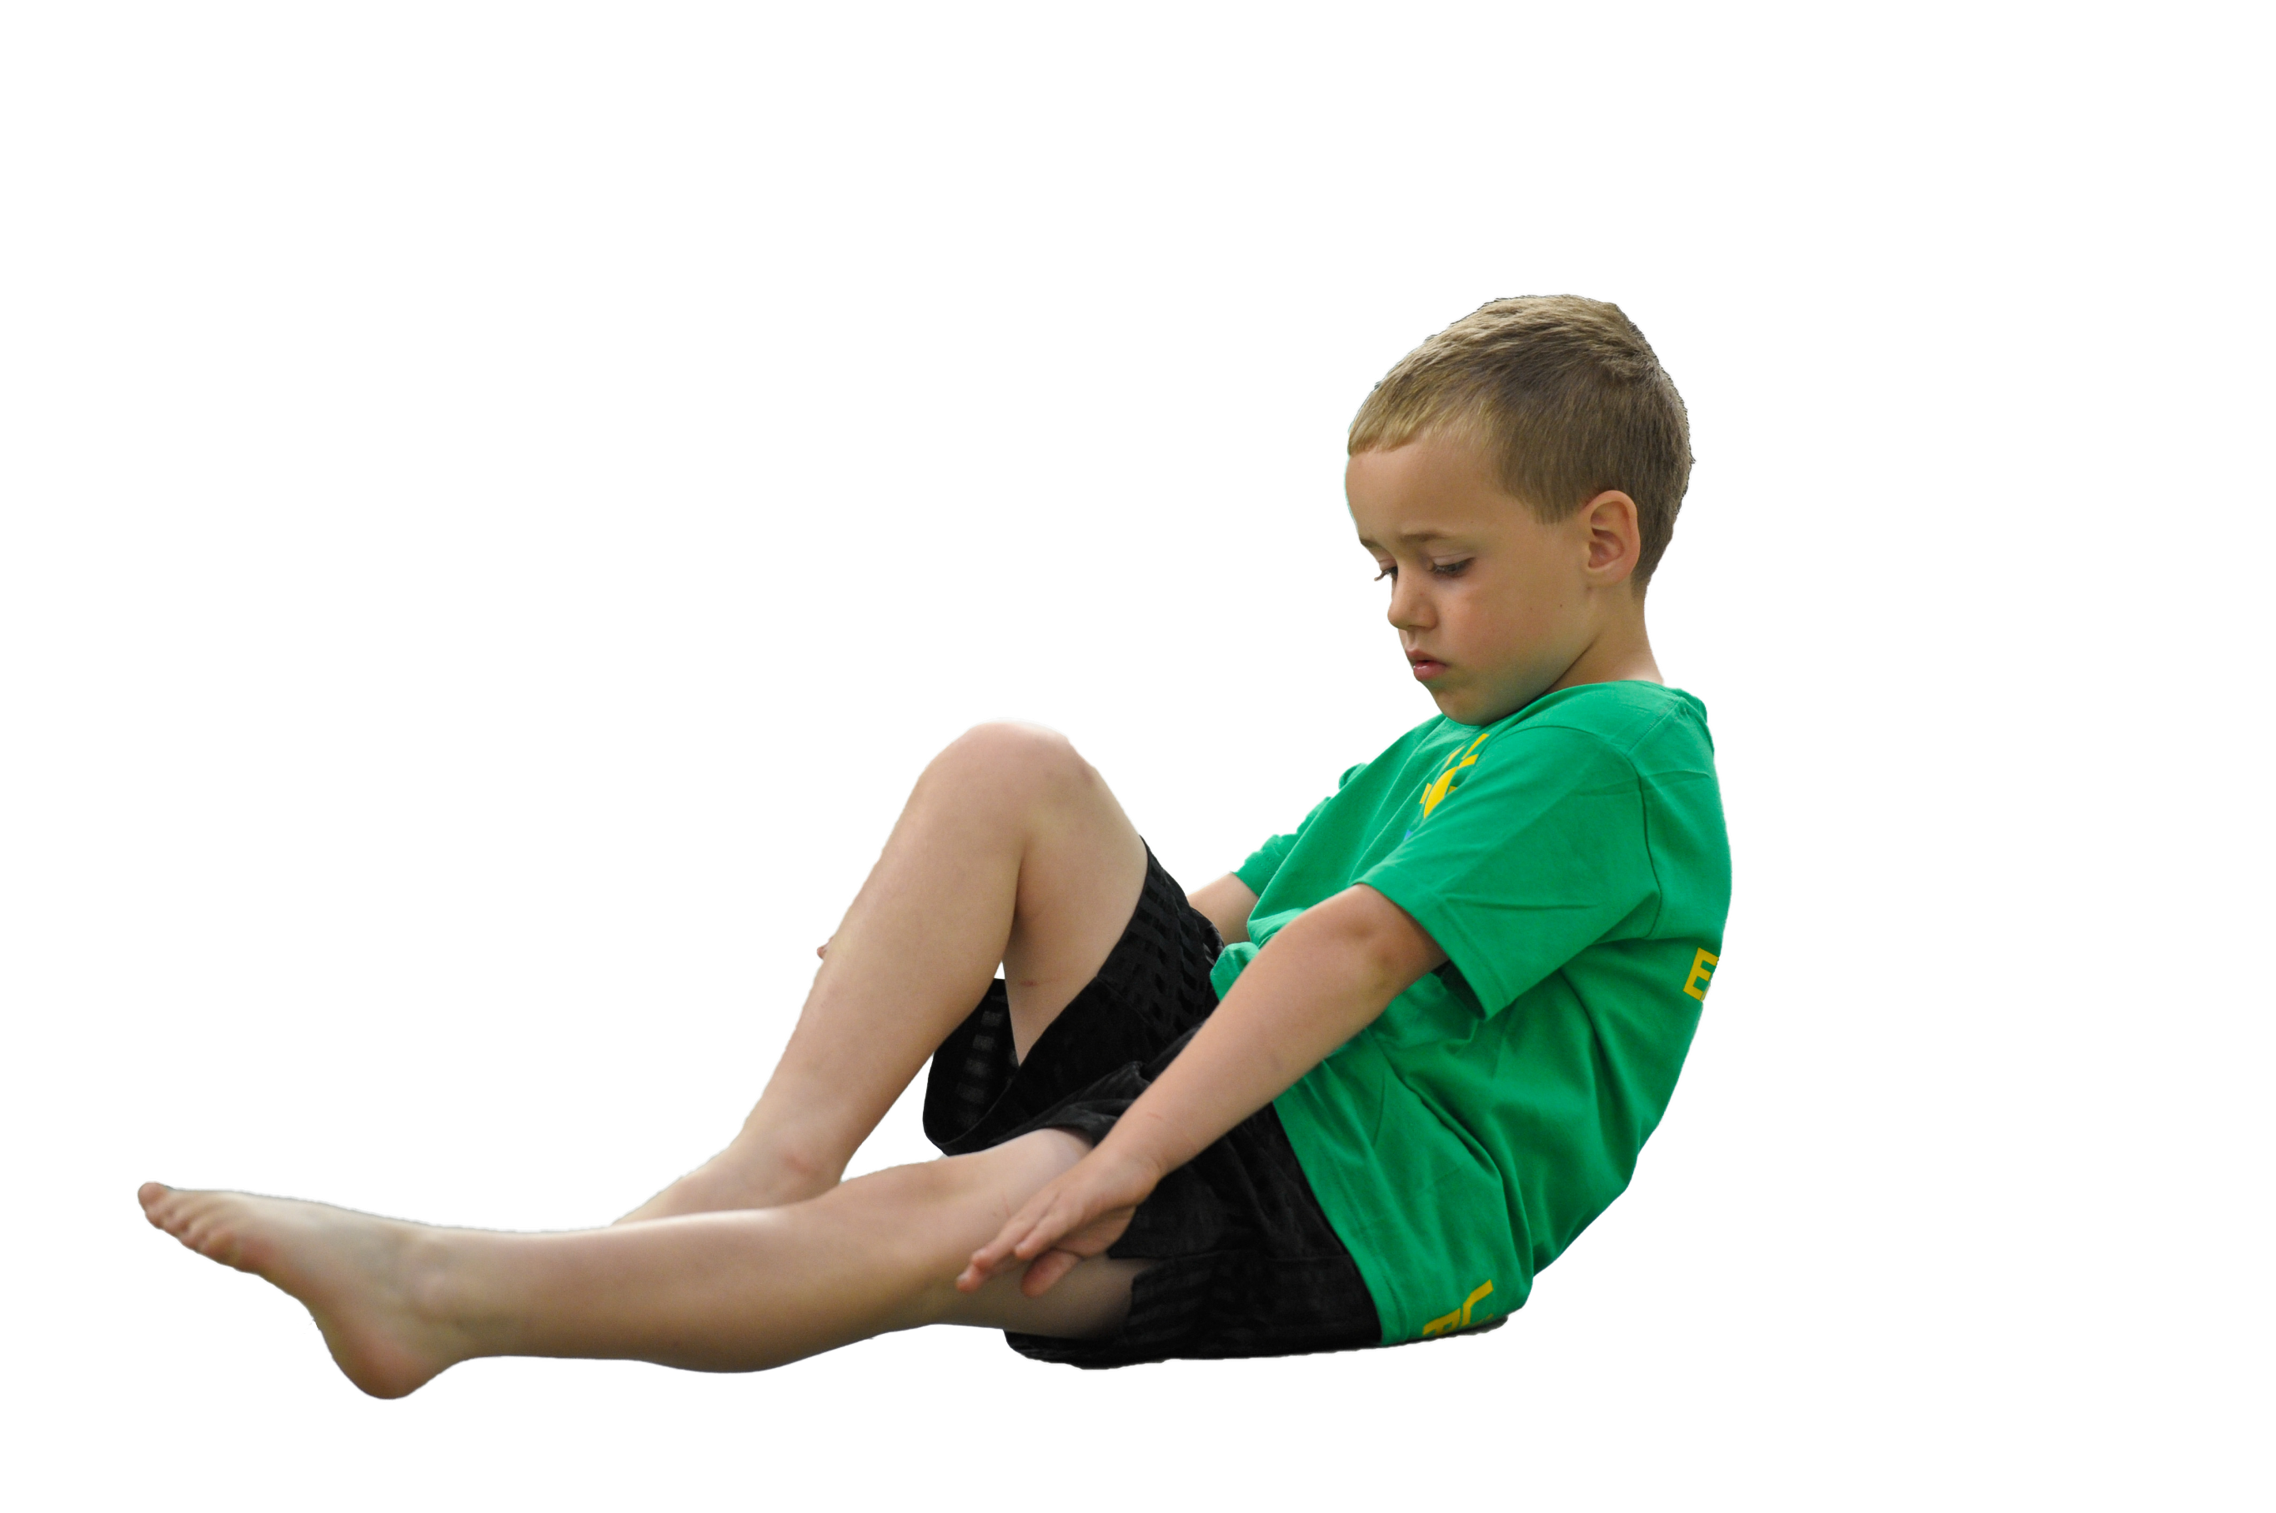
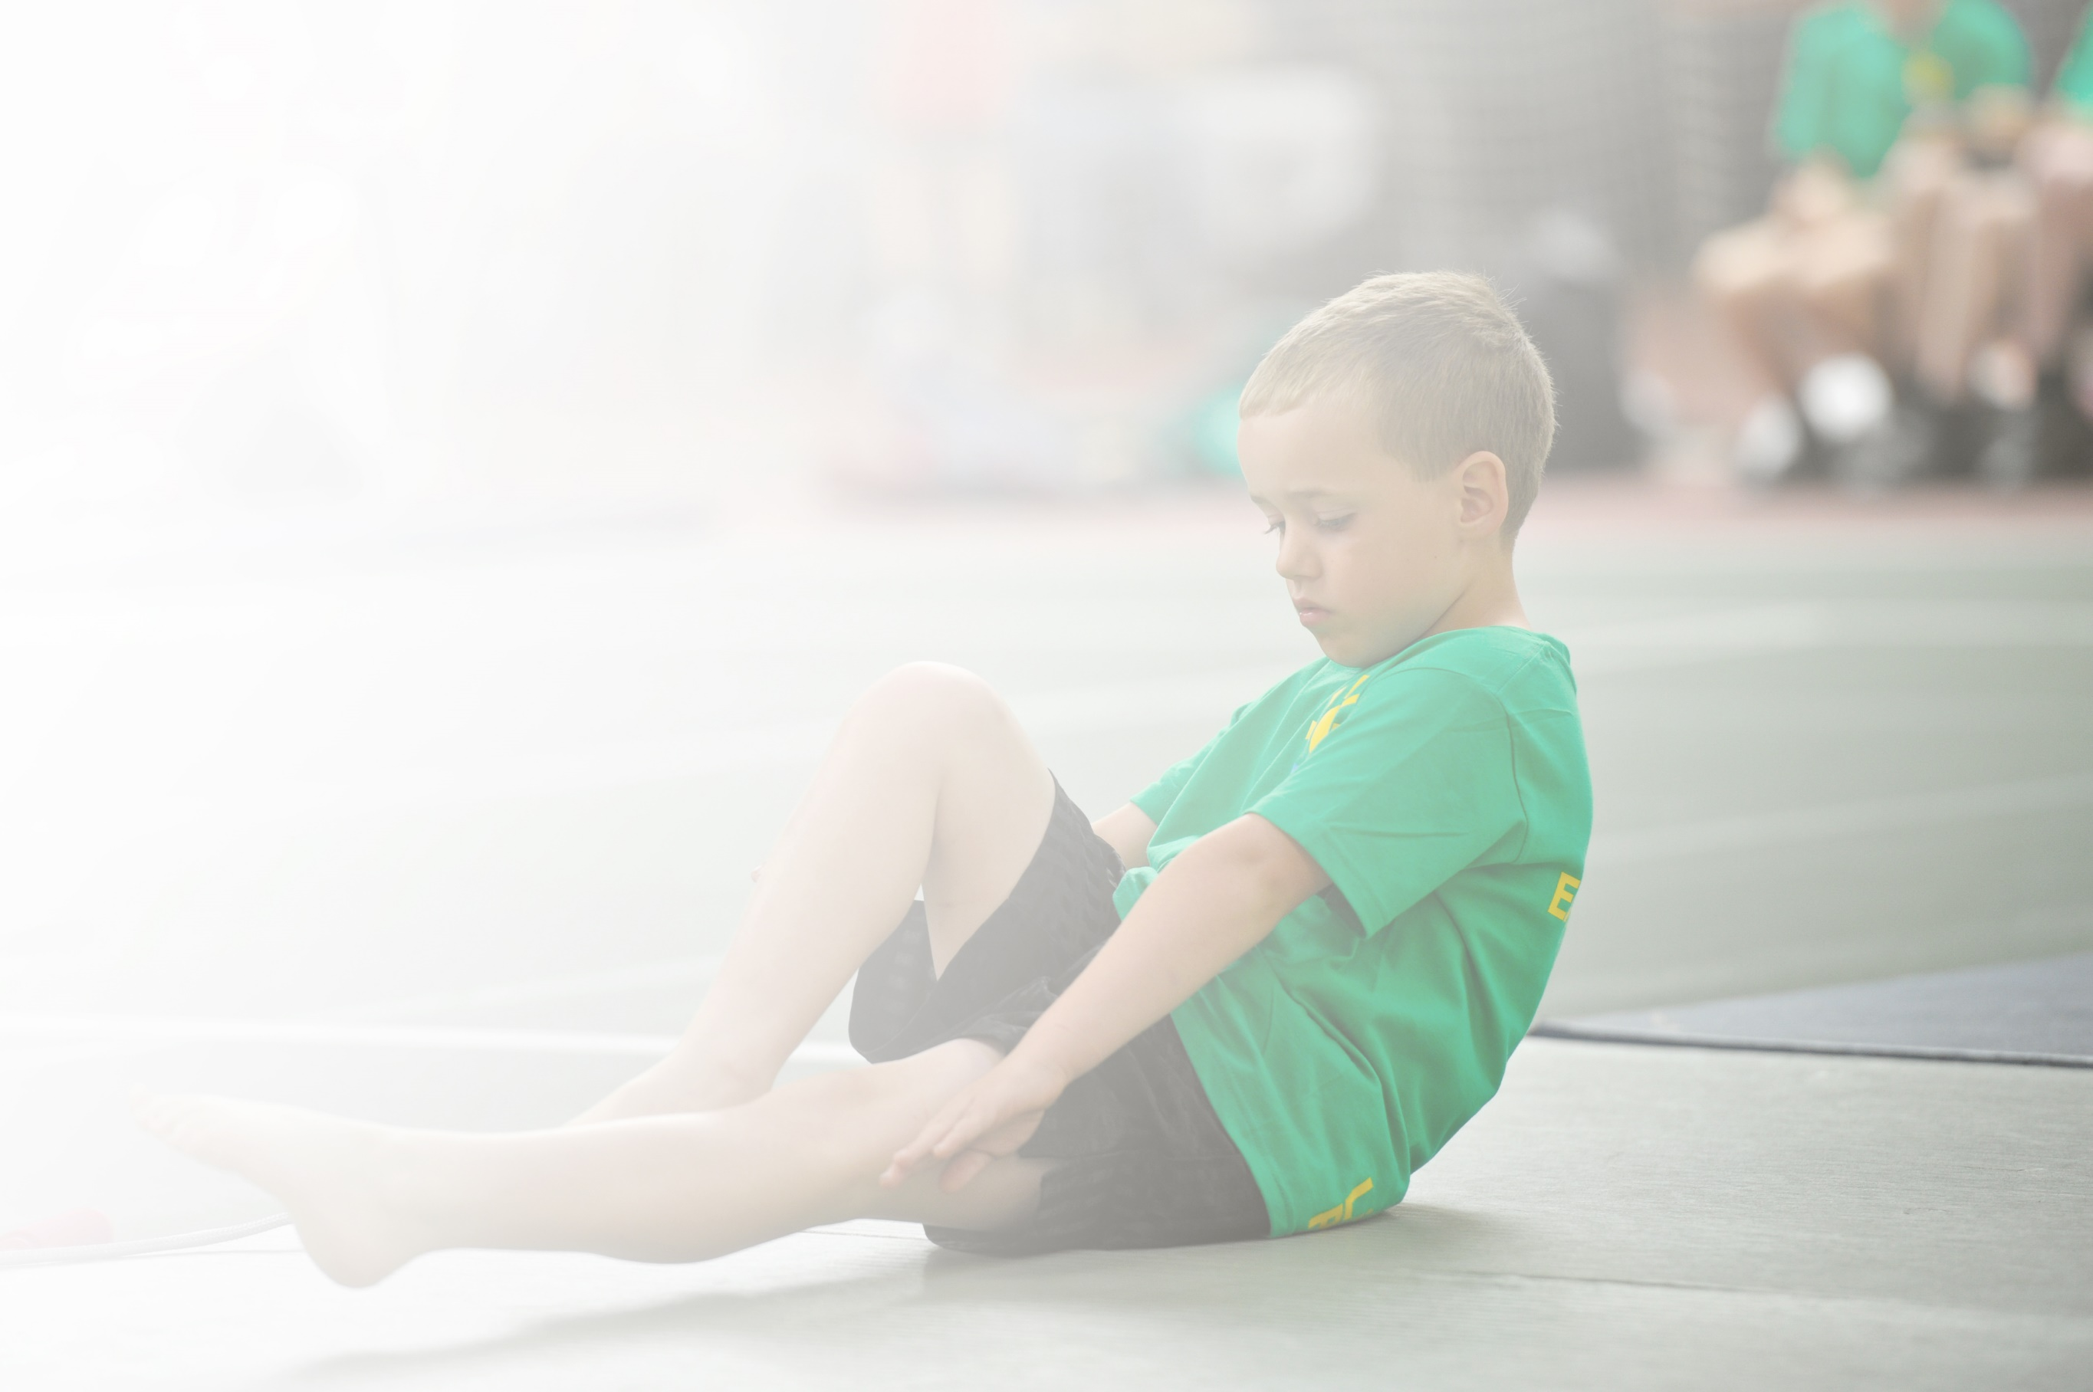
Schools must use the funding to make additional and sustainable improvements to the quality of Physical Education, Sport and Physical Activity (PESPA) they offer. This means that you should use the Primary PE and Sport Premium to:

- Develop or add to the PESPA activities that your school already offer
- Build capacity and capability within the school to ensure that improvements made now will benefit pupils joining the school in future years

Please visit gov.uk for the revised DfE guidance including the 5 key indicators across which schools should demonstrate an improvement. This document will help you to review your provision and to report
your spend. DfE encourages schools to use this template as an effective way of meeting the reporting requirements of the Primary PE and Sport Premium.

We recommend you start by reflecting on the impact of current provision and reviewing the previous
spend. Under the Ofsted Schools Inspection Framework, inspectors will assess how effectively leaders use the Primary PE and Sport Premium and measure its impact on outcomes for pupils, and how effectively governors hold them to account for this.

Schools are required to publish details of how they spend this funding as well as on the impact it has on pupils’ PE and sport participation and attainment by the end of the summer term or by 31 July 2019 at the
latest.
We recommend regularly updating the table and publishing it
on your website throughout the year, as evidence of your
ongoing review into how you are using the money to
secure maximum, sustainable impact. To see an
example of how to complete the table please
click HERE.

Support for review and reflection - considering the 5 key indicators from DfE, what development needs are a priority for your setting and your students now and why? Use the space below to reflect on previous spend, identify current need and priorities for the future.

Key achievements to date: | Areas for further improvement and baseline evidence of need:
- Activities to encourage more pupils to take up sport and physical activities.  - Raising the profile of sport across the school.  - Increase percentage of children involved in extracurricular sport and inter and intra school tournaments. | - Introduce new sports or other activities to encourage more pupils to take up sport and physical activities.  - Raising the profile of sport across the school by making links within the community. Use P.E. and school sports as a tool to improve and narrow the attainment gaps and to ensure at least expected progress is made.  - To continue to increase percentage of children involved in extracurricular sport and inter and intra school tournaments.

Meeting national curriculum requirements for swimming and water safety | Please complete all of the below:
What percentage of your current Year 6 cohort swim competently, confidently and proficiently over a distance of at least 25 metres?  N.B. Even though your children may swim in another year please report on their attainment on leaving  primary school. | TBC when Year 6 complete their term of swimming lessons in Autumn.
What percentage of your current Year 6 cohort use a range of strokes effectively [for example, front crawl, backstroke and breaststroke]? | TBC when Year 6 complete their term of swimming lessons in Autumn.
What percentage of your current Year 6 cohort perform safe self-rescue in different water-based situations? | TBC when Year 6 complete their term of swimming lessons in Autumn.
Schools can choose to use the Primary PE and Sport Premium to provide additional provision for swimming but this must be for activity over and above the national curriculum requirements. Have you used it in this way? | Yes – support for annual local swimming gala.

Action Plan and Budget Tracking
Capture your intended annual spend against the 5 key indicators. Clarify the success criteria and evidence of impact that you intend to measure to evaluate for students today and for the future.

Academic Year: 2020/19 | Total fund allocated: £18,000  Plus funding carried over from previous year. | Date Updated: September 2021
Key indicator 1: The engagement of all pupils in regular physical activity – Chief Medical Officer guidelines recommend that primary school children undertake at least 30 minutes of physical activity a day in school |  |  |  | Percentage of total allocation:
 |  |  |  | %
School focus with clarity on intended impact on pupils: | Actions to achieve: | Funding allocated: TBC Estimated Amounts | Evidence and impact: | Sustainability and suggested next steps:
- To promote team building and to attract whole school in extra physical activity.  - Y5 pupils learn to ride safely and develop confidence and enjoyment from cycling.  - All pupils from nursery have the opportunity to participate in a variety of sports for fun, fitness and friendship.  - All pupils are encouraged to experience a variety of physical activities to find one that sets the template for an active life.  - Provision to promote active lifestyles.  - To ensure that all pupils learn to swim by the end of KS2 for fun, safety and fitness for life.  - To develop and enhance resources/equipment/planning to provide a broader P.E. curium | - Provision of extra-curricular sports clubs  - Swimming  - Swimming for target all KS2 to achieve 25m by end of KS2 – extra provision due to no swimming due to Covid disruption (Lower and Upper KS2 Provision.)  - Developing sport on a lunch and break time to instil a love of sport and pupil interaction through fun, physical activities  (James Lofthouse and Mark Shimwell).  - Bike ability  - To develop a broader curriculum with new activities and skills to learn through sports. | £2000  £2000  £800  £500  £1000
Key indicator 2: The profile of PESSPA being raised across the school as a tool for whole school improvement |  |  |  | Percentage of total allocation:
 |  |  |  | %
School focus with clarity on intended impact on pupils: | Actions to achieve: | Funding allocated: | Evidence and impact: | Sustainability and suggested next steps:
- To encourage improvement in sport and fitness through ‘sport’ and ‘exercise for fun’.  - To make links with the local community through sporting activities.  - To share the creative and performance aspect of physical activity and encourage active lifestyles into the future. To raise the status and profile of this aspect of PE  - To raise the status and profile of PE both through celebrating individual or group achievement and also to encourage participation for fun and fitness.  - To highlight the variety of opportunities for activity in the local community.  - To provide a structure and criteria to ensure that a comprehensive programme of activity promoting health and fitness is in place  - To develop leadership and organisational skills in older children – play buddies. Leaders support sport events in summer term  - Increase opportunities for new sporting activities and target children less active through P.E. lessons, clubs and lunch/break activities on the MUGA.  - Range of inter and intra school competitions  - Sports day and a celebration of children’s participation.  - Achievements celebrated in class and assemblies. | - Improvements to be recognised and celebrated. To use local facilities in the area such as squash courts, tennis, golf and foot golf to improve sporting skills as well as providing new experience.  - To take part in outer school sporting activities (links with local primary schools and secondary school.)  - Virtual events across all Hambleton Schools.  - Celebration of individual pupils or groups or teams for participation or achievement in physical pursuits in and out of school. Celebration in assemblies, school website and notice board.  - To achieve Schools Mark Gold PE Award.  - Whole school events such as ‘Stokesley School’s World Cup Cricket or Tag Rugby Festival’ linked to events happening out of school. Providing opportunities to celebrate sporting events and work within a team across keys stages. Links to PSHE and how pupils resemble professional sporting athletes’ qualities in their own lives.  - Sports Day - broadening activities both individual and team events and giving purpose (links to Olympics 2021)  - Change for life event – ensuring children participate in sporting events for fun and to promote active lifestyles. Mark Shimwell club focused groups in the Summer Term.

Key indicator 3: Increased confidence, knowledge and skills of all staff in teaching PE and sport |  |  |  | Percentage of total allocation:
 |  |  |  | %
School focus with clarity on intended  impact on pupils: | Actions to achieve: | Funding  allocated: | Evidence and impact: | Sustainability and suggested  next steps:
- To ensure that PE provision is improving sustainably through quality CPD for staff.  - Pupils to experience personal challenge and to develop confidence. | - Provision of training for staff working with own class alongside sports coach.  - James Lofthouse (Football)  - Jennifer (Tennis)  - Grant White (Cricket)  - West End Dance links to other curriculum areas, such as Bringing Books to life in 2020/21 English, Drama, etc.  - Orienteering events hosted by PE Lead across the school.  - Gymnastics/Yoga expertise in this area? Discuss with other teachers to select an area for CPD development. | £3,000  introducing new sports  Tennis Coach - £300  Grant White - £300
Key indicator 4: Broader experience of a range of sports and activities offered to all pupils |  |  |  | Percentage of total allocation:
 |  |  |  | %
School focus with clarity on intended  impact on pupils: | Actions to achieve: | Funding  allocated: | Evidence and impact: | Sustainability and suggested  next steps:
Additional achievements:  - To challenge and develop more experienced bike riders  - To encourage awareness and interest in a wider range of physical activities  - To develop physical activity during break and lunch times.  - 30 mins extra per day. To develop enjoyment through active play. Keeping active during lessons and break times.  - Introduce wake up shake up in each class at the start of each day or break times? | - To provide a variety of lunch time activities, after school activities and improving lesson facilities for a range of sports with the use of the MUGA.  - To support teacher’s skills in sports by increasing the range of sporting opportunities and activity by introduction new sports in lessons and clubs.  - Clubs and break activities available as well as targeting inactive children (selected groups with Mark Shimwell.)  - Classes to take part in n sporting virtual events across Hambleton schools.
Key indicator 5: Increased participation in competitive sport |  |  |  | Percentage of total allocation:
 |  |  |  | %
School focus with clarity on intended  impact on pupils: | Actions to achieve: | Funding  allocated: | Evidence and impact: | Sustainability and suggested  next steps:
- As many children as possible have the opportunity at least once to participate in local events, experiencing both the activity but also representing the school, collaborating as a team and enjoying being active with others.  - Competitions organised to target children including less active children.  - During all available opportunities, children will take part in inter and intra school opportunities (Duncan Burgess.) | - Participation in local tournaments – Netball, Rugby, Football, Kwik-Cricket, Athletics, Gymnastics, Cross Country, Swimming Gala, etc  - Local school friendly competitions, e.g. netball, quadkids, football, etc.  - Attend all companions ran by Duncan Burgess - organisation of cluster events/tournaments. | £2000 – Duncan Burgess  Estimate cost - £500 – coaches to sporting events

