**What is classification? Find out more about how animals are grouped and explain your findings.**

**How many different types of teeth do humans have? What are their names and function? Explain.**

**Classification**

**Science - March 2021**

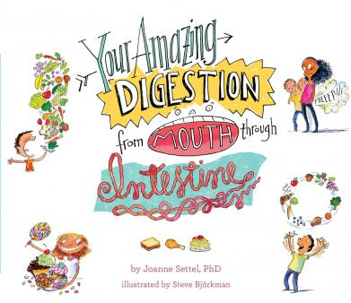

**Deciduous Teeth**

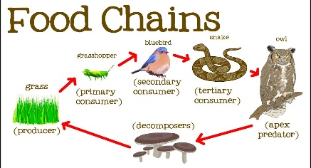

**What happens when humans interfere with habitats? After choosing an animal, find out more about how we have impacted upon their environment and the way they live.**

**What is a habitat? Explain what this word means. Select an animal and write a paragraph to describe the key features of where it lives.**

**What is a food chain? Find an example, write about it and then illustrate it.**

**What is the digestive system? Write a list to show each of the steps your food takes between entering and leaving your body.**

**Digestion**

**Nutrition**

**What types of food does our body need? Identify the names of different food types and explain why they are important.**

**Find out more:**

<https://www.bbc.co.uk/bitesize/topics/z27kng8>

<https://www.bbc.co.uk/bitesize/topics/zn22pv4/articles/z3nbcwx>

https://www.bbc.co.uk/bitesize/topics/zbnnb9q

**Food Chain**

**Habitat**

**Environmental Impact**