**Fairtrade**

**Palm Oil**

**How is Palm Oil bed for the environment?**

**Why is Fairtrade important?**

**What is the true cost of what we eat?**

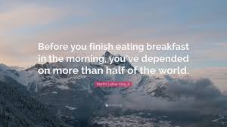

**deforestation**

**Should our eating habits affect the environment?**

**How does Fairtrade help people living in poorer countries?**

**Which countries are supported by Fairtrade projects?**

**community**

**endangered**

**sustainability**

**How do our food choices affect animal habitats?**

**Things you could do:**

Go to the library and borrow some books.

Visit the Co-op and investigate their Fairtrade range of food.

Cook a meal using Fairtrade products.

Find out the names of some animals that are endangered and why this is the case.

**Books and Websites to Explore:**

[**https://www.bbc.co.uk/newsround/39492207**](https://www.bbc.co.uk/newsround/39492207)

[**http://www.fairtrade.org.uk/**](http://www.fairtrade.org.uk/)

**Who ate my bana? – Ruth Walton**

**The world came to my place today – Dr Jo Readman**