**Protein**

Complete a food diary for a week.

What kind of nutrients do humans need? Make a list of the types of nutrients humans need to stay healthy and the foods you will find them in.

**Plants & Animals, including Humans**

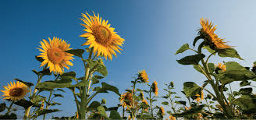

**Nutrition**

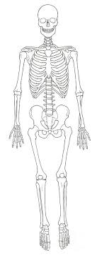 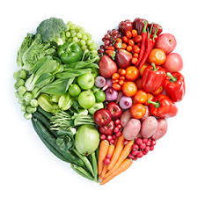

**Stigma**

List or draw and label the features of a flowering plant.

**Life Cycle**

Name three of the main stages of a flowering plant’s life cycle. Why not try caring for a plant at home or in the garden? Maybe you could even have a go at growing a plant from a seed! Try a sunflower or a bean.

**Growth**

**Find out more:**

**https://www.bbc.co.uk/bitesize/articles/z2w3p4j**

[**https://www.bbc.co.uk/bitesize/articles/ztqbn9q**](https://www.bbc.co.uk/bitesize/articles/ztqbn9q)

**https://www.bbc.co.uk/programmes/articles/Mf5rhbTkHLZ3fbJzScyDvC/pri**

**https://www.bbc.co.uk/bitesize/subjects/z2pfb9qmary-science-plants**

**Skeleton**

Can you name some of the bones in a human body?

Can you write a list or an acrostic poem to explain what plants need to grow well?