**What is special about our home… planet Earth?**

**What will you see on planet Earth?**

**What can you do on planet Earth?**

**What does our planet look like?**

**How have you changed as you have grown up? Can you think of 5 things you can do now that you couldn’t when you were a baby?**

**What do you want to do in the future?**

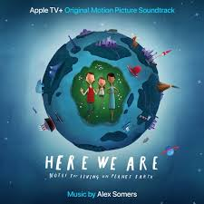

**Change**

**Earth**

**What does endangered mean?**

**How can we help protect endangered animals?**

**How did you feel when we were not at school?**

**What have been doing at home? What have you enjoyed most?**

**Can you name all the parts of your body?**

**Can you think of ways to keep your body healthy?**

**Books to Explore, why not borrow one from the library:**

**This Moose Belongs to Me by Oliver Jeffers.**

**The Way Back Home by Oliver Jeffers.**

**The Skies above my eyes by Charlotte Gullain.**

**Dear Earth by Isabel Otter.**

**The Big Book of stars and planets by Emily Bone.**

**Endangered**

**Kind**

**Why is it important to be kind?**

**What would you ask people to do to make our world a better place?**

**Feelings**

**Healthy**

**Things you could do:**

**Look at photographs of our planet, what can you see? Draw, paint or collage a picture of our planet or the things that you will see on it.**

**Talk about all the things you have done at home, what have been the best bits? Make a list of all the things you have enjoyed during lockdown.**

**Look back at baby photos of you, talk about what they could do at each stage.**

**Find out about endangered animals, draw a picture and write a fact about an endangered animal.**

**Can you make a map of your journey to school?**