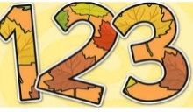
We will be thinking about taking turns and being aware of how our actions may make others feel.

This half term we will …
We will be creating friendly monster puppets and paintings.

Enjoy dancing and get moving to the beat using different body parts.

We will learn more about festivals, bonfire night, advent and Christmas.

Watch for the sign for the end of Autumn. Getting busy in our garden planting bulbs ready for spring.

Enjoy improving our fine motor skills by doing lots of cutting, threading and weaving activities.

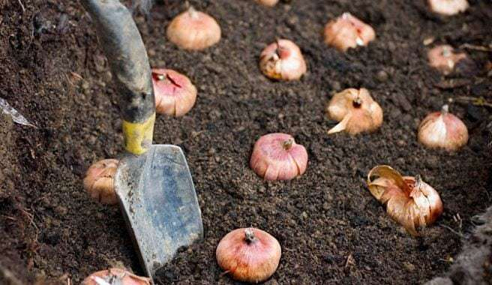

Do lots of counting, practise recognising and ordering our numbers as well as learning about size, shape and patterns.

We will do lots of phonic activities and will learn lots of new sounds and use technology such as ipads or photocopier to record our learning.

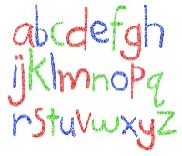
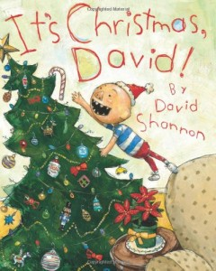
Enjoy lots of books and stories, especially Bedtime for Monsters by Ed Vere and books linked to Christmas.

Help us at home by …
Week 1  5/9/17 | Send in a family photo so your child can talk to their friends about their family.
Week 2  11/9/17 | Sing songs and rhymes with your child. You could send in a copy of your child’s favourite rhyme so we can all learn to sing it too.  Need inspiration… try http://www.bbc.co.uk/learning/schoolradio/subjects/earlylearning/nurserysongs
Week 3  18/9/17 | Send in a photo of your child at the Stokesley Show or Fair (if you go) this will help your child share their experiences with their friends and is always a good conversation starter.  We are hoping to go out on a local walk to Stokesley and visit the church at some time during these two weeks. Please let us know if you are free to help us walk.
Week 4

25/9/17
Week 5  2/10/17 | Try a new fruit or vegetable at home. Let us know what you tried and what you thought!
Week 6  9/10/17 | We may be starting to see signs of Autumn, go on a short walk and collect some ‘Autumn Treasure ‘. Bring something in and tell us all about it.
Week 7  16/10/17 | We are hoping to organise a harvest fundraising event. Send in a vegetable for our harvest soup. More details to follow.

You can send in photos by emailling them to l.challenger@stokesleypa.org.uk and I will print them for your child.
We always love to hear what your child has been up to at home so please feel free to send in other photos or objects for your child to talk about with their friends.

