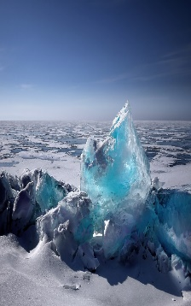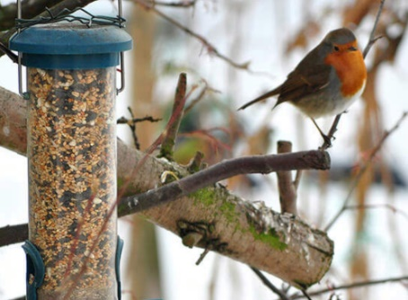

We will be learning about penguins and animals that live in Antarctica. We will be asking questions and finding out the answers to help us to create a fact wall.

We will create and develop our own penguin stories. We will act out stories using puppets and our small area.

We will create penguin puppets. Painting, drawing and making all kinds of icy scenes.

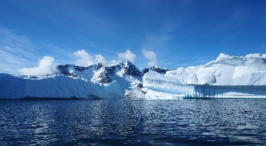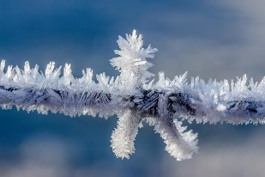

We will find out more about the seasons by observing winter. Investigating ice and snow and looking after the birds in our garden, making winter bird food.

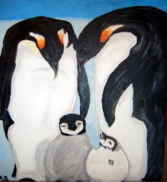

This half term in FS1 ………

We will do lots of counting, practise recognising our numbers as well as learning about sorting objects into groups.



We will be developing our language and writing skills in lots of ways. We will use lots of talk for writing to describe environments and animals.

We will be creating labels and captions for our work.

We will use technology such as the ipad or photocopier to help us record and share our learning.

We will learn more about feelings, thinking about what we like to do with our friends, feeling sad and what we can do to help cheer people up.

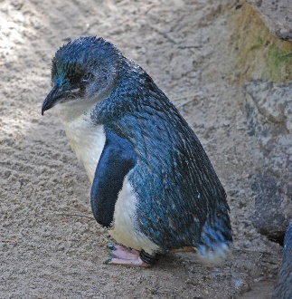

We will enjoy lots of books and stories, especially Blue Penguin by Petr Horacek.

