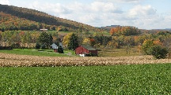

Continue to develop our painting, drawing and making skills to make all kinds of models… especially farms, machinery and observational drawings of plants and flowers.

learn about the environment around us and look at farms and farm animals.

Find out more about the seasons by looking out for the first signs of spring, getting the garden ready for planting and continuing to look after the bulbs that we planted.

Thinking about keeping healthy, being active in our PE sessions, developing skills like rolling, jumping, hopping, skipping and balancing.

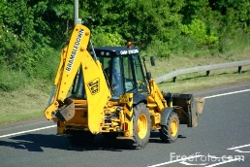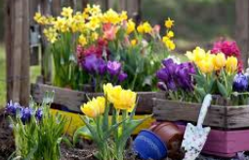

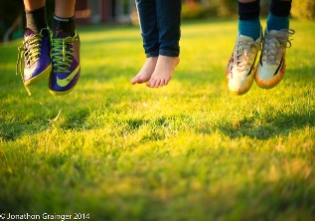

This half term we will …

Develop our writing skills in lots of ways. We will look at how characters are feeling and the plot of stories.

Do lots of counting, practise. We will continue to use numicon to help us recognise amounts. We will look at different ways of grouping objects.

Find out about Shrove Tuesday and Easter. Developing our understanding that different people celebrate in different ways at different times.

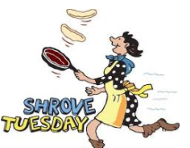

Learn more about feelings and right and wrong choices. We will look at how we can make the right decisions. Also how we can be a good friend.

Enjoy lots of books and stories, especially what the ladybird heard. Looking closely at the cunning plan.

Use technology such as the ipad or interactive whiteboard to help us record and share our learning.

