**Parental controls**



With Christmas nearly here and perhaps with presents including new technology or related games being received, we thought we’d provide you with a little reminder of how to set up appropriate parental controls.

**Games/consoles**

**Instagram**

Is your child on Instagram? **You should be over 13 years of age to set up an account.**

Instagram is used to post photos and videos. Users can also DM (direct message), send disappearing messages, add to their stories (these disappear after 24 hours) and broadcast live.

Instagram have now introduced new age verification software to help confirm the age of users. Any user who tries to change their age will have to upload an ID document or take a video selfie. You can find out more here:

<https://saferinternet.org.uk/blog/instagram-rolls-out-age-verification-for-users>

First, check the PEGI rating of any new games to ensure that your child is old enough to be playing them. PEGI provides age classifications for games and **considers the age suitability of a game, not the level of difficulty.** It is important to note that PEGI do not take into consideration the chat facilities within games. If a game does allow your child to communicate with others then you can adjust the settings so they are appropriate to your child - or disable it completely.

Secondly, for any consoles (new and old), it is important to set up appropriate controls such as restricting spending limits and again managing who they can communicate with. Follow the links below to find out how to set up Parental Controls for each device:

**Tablets/Smart phones**

As well as setting up parental controls on the device itself, remember to check any apps your child would like on their device. Is it suitable for their age? Review all settings and privacy options for each app. For the devices themselves use the available settings to prevent purchases, restrict content viewed and adjust privacy settings. Follow the links below to find out more:

**iPhones/iPads:** <https://support.apple.com/en-gb/HT201304>

**Google Play:** <https://support.google.com/googleplay/answer/1075738>



Users of this guide do so at their own discretion. No liability is entered into. Current as of the date released 1.12.22.

**Online Safety with Google**

As part of Google Families, Google have a hub of resources that you can use including conversation starters with links to additional tools and advice and information about parental controls. Google also provide you with resources to help your children build healthier habits and stay safe online. There is also a selection of ideas on how to use technology as a family in a fun and engaging manner such as exploring the world and learning how to code. You can access the hub here:

<https://families.google/intl/en_uk/>

**Be kind online**

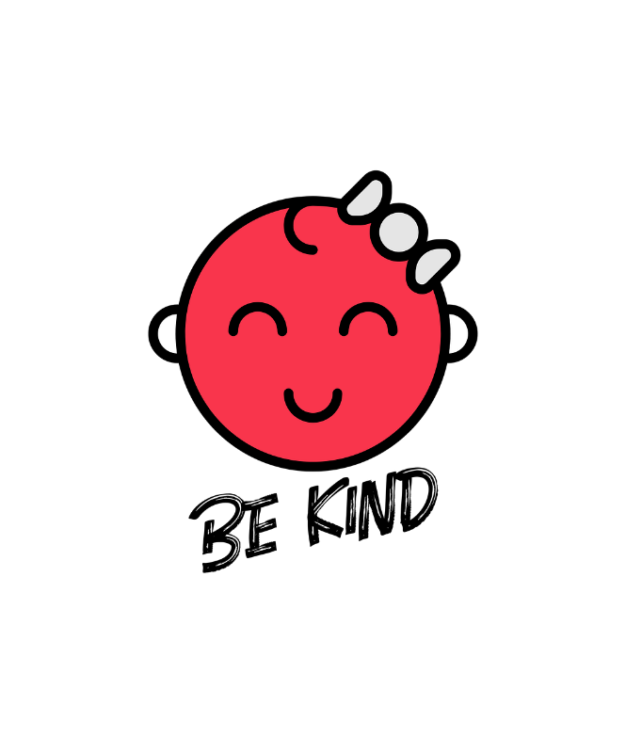

It can be very easy online for children to behave in a way that they wouldn’t if they were face to face with each other. Talk to your child about how they are speaking to others online and encourage them to talk to people online with respect and kindness, like they would if they were face-to-face.

Dr Linda Papadopoulos (Internet Matters Ambassador) provides tips on how you can help your child to be kind online in this YouTube video such as teaching them how to be inclusive and think about how they would like to be treated online themselves: <https://www.youtube.com/watch?v=1BqKi3J7g6Q&t=9s>

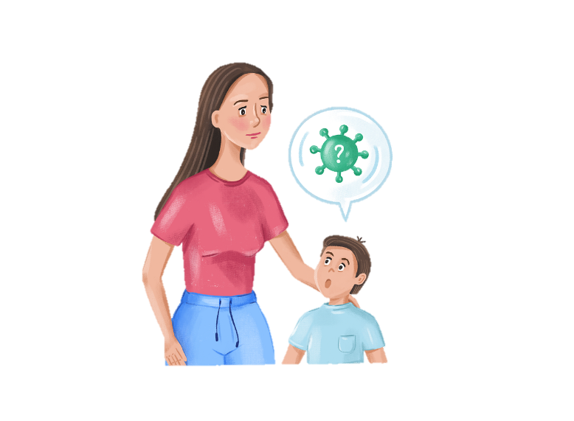

Ensure that your child understands that if they receive unkind messages (or see something that worries them) then they should not reply or engage in conversation with them, but that they should tell a trusted adult. You can use the tools within an app to report any offensive or hurtful content as well as block people so they cannot contact you again in the future.

Unicef have a comprehensive area on their website, which talks about what Cyberbullying is and how to stop it:

<https://www.unicef.org/end-violence/how-to-stop-cyberbullying>

**CEOP: Updated 4-7s website and guide**

This updated website from CEOP Education is designed for children to visit with their parents/carers. The children answer a series of questions as they work towards collecting badges. You can find out more here:

<https://www.thinkuknow.co.uk/professionals/resources/4-7s-website/>

Childline also have a lot of information about Cyberbullying, including advice to those that might be bullying:

<https://www.childline.org.uk/info-advice/bullying-abuse-safety/types-bullying/bullying-cyberbullying/>

Whilst we wait for the Online Safety Bill to be passed, which will hopefully improve Online Safety, there are certain laws already established to help protect us online. For example, in the UK we have the Malicious Communications Act 1988 that states it is an offence to send a communication that conveys an indecent or grossly offensive message or a threat. We also have the Protection from Harassment Act 1997, which covers threatening behaviour or harassment online.

**Screentime advice**

We’re often asked how long children should spend on their devices each day. Childnet have created a blog discussing why it is difficult to specify a limit and what you should consider. You can read it here:

<https://www.childnet.com/blog/screen-time-guidance-for-parents-and-carers/>

Report Harmful Content have curated a list of laws that are relevant to online behaviour here:

<https://reportharmfulcontent.com/when-should-you-go-to-the-police/>