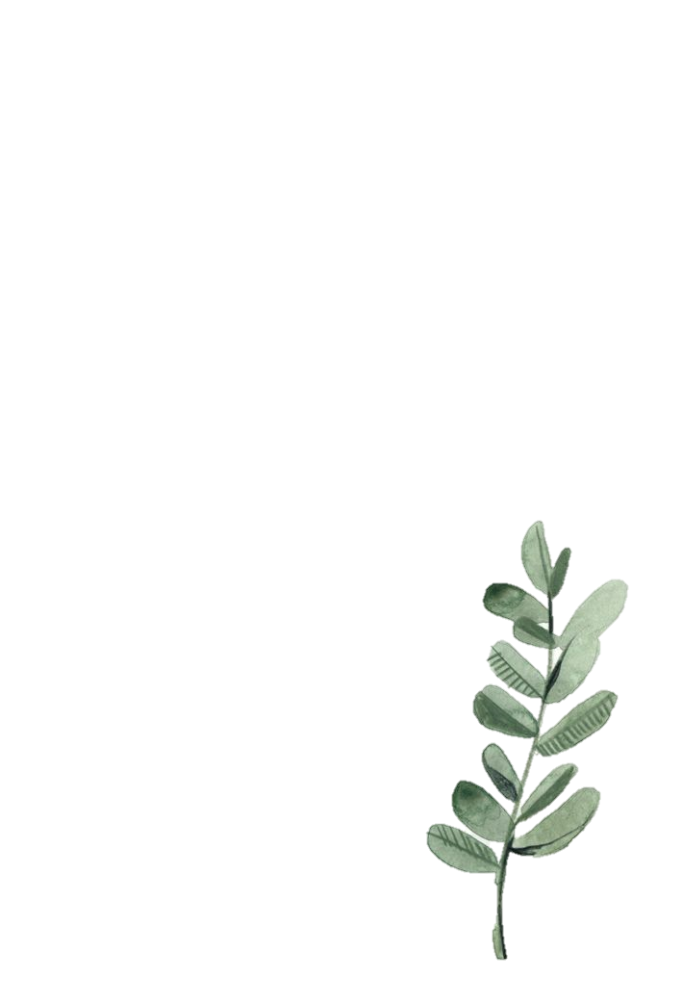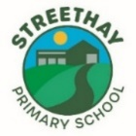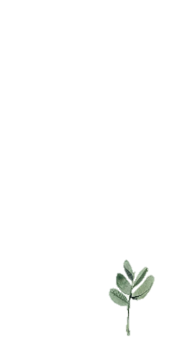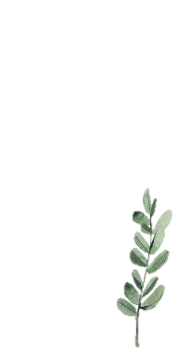

**Values**

There will be an emphasis on appreciating individuality and our unique qualities that make us special.

Emphasis on the Characteristics of Effective Learning.

Engagement, finding out and exploring, playing with what they know.

**Mindfulness and Personal, Social and Emotional Development**

Children will continue to develop their social and emotional skills with Jigsaw Jenie. We will focus us:

* What makes us special and unique
* Our families and people who are special to us
* Making friends



**Foundation of Phonics**

The children will begin the Foundation of Phonics programme. We will be practising a range of listening and oral blending games to develop children’s phonological awareness.

**Mark Making**

The children will make marks and talk about what they represent.

Children will continue to trace and write their name.

**Book Focus**

Our texts this half term are We’re going on a leaf hunt, Home is where the heart is and The Gruffalo.

*Children will also be reading a range of celebration stories around Diwali and Christmas.*

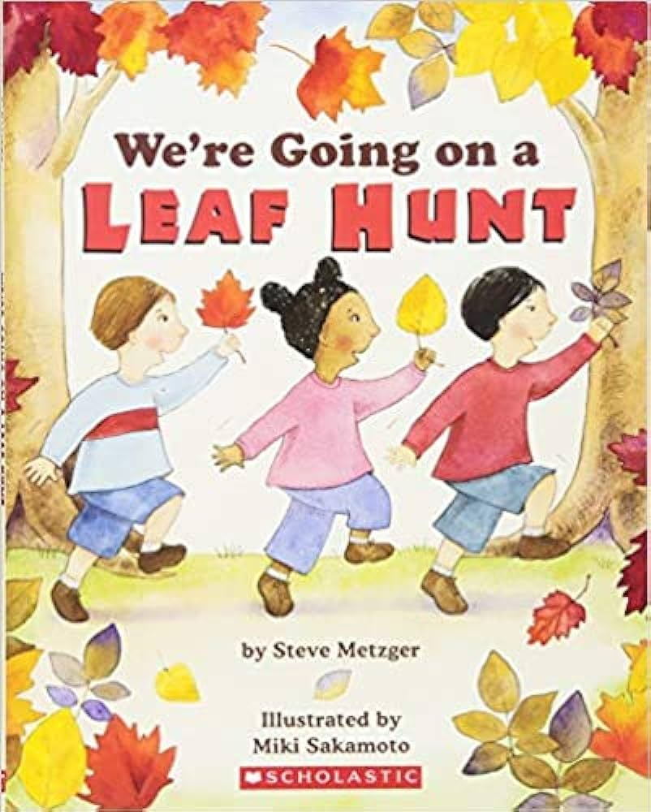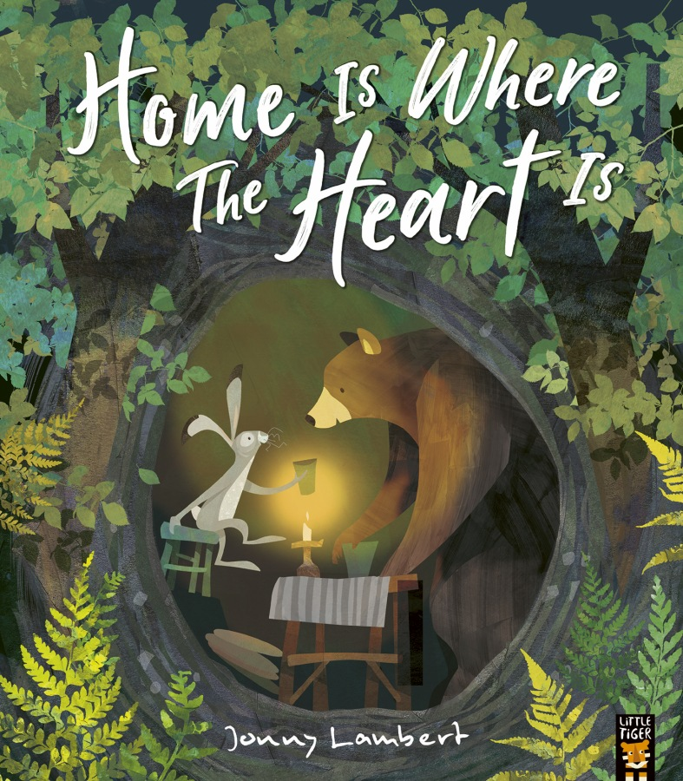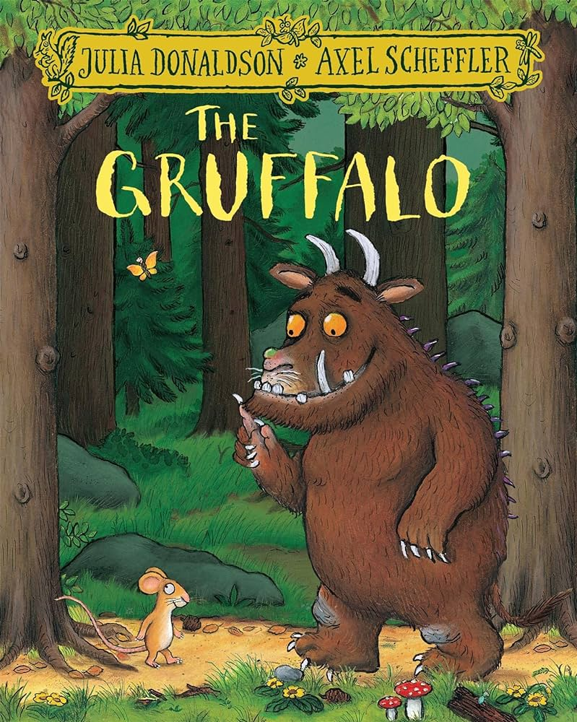

**Daffodils’ Curriculum Map**

**Term: Autumn 2 2023**

**Communication and Language**

The children will:

* Continue to develop their communication and language skills, interacting with peers in provision.
* Continue to develop their language, being exposed to new vocabulary, and encouraged to use this during play.
* Have daily nursery rhyme time, exploring rhymes, alliteration, and voice sounds.

**Mathematics**

The children will continue to explore numbers to 5.

They will look at 2D shapes and the use of positional language.

**Physical Development**

Fine motor skills: Threading, cutting and mark making.

Gross Motor skills: Dancing with ribbons and building with large construction. Children will continue to develop their gross motor skills during weekly Write Dance sessions.

Children will develop personal care skills and the ability to go to the toilet and wash hands independently.