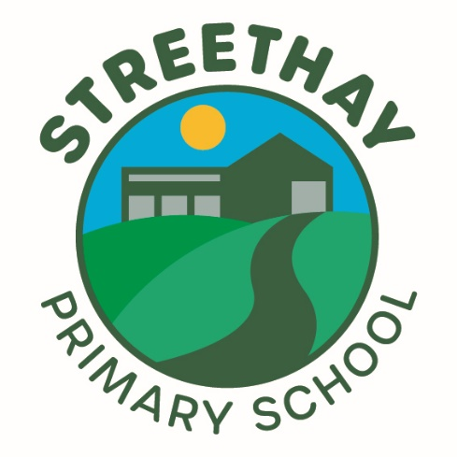

Date Published: September 2025

Author: Charlotte Price

Ratified by: Stuart Taylor

Review date: September 2026

**Nursery Admissions**

**Policy**

**Nurtured. Inspired. Prepared.**

Working together to be the best we can be.

**Equality Impact Assessment**

This policy has been equality impact assessed and we believe it to be in line with the Equality Act 2010. It does not have an adverse effect on any of the protected characteristics.

At Streethay we are ambitious about inclusion and go much further than our statutory duty. When writing and developing policies we review our plans against our inclusion goal below.

‘Every person in our community at Streethay should feel safe, supported, celebrated, valued, and feel like they belong.’

Following consultation with the Shaw Education Trust Executive team Streethay Primary School is now responsible for the Nursery Admissions process. Admission to Streethay Nursery is subject to an application being made and places subject to availability.

**Nursery Places**

There are currently 42 Nursery places available between 8.35am & 3.15pm. This is broken down into 16 places in the ‘Daises’ room & 26 places in the ‘Daffodils’ room. Children will be eligible to attend the Nursery the September after their 2nd birthday. We group our children into academic year groups to support transition through the school.

We run morning and afternoon sessions, 3 hours per session Monday to Friday from 8.35am to 11,.45 am & 12.15pm – 3.15pm. *Additional wraparound care outside standard nursery times are available through our wraparound team.*

All of our sessions are chargeable (unless you receive Think2, Universal 15 or Extended 30 hours funding).

**Costs of Provision**

|  |  |  |
| --- | --- | --- |
| *7:30am to 8:35am* | *£5.80* | *Breakfast provided* |
| *8.35am to 11.45am* | *£17.85*  *(where charges are applicable)* |  |
| *12.15noon to 3.15pm* | *£17.85*  *(where charges are applicable)* | *Hot lunch available at an extra cost. Alternatively, please send a packed lunch* |
| *3.15 pm to 6pm* | *£11.10* | *Snack/light meal included* |

**Funded Childcare**

All funded hours can be used term time only. Parents receiving 15 free hours childcare can use these hours in our morning sessions only. Where applicants receive Think2, Universal 15 or Extended 30 hours funding an EEF funding form will need to accompany the application form. This is to support staffing the Nursery and to ensure children to not miss out on key learning.

**How to apply**

Information about the provision we offer, and our open days can be found on our website. Application open, close and offer dates are outlined below. We reserve the right to amend our application process at any point including the dates and number of intakes.

An application form is available in the Nursery admissions section of our website.

[Please click here to be directed to the application.](http://www.streethayprimary.org.uk/how-to-apply/applying-for-nursery-2)

Completed application forms should be sent to:

[**info@streethay.shaw-education.org.uk**](mailto:info@streethay.shaw-education.org.uk).

**Application for September Intake**

We run one application cycle for September each year. The majority of our tours and open events will take place in Spring Term.

|  |  |  |  |  |
| --- | --- | --- | --- | --- |
| **Nursery Intake (Term)** | **Nursery Tour** | **On-line Applications Open** | **On-line Applications close** | **Offer/No Offer** |
| **September**  **(Autumn Term)** | Autumn Term | Now | 29th February | 22nd March |

**Applications Throughout the Year**

We accept applications throughout the year for both of our Nursery rooms until we are full, after this we operate a waiting list.

**Oversubscription Criteria**

It is our policy to try and meet parents’ wishes where possible, however, in some cases there may be more applications for a Nursery intake than there are places and in this instance admission to Nursery will be determined by the oversubscription criteria detailed below.

In accordance with legislation, children who have an Education, Health and Care Plan that names our nursery must be admitted. This will reduce the number of places available to other applicants.

Thereafter places will be offered in accordance with the following specified criteria:

1. Relevant Children in Care, including those previously determined as Looked After Children. (That is, children who were looked after but ceased to be so because they were adopted or became subject to a residence order or special guardianship order).
2. Children who have an elder brother or sister in attendance at the school and who will still be attending the school at the time of the proposed admission date. *(For admission purposes, a brother or sister is a child who lives at the main address provided and either: have one or both natural parents in common; are related by a parents marriage; are adopted or fostered by a common parent or are unrelated children who live at the main address, whose parents live as partners.)*
3. Children will be offered a place in consideration of the number of sessions requested. (We strictly adhere to child to adult ratios and child to floor space ratios as set out by Ofsted)
4. Children who will be eligible to apply for a Reception place based on distance from school.

Distance is measured using the **Google Walking Map** for Nursery applications only and is in no way linked with the Reception Admissions method of calculation via the Local Education Authority’s Admission Team.

**Waiting List**

Where Streethay Nursery is oversubscribed a waiting list will be maintained in criteria order where ranking places for applicants may change dependent on further applications being submitted.

Please note Nursery education is a non-statutory provision and there is therefore no right of appeal against the admission authority’s decision.

Streethay expect that parents applying for places for their children will accept and uphold the attendance policy for our school, where the expectation is pupils attend every day. If a nursery child misses 10 days during a half term without any viable explanation, a meeting will be called with the school attendance officer and this could lead to the nursery place being revoked.

**Admission to the school’s Nursery does not guarantee admission to the Reception class at our school. Applications for Reception must be made on a separate application through the Local Authority and be submitted by the statutory deadline in order to be considered.**