Document Owner: | B. Duffy
Approved By: | C-Suite
Queries to: | B. Duffy
Review Period: | 3 years or as appropriate
Date of last review: | 1st September 2024


Mental Health Policy (Pupils)
Contents Page No.

- Introduction 3
- Aims 3
- Key Staff Members within our Academy 4
- Teaching about Mental Health 4
- Assessment & Provision 5
- Warning signs 5
- Individual Plans 6
- Referrals and Working with External Providers 6
- Working with Parents/Carers 7
- Supporting peers 7

Annex A: 8

Introduction
Shaw Education Trust and our academies are committed to promoting positive mental health and emotional wellbeing for all pupils, their families, members of staff and local academy councillors. Good mental health and wellbeing helps children and young people to:
Develop into a happy, well-rounded citizen
attend school regularly
fully engage in learning
fulfil their potential and lead a fulfilling life

Our academy contributes to wellbeing by providing:
a safe, calm and supportive learning environment
early targeted support for learners who need help
opportunities for pupil voice

This policy is for all adults, including parents/carers, outlining our approach to promoting mental health and emotional wellbeing and should be read alongside our ‘Safeguarding & Child Protection Policy’ (see especially section 22 within that policy).
This policy has been equality impact assessed and we believe is in line with the Equality Act 2010. It does not have an adverse effect on race, gender or disability equality.

Aims
Our academy aims and principles align with those promoted by DfE, namely:
an ethos and environment that promotes respect, and values diversity
leadership and management that supports and champions efforts to promote emotional health and wellbeing
staff development to support their own wellbeing and, that of pupils and learners
curriculum teaching and learning to promote resilience and support social and emotional learning
enabling student voice to influence decisions
identifying the need for and monitoring the impact of interventions
targeted support and appropriate referral
working closely with parents and carers

Key staff members within our Academy
This policy aims to ensure all staff take responsibility to promote the mental health of pupils, however key members of staff have specific roles to play:
SLT: to ensure a positive approach to mental health is encouraged across the academy, and a process is in place to identify and support pupils in need.
Mental Health Lead: to determine and implement the processes which identify and support pupils in need, including external support.
Designated Safeguarding Lead: To ensure all relevant incidents are recorded and information is shared with relevant colleagues both regarding individual pupils and mental health data.
PSHE/RSC Lead: to ensure that mental health and well-being are integral aspects of the PSHE Curriculum (or equivalent), and relevant to the academy cohort’s needs.
Other staff with specific responsibilities to support MH work, e.g. Pastoral Leads, Attendance leads, SEND staff, and MH Trained staff: to support relevant pupils in their care, including those most in need through use of personal plans.
All staff: to be vigilant of all behaviours which may indicate that a pupil is in need of support and refer as appropriate to the relevant colleague.
All staff will have regular training around mental health issues and identified staff will have further in-depth training to suit their role.
If there is a concern that the student is high risk or in danger of immediate harm, the academy’s safeguarding procedures will be followed.
If the pupil presents a high-risk medical emergency, relevant procedures will be followed, including involving the emergency services if necessary.

Teaching about Mental Health
The skills, knowledge and understanding our pupils need to keep themselves, and others, physically and mentally healthy and safe, are included as part of our PSHE/RSC curriculum and other relevant support programmes.
We ensure that mental health is a key component in the relevant curriculum areas and has been designed using the very best resources. More importantly, the content and method of delivery are tailored to meet the needs of our academy.
More broadly, the overall culture of our academy promotes positive relationships and is ‘people-centred’.
Assessment & Provision
Across our academy, we aim to ensure that our provision meets our needs, both through internal and external intervention. In broad terms the table below summarises how we see each level of need across our mental health work, in terms of basic descriptor of ‘assessment’, and subsequently, matching ‘provision’. Please note that both aspects are more detailed than this, but this will give the reader some sense of our approach.
Only appropriately trained professionals should attempt to make a diagnosis of a mental health problem. However, our staff are well placed to observe children day-to-day and identify those whose behaviour suggests that they may be experiencing an emotional or mental health problem or be at risk of developing one.

Level of Need | Assessment of Mental Health | Provision offered/available
1 | Pupil exhibits a ‘normal’ range of emotions, displaying expected levels of resilience to life issues. | Pupil is supported by whole-school processes within the pastoral system. This is deemed sufficient for this pupil.
2 | Pupil exhibits a ‘normal’ range of emotions on most occasions, but emotion / mood peaks and / or troughs are observed. | Pupil may receive some additional identified support possibly either via pastoral system and/or trained internal MH trained staff.
3 | Pupil exhibits a regular inability to cope with issues thus causing impact on school life. | Pupil will receive additional identified support via trained staff in-school and possibly also have external support, e.g. external counsellor.
4 | Pupil has a diagnosed mental health concern, such as anxiety or depression. | Pupil will be receiving external support, e.g. CAMHS, and school will support pupil in line with the external intervention.

Warning Signs
Signs can be varied and similar to signs of any number of issues, but can generally include:
inability to cope with daily tasks
social withdrawal
dramatic changes in eating/sleeping habits
feeling anxious
substance misuse
thoughts or actions around self-harm

Staff may become aware of warning signs which indicate a student is experiencing mental health or emotional wellbeing issues. These warning signs will always be taken seriously and staff observing any of these warning signs will alert relevant colleagues, and we will refer to external services if appropriate.
Where a disclosure is made to staff, our safeguarding procedures, including confidentiality rules, will apply as stated in our Safeguarding Policy.

Individual Plans
When a pupil has been identified as having cause for concern, and/or has received a diagnosis of a mental health issue or is receiving support either through CAMHS or another organisation, it is recommended that an Individual Plan should be drawn up. The development of the plan should involve the pupil, parents, and relevant professionals.
Suggested elements of this plan include:
Details of the pupil’s situation/condition/diagnosis
Special requirements or strategies, and necessary precautions
Medication and any side effects (if relevant)
Who to contact in an emergency
The role the school and specific staff

Referrals and Working with External Providers
When our staff have ‘assessed’ need as best they can, they will determine if additional support and expertise is needed beyond the work of our trained staff within our academy. This may occur by advising parents to visit their GP or making a referral ourselves. Our staff work closely with external services, such as the NHS funded MHST programme, in supporting the emotional and mental health needs of pupils, but it is important to note that external services quite often make the ultimate decision on what support is provided, including CAMHS. Even if parents and/or school may wish for more intervention, CAMHS will make that decision based on their own assessment of need and their capacity to intervene.

Working with parents/carers
We are mindful that for a parent, hearing about their child’s issues can be upsetting and distressing. Therefore, we wish to work with all our parents where the mental health of a pupil needs supporting. Parents will be involved at every step ensuring that open lines of communication exist. It is important to note however, that some mental health issues faced by children are caused by home situations, including relationship with parents etc. Unfortunately, neglect and abuse at home does happen, which does affect the mental health of a child. Where our staff feel this is the case, our safeguarding procedures will be implemented, and relevant external services will be informed. The pupil’s welfare will always be our main priority.
Signposting parents to other sources of information and support can be helpful in supporting their child. Academy staff will endeavour to ensure parents have information for any agency who may be able to support them around their child’s mental health.

Supporting Peers
When a pupil is suffering from mental health issues, it can be a difficult time for their friends who may want to support but do not know how. To keep peers safe, we will consider on a case-by-case basis which friends may need additional support. Support will be provided in one to one or group settings and will be guided by conversations by the pupil who is suffering and their parents/carers.

Annex A: Academy Procedures

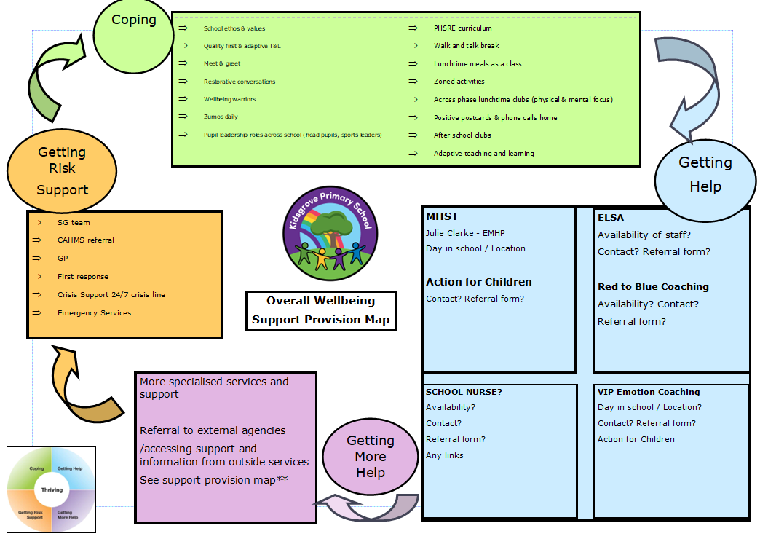



Shaw Education Trust Head Office,  Kidsgrove Secondary School, Gloucester Road,  Kidsgrove,  ST7 4DL | Twitter  LinkedIn  Call  Email  Visit | @ShawEduTrust  @ShawEducationTrust  01782 948259  info@shaw-education.org.uk  shaw-education.org.uk



