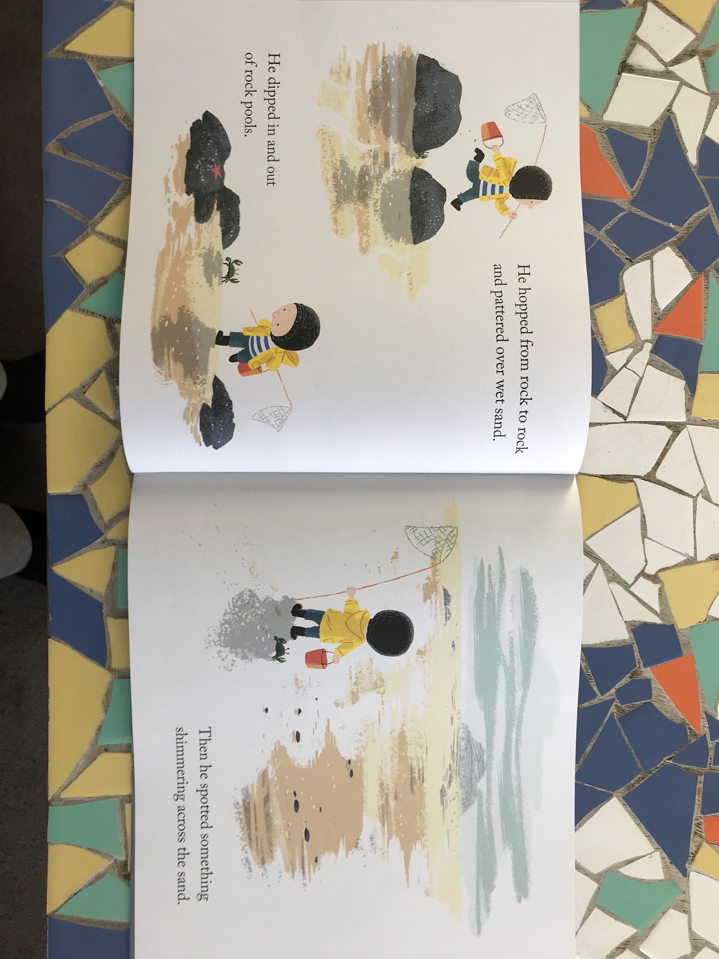

**Additional Information**

* **Daffodils will now have PE on a Friday. Please can you send your child in to school in their PE kits. Thank you.**
* Famly is our new learning journal for your child. Please look on Famly for any WOW or in the moment impact moments of your child. We also welcome any home learning or experiences that you would like to share too. Please be aware that we are no longer using Tapestry.

Thank you for your continued support.

Miss Pitcher & Miss Griffiths 😊

**Marvellous Me Topic**

This half term our topic is Marvellous Me. We will be learning all about ourselves, our families and how to keep our bodies happy and healthy.

Next week, Miss Pitcher & Miss Griffiths will be sharing their Marvellous me boxes. This is a box that contains all things marvellous about them. E.g. family, pets, favourite colour etc.

Over this half term, can you create your own Marvellous me boxes to bring in a show to the class.

*You can include anything that makes you, you! This could be photos or objects that fit in a small shoe box.*

**You can bring your box in once it is ready to share. We will be sharing these boxes until the October half term.**

**Reading**

Our story of the week is ‘Harry and his dinosaurs go to school’. We have enjoyed reading this book and have been thinking about our typical day at school. We have used our visual timetable to talk about our school day.

Can you discuss your school day with a family member? Maybe you could draw a picture of your favourite part of the school day. This might be playing time, or story time or lunchtime in the hall!

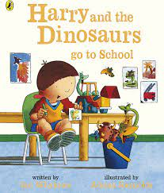

Can you sort objects into More and Less at home?

**Listening and Attention**

This week we have enjoyed playing listening games with Listening Lola. This week, the children have met Lola and have introduced themselves using full sentences. ‘Hello, my name is Miss Pitcher.’

Can you play this game with your teddies? You could hide them in a box and as each one pops out, they introduce themselves. ‘Hello, my name is…’



**Daffodils Learning Update**

**Friday 15th September 2023**

This week we have enjoyed our first full week in Daffodils. The children have really enjoyed playing and exploring in the classroom and outside areas.

Below are some home learning suggestions, please upload any home learning onto **Famly.**

Miss Pitcher