Strike Lane
Calculations Policy



Addition
In developing a written method for addition, it is important that children understand the concept of addition, in that it is:
- Combining two or more groups to give a total or sum
- Increasing an amount

They also need to understand and work with certain principles, i.e. that it is:
- the inverse of subtraction
- commutative i.e. 5 + 3 = 3 + 5
- associative i.e. 5 + 3 + 7 = 5 + (3 + 7)

The fact that it is commutative and associative means that calculations can be rearranged, e.g.
4 + 13 = 17 is the same as 13 + 4 = 17.

Expectation | Example | Additional Information
Using quantities and objects, children add two single-digit numbers and count on to find the answer. | 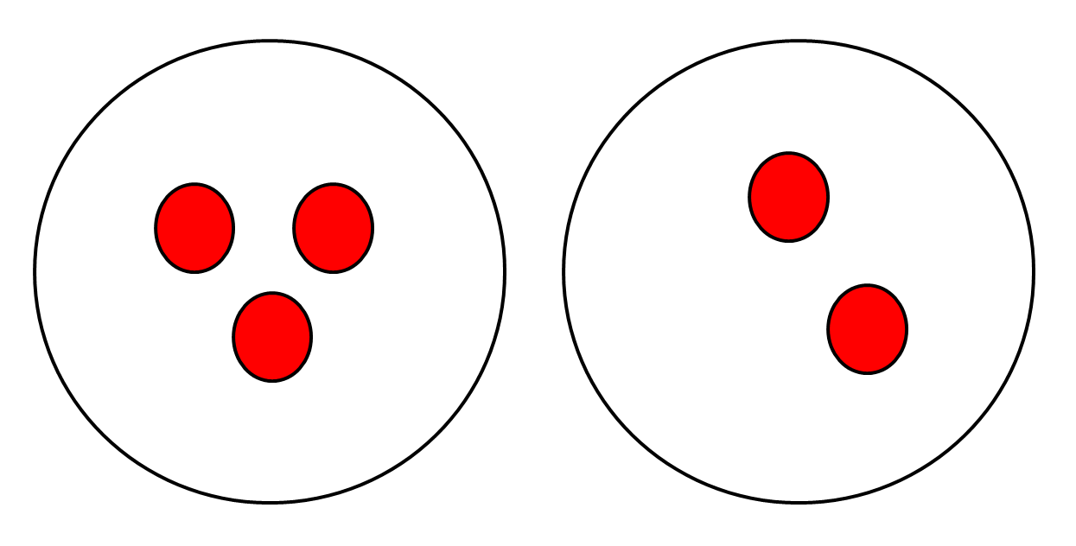  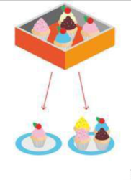  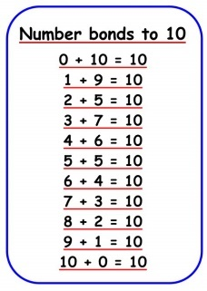 | Children are encouraged to develop a mental picture of the number system in their heads to use for calculation. They should experience practical calculation opportunities using a wide variety of practical equipment, including small world play, role play, counters, cubes etc.  At this stage, children will focus on a counting all method and then a counting on method.  i.e. Combining two parts to make a whole using concrete methods to support addition of single digit numbers.  Solve problems using concrete and pictorial methods.  Children will also be able to mentally Recall number bonds to 10.
Add one-digit and two-digit numbers to 20, including zero (using concrete objects and pictorial representations). | 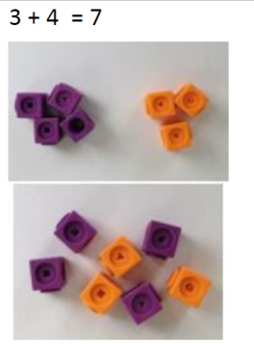  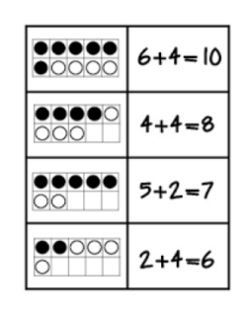  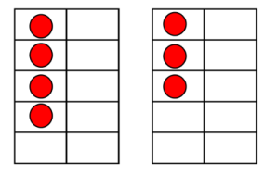  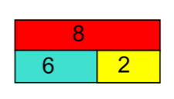  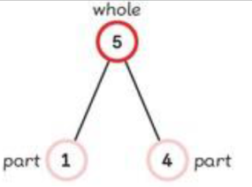  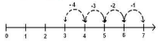 | Combining two parts to make a whole  Continuing to use concrete and pictorial methods to support addition, i.e. counters and ten frames (Joining two groups and then recounting all objects (lots of practice making 10 and numbers to 10 e.g. 6 + 4 = 10 or 3 + 5 = 8).  Use the bar model and the part whole model to support addition of one and two digit numbers up to 20.  To support addition children will count on on a numbered number line.
Learn number bonds to 20 and demonstrate related facts. | 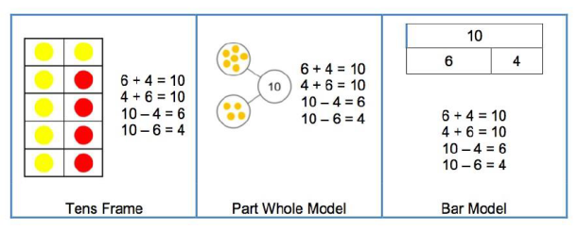
Addition and subtraction taught alongside each other as pupils need to see the relationship between the facts. | 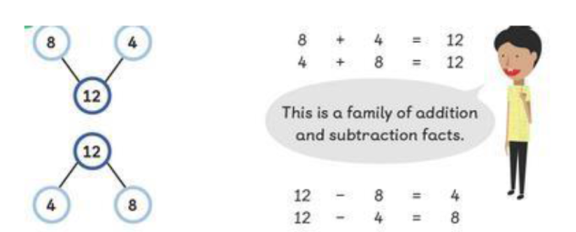
Add numbers using concrete objects, pictorial representations, and mentally, including: a two-digit number and ones; a two-digit number and tens; two two-digit numbers; three one-digit numbers. | 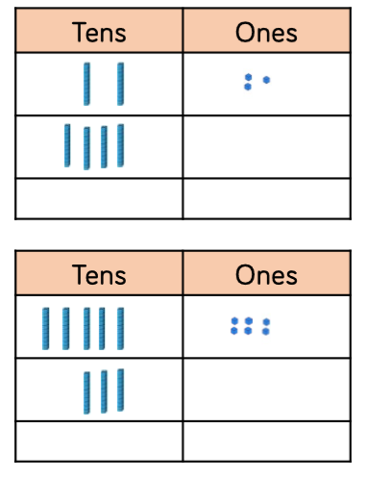  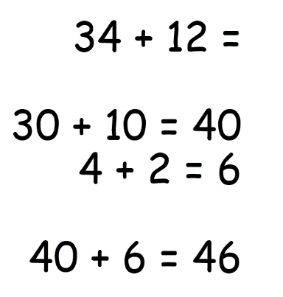  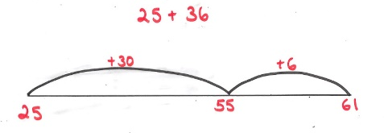
Add numbers with up to three digits, using formal written method of columnar addition.  Add numbers with up to 4 digits and decimals with one decimal place using the formal written method of column addition where appropriate.  Add whole numbers with more than 4 digits and decimals with two decimal places, including formal written methods (columnar addition).  Add whole numbers and decimals using formal written methods (columnar addition). – Need year 6 modelled example. | Stage 1  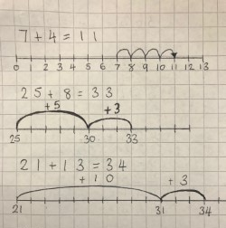  Step 2  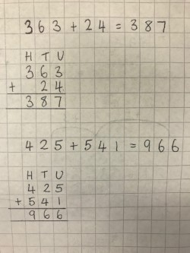  Step 2 with decimals  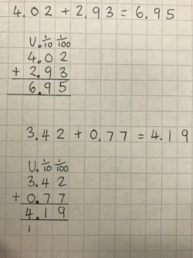  Step 3  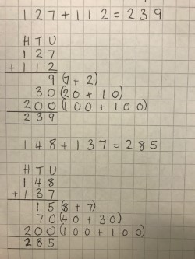 | Stage 1 would start in Year 3 and stage 4 would typically appear in Year 6.  Addition starts with adding on using a numbered number line (jumps above the number line) using mental ‘counting on’ strategies such as number bonds.  A similar method is used to develop this stage but on a blank number line.  This method relies on the children’s knowledge of place value and mental addition strategies.  Stage 2 and 3 are the next stage of addition where formal written method is introduced where the children must have secure knowledge of place value.  Stage 3 is the final stage of addition with regular use of exchanging relying heavily on the children’s knowledge of place value and adding multiples of 10 and 100.
Subtraction
In developing a written method for subtraction, it is important that children understand the concept of subtraction, in that it is:
- Removal of an amount from a larger group (take away)
- Comparison of two amounts (difference)

They also need to understand and work with certain principles, i.e. that it is:
- the inverse of addition
- not commutative i.e. 5 - 3 is not the same as 3 - 5
- not associative i.e. 10 - 3 - 2 is not the same as 10 - (3 - 2)

Expectation | Example |  |  | Additional Information
Using quantities and objects, children subtract two single-digit numbers and count on or back to find the answer.  Subtract one-digit and two-digit numbers to 20, including zero (using concrete objects and pictorial representations).  Subtract numbers using concrete objects, pictorial representations, and mentally, including: a two-digit number and ones; a two-digit number and tens; two two-digit numbers. | Count out the first number and take away the second number, e.g. 9-4=  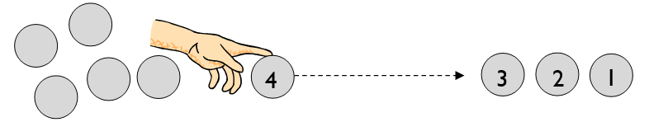  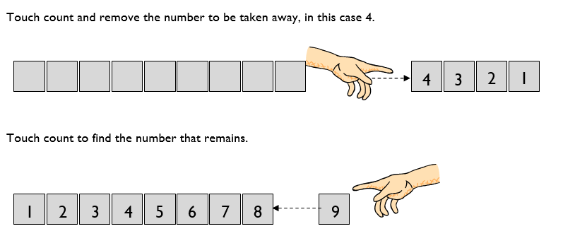  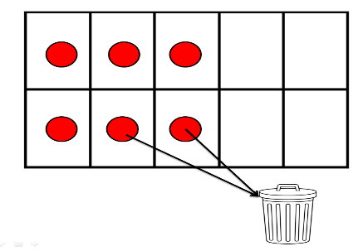  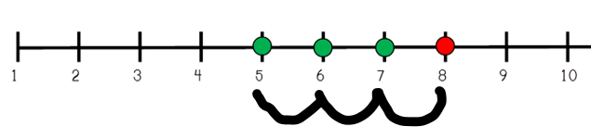  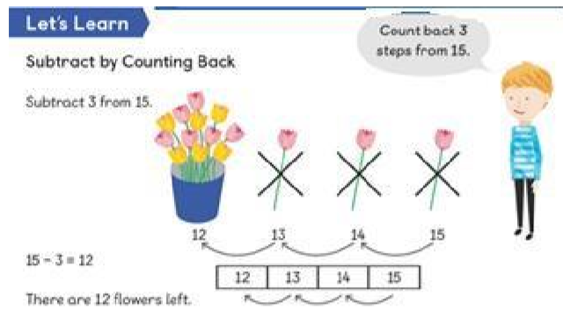  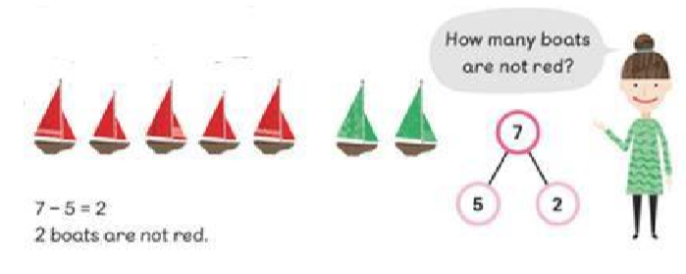  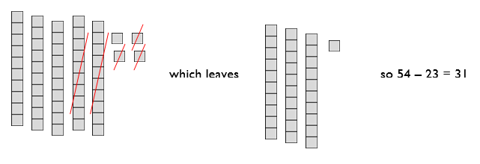  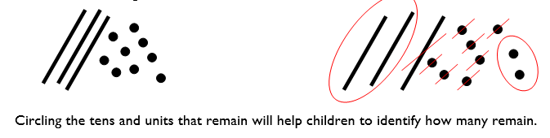  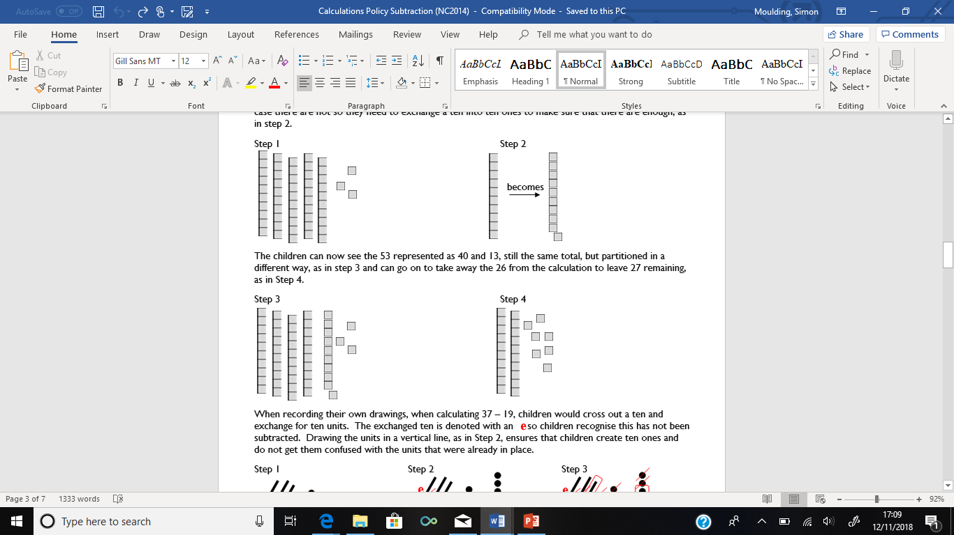  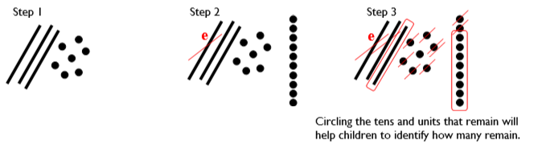 |  |  | Children are encouraged to develop a mental picture of the number system in their heads to use for calculation.  They should experience practical calculation opportunities using a wide variety of practical equipment, including small world play, role play, counters, cubes etc.  Those who are ready can then begin to record their answers, e.g. 9-4=5.  Children will continue to use practical equipment and taking away strategies. To avoid the need to exchange for subtraction at this stage, it is advisable to continue to use equipment such as counters, cubes and the units from the Base 10 equipment, but not the tens, e.g. 13 – 4.  Children will then use a number line to support subtraction by counting back.  Subtracting using the part part whole model (include problem solving with missing digits). E.g. ? - 5 = 2  Children will begin to use the Base 10 equipment to support their calculations, still using a take away, or removal, method. They need to understand that the number being subtracted does not appear as an amount on its own, but rather as part of the larger amount.  For example, to calculate 54 - 23, children would count out 54 using the Base 10 equipment (5 tens and 4 units). They need to consider whether there are enough units/ones to remove 3, in this case there are, so they would remove 3 units and then two tens, counting up the answer of 3 tens and 1 unit to give 31.  Children will also record their own calculations using their own drawings of the base 10 equipment.  When the amount of units to be subtracted is greater than the units in the original number, an exchange method is required. This relies on children’s understanding of ten units being an equivalent amount to one ten.  To calculate 53 – 26, by using practical equipment, they would count out 53 using the tens and units, as in Step 1. They need to consider whether there are enough units/ones to remove 6. In this case there are not so they need to exchange a ten into ten ones to make sure that there are enough, as in step 2.  The children can now see the 53 represented as 40 and 13, still the same total, but partitioned in a different way, as in step 3 and can go on to take away the 26 from the calculation to leave 27 remaining, as in Step 4.  When recording their own drawings, when calculating 37 – 19, children would cross out a ten and exchange for ten units. The exchanged ten is denoted with an so children recognise this has not been subtracted. Drawing the units in a vertical line, as in Step 2, ensures that children create ten ones and do not get them confused with the units that were already in place.
Subtract numbers with up to three digits, using formal written method of columnar subtraction.  Subtract numbers with up to 4 digits and decimals with one decimal place using the formal written method of columnar subtraction where appropriate.  Subtract whole numbers with more than 4 digits and decimals with two decimal places, including formal written methods (columnar subtraction).  Subtract whole numbers and decimals using formal written methods (columnar subtraction). | Stage 1  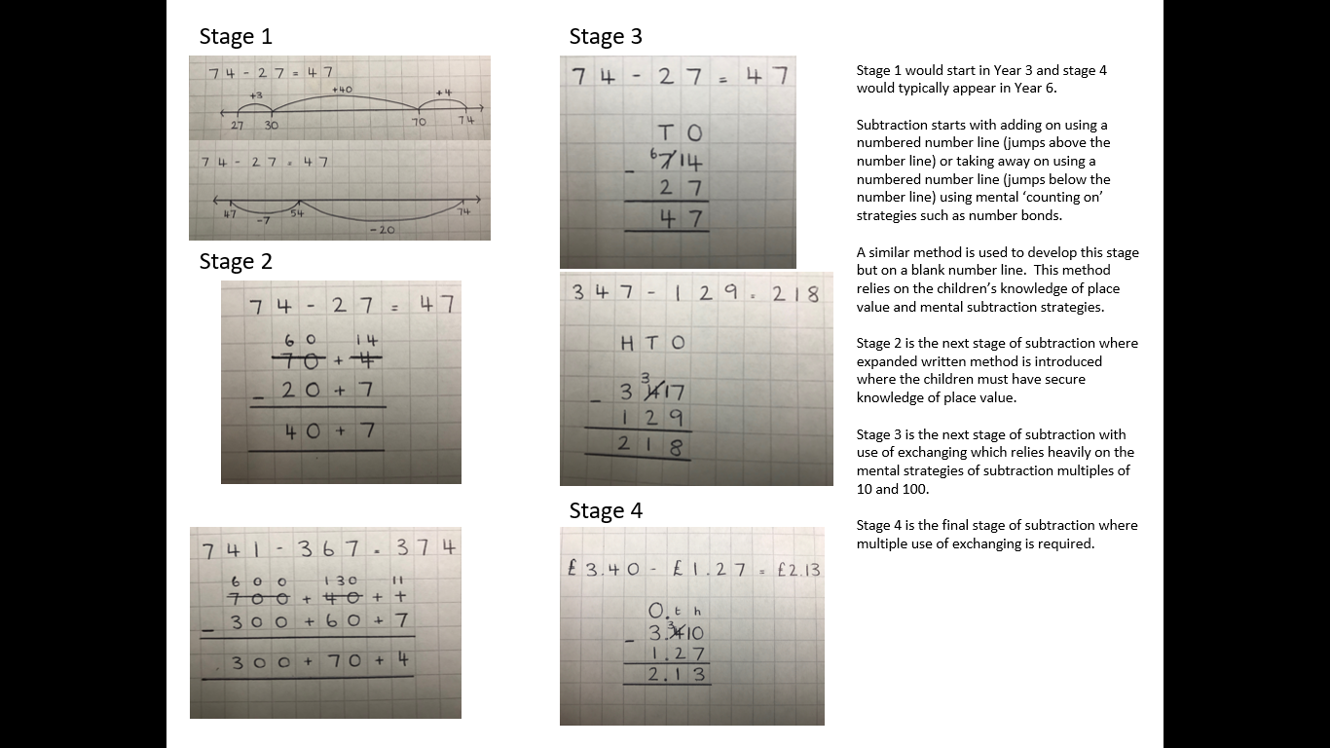  Stage 2  Stage 3  Stage 4 |  | Stage 1 would start in Year 3 and stage 4 would typically appear in Year 6.  Subtraction starts with adding on using a numbered number line (jumps above the number line) or taking away on using a numbered number line (jumps below the number line) using mental ‘counting on’ strategies such as number bonds.  A similar method is used to develop this stage but on a blank number line. This method relies on the children’s knowledge of place value and mental subtraction strategies.  Stage 2 is the next stage of subtraction where expanded written method is introduced where the children must have secure knowledge of place value.  Stage 3 is the next stage of subtraction with use of exchanging which relies heavily on the mental strategies of subtraction multiples of 10 and 100.  Stage 4 is the final stage of subtraction where multiple use of exchanging is required.

Multiplication
Multiplication

In developing a written method for multiplication, it is important that children understand the concept of multiplication, in that it is:
- repeated addition

They should also be familiar with the fact that it can be represented as an array

They also need to understand and work with certain principles, i.e. that it is:
- the inverse of division
- commutative i.e. 5 x 3 is the same as 3 x 5
- associative i.e. 2 x 3 x 5 is the same as 2 x (3 x 5)

Expectation | Example | Additional Information
EYFS/KS1 Multiplication  Early Learning Goal - Children solve problems, including doubling.  Year 1 – End of Year Objective:  Solve one-step problems involving multiplication by calculating the answer using concrete objects, pictorial representations and arrays with the support of the teacher.  Year 2 – End of Year Objective:  Calculate mathematical statements for multiplication (using repeated addition) and write them using the multiplication (x) and equals (=) signs. | Stage 1  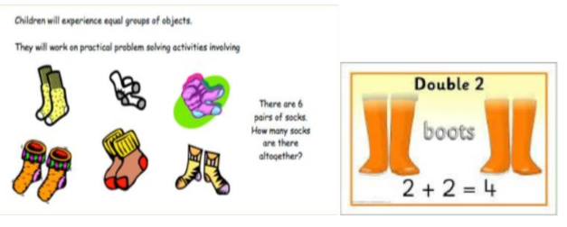  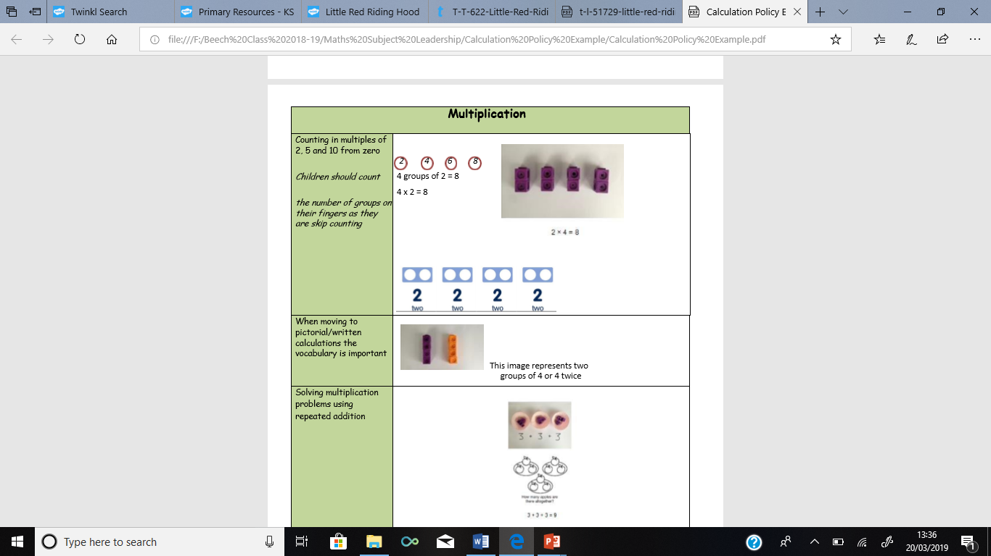  Stage 2  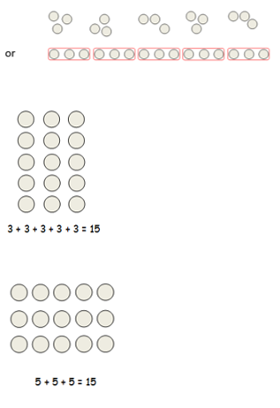  Stage 3  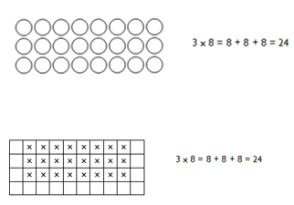  Stage 4  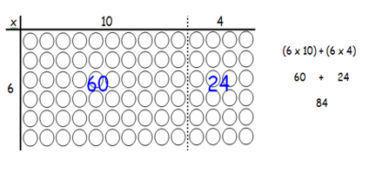  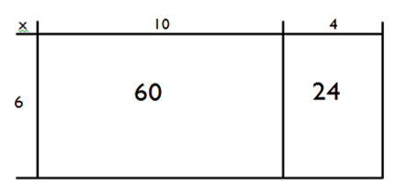 | Children are encouraged to develop a mental image of the size of numbers. They will learn about equal groups or sets of objects in practical and real life situations.  Stage 1  Experiencing equal groups of objects.  They will think about doubling when solving practical problems.  Stage 2  Children understand that multiplication is repeated addition and that it can be done by counting in equal groups/steps.  Children may be introduced to the image of a rectangular array, initially through real life items such as egg boxes, wrapping paper, ice cube trays, etc.  These are used to show that counting up in equal groups can be a quicker way of finding a total.  Children also understand that 3x5 is the same as 5x3.  Stage 3  Children continue to use arrays and create their own to represent multiplication calculations.  Stage 4  Children will continue to use arrays to lead into the grid method of multiplication.  14 x 6  The 14 is partitioned (split) into 10 and 4.  The answer to 6 x 10 is found = 60  The answer to 6 x 4 is found = 24  The two answers are added together 60 + 24 = 84
KS2 Multiplication  Year 3 – End of Year Objective:  Write and calculate mathematical statements for multiplication using the multiplication tables that they know, including for two-digit numbers times one-digit numbers, progressing to formal written methods.*  Year 4 – End of Year Objective:  Multiply two-digit and three-digit numbers by a one-digit number using formal written layout.  Year 5 – End of Year Objective:  Multiply numbers up to 4 digits by a one- or two-digit number using a formal written method, including long multiplication for two-digit numbers.  Year 6 – End of Year Objective:  Multiply multi-digit numbers up to 4 digits by a two-digit whole number using the formal written method of long multiplication.  Multiply one-digit numbers with up to two decimal places by whole numbers. | Stage 1  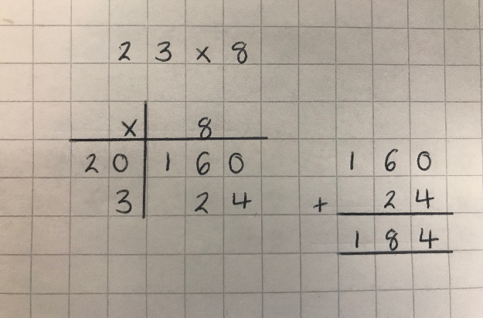  Stage 2  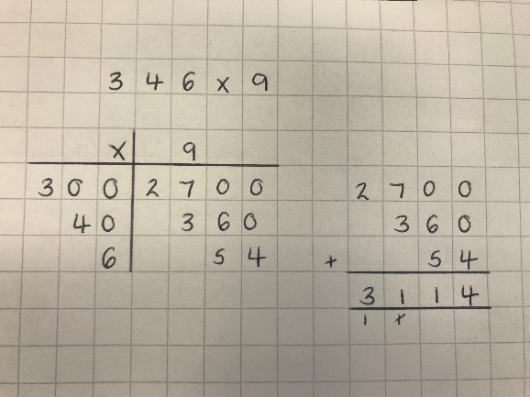  Stage 3i  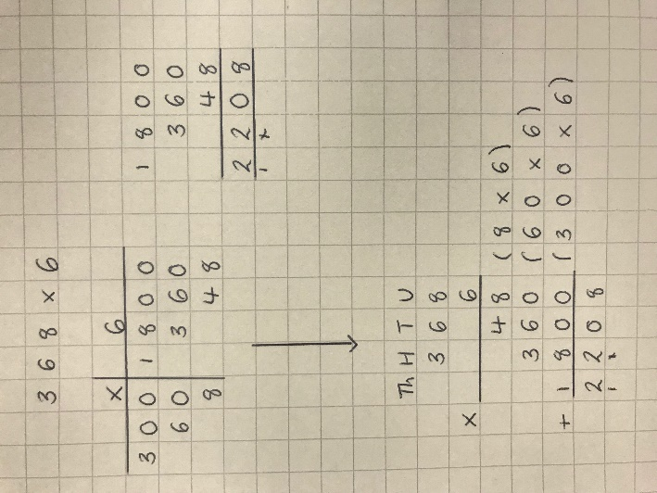  Stage 3ii  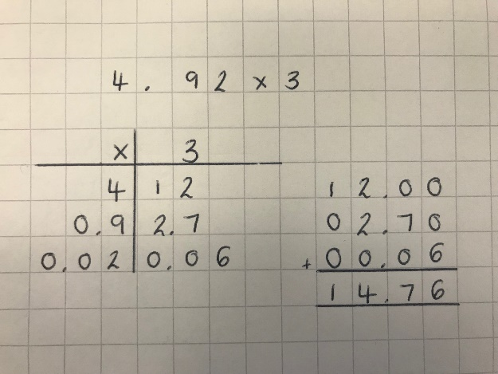  Stage 4  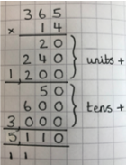  Stage 5  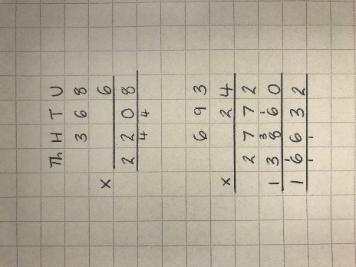 | Stage 1 would start in Year 3 and stage 4 would typically appear in Year 6.  Multiplication starts with multiplying a single digit by a two digit number using grid method with awareness of place value.  It is made up of two stages; the multiplication stage and then column addition to get the final answer.  The same method is used to multiply single digits by three digit numbers and decimals  Stage 4 is an additional stage to our policy with the hope it will help children to understand to method needed when multiplying two digit numbers by three or four digit numbers. With the method clearly showing the stages of multiplying the ones and then the tens it allows them to understand the following  342 x 45 is broken down as:  300 x 5  40 x 5  2 x 5  and then  300 x 40  42 x 40  2 x 40  Stage 5 is the final stage of multiplication using the formal written method where the children will require secure knowledge of multiplying numbers by ten and column addition with exchanging where appropriate
Division
Division

In developing a written method for division, it is important that children understand the concept of division, in that it is:
- repeated subtraction

They also need to understand and work with certain principles, i.e. that it is:
- the inverse of multiplication
- not commutative i.e. 15 ÷3 is not the same as 3 ÷ 15
- not associative i.e. 30 ÷ (5 ÷ 2) is not the same as (30 ÷ 5) ÷ 2

KS1 Division  Early Learning Goal:  Children solve problems, including halving and sharing.  Year 1 – End of Year Objective:  Solve one-step problems involving division by calculating the answer using concrete objects, pictorial representations and arrays with the support of the teacher.  Year 2 – End of Year Objective:  Calculate mathematical statements for division within the multiplication tables and write them using the division (÷) and equals (=) signs. | Stage 1  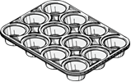  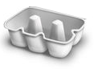  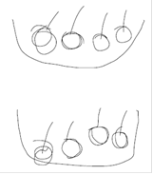  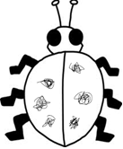  Stage 2  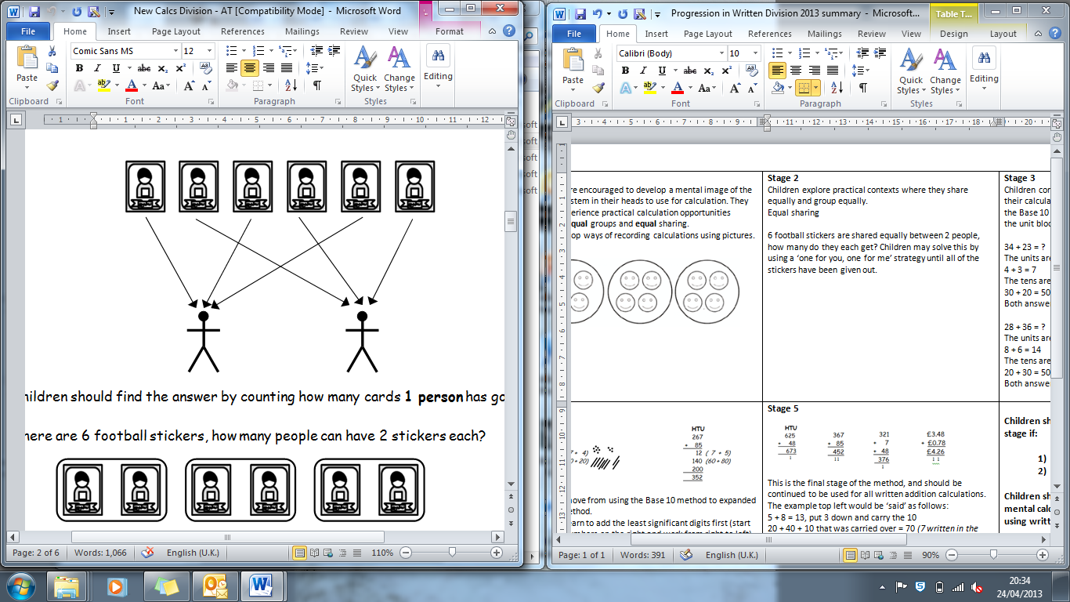  Stage 3  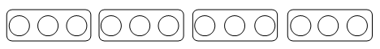  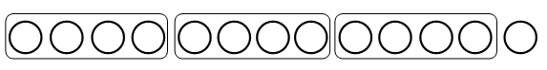  Stage 4  Stage 5  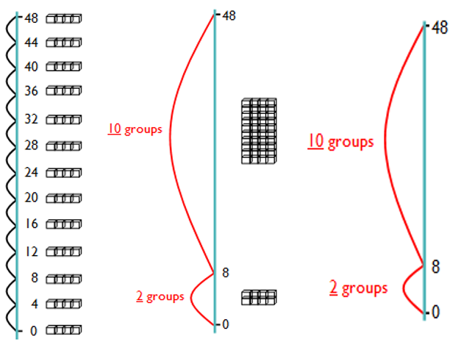 |  | Stage 1  Children are encouraged to develop a mental image of the number system in their heads to use for calculation. They should experience practical calculation opportunities involving equal groups and equal sharing.  They may develop ways of recording calculations using pictures.  A child’s jotting showing halving six spots between two sides of a ladybird.  A child’s jotting showing how they shared the apples at snack time between two groups.  Stage 2  Children explore practical contexts where they share equally and group equally. 6 ÷ 2 = ?  Equal sharing (6 shared equally between 2)  6 football stickers are shared equally between 2 people, how many do they each get? Children may solve this by using a ‘one for you, one for me’ strategy until all of the stickers have been given out.  Equal grouping (How many groups of 2 are there in 6?)  There are 6 football stickers, how many people can have 2 stickers each?  Stage 3  Children continue to use practical equipment to represent division calculations as grouping (repeated subtraction) and use jottings to support their calculation.  12 ÷ 3 = ? Children begin to read this calculation as,  ‘How many groups of 3 are there in 12?’  At this stage, children will also be introduced to division calculations that result in remainders.  13 ÷ 4 = 3 remainder 1  Stage 4  43 ÷ 8  43 ÷ 8 = 5 remainder 3  At this stage, children also learn if the remainder should be rounded up or down e.g. 62 ÷ 8 = 7 remainder 6  I have 62p. Sweets are 8p each. How many can I buy?  Answer: 7 (the remaining 6p is not enough for another sweet)  Apples are packed into boxes of 8. There are 62 apples. How many boxes do I need?  Answer: 8 (the remaining 6 apples still need to be placed into a box).  Stage 5  The previous method of repeated subtraction on a number line is continued, but using a vertical number line alongside practical equipment.  The repeated subtraction is made more efficient by subtracting ‘chunks’ of the divisor.
KS2 Division  Year 3 – End of Year Objective:  Write and calculate mathematical statements for division using the multiplication tables that they know, including for two-digit numbers divided by one-digit numbers, progressing to formal written methods.*  Year 4 – End of Year Objective:  Divide numbers up to 3 digits by a one-digit number using the formal written method of short division and interpret remainders appropriately for the context.  Year 5 – End of Year Objective:  Divide numbers up to 4 digits by a one-digit number using the formal written method of short division and interpret remainders appropriately for the context.  Year 6 – End of Year Objective:  Divide numbers up to 4 digits by a two-digit number using the formal written method of short division where appropriate, interpreting remainders according to the context.  Use written division methods in cases where the answer has up to two decimal places. | Stage 6  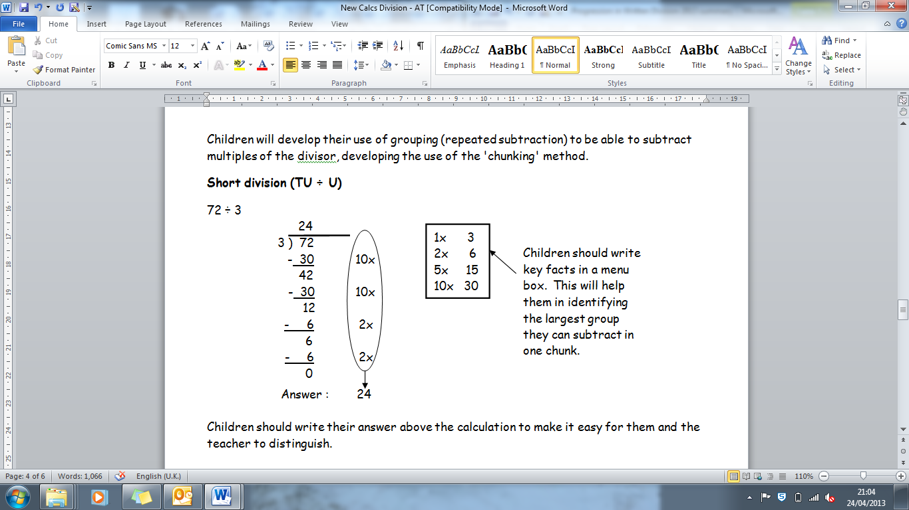  Stage 7  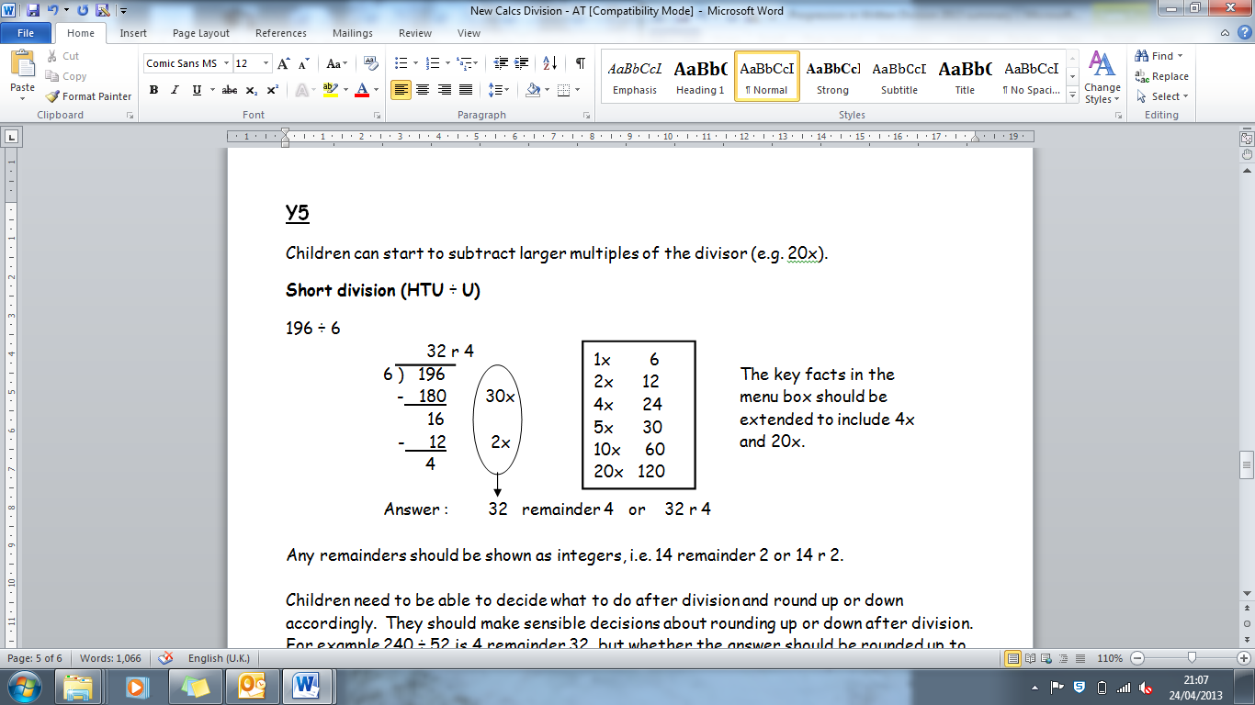  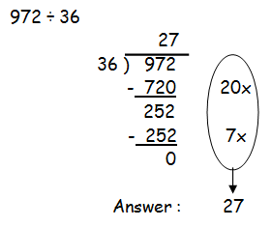  Stage 7 Continued |  |  | Stage 6  This is the ‘chunking’ method of division in which children use key facts of the multiplication tables of the divisor.  Stage 7  During this stage children should become more efficient when using the chunking method by not having any subtraction steps that repeat a previous step. For example, when performing 196 ÷ 6 an initial subtraction of 60 (10 x 6) and two further subtractions of 60 (10 x 6 each) should be changed to a single subtraction of 180 (30 x 6).

