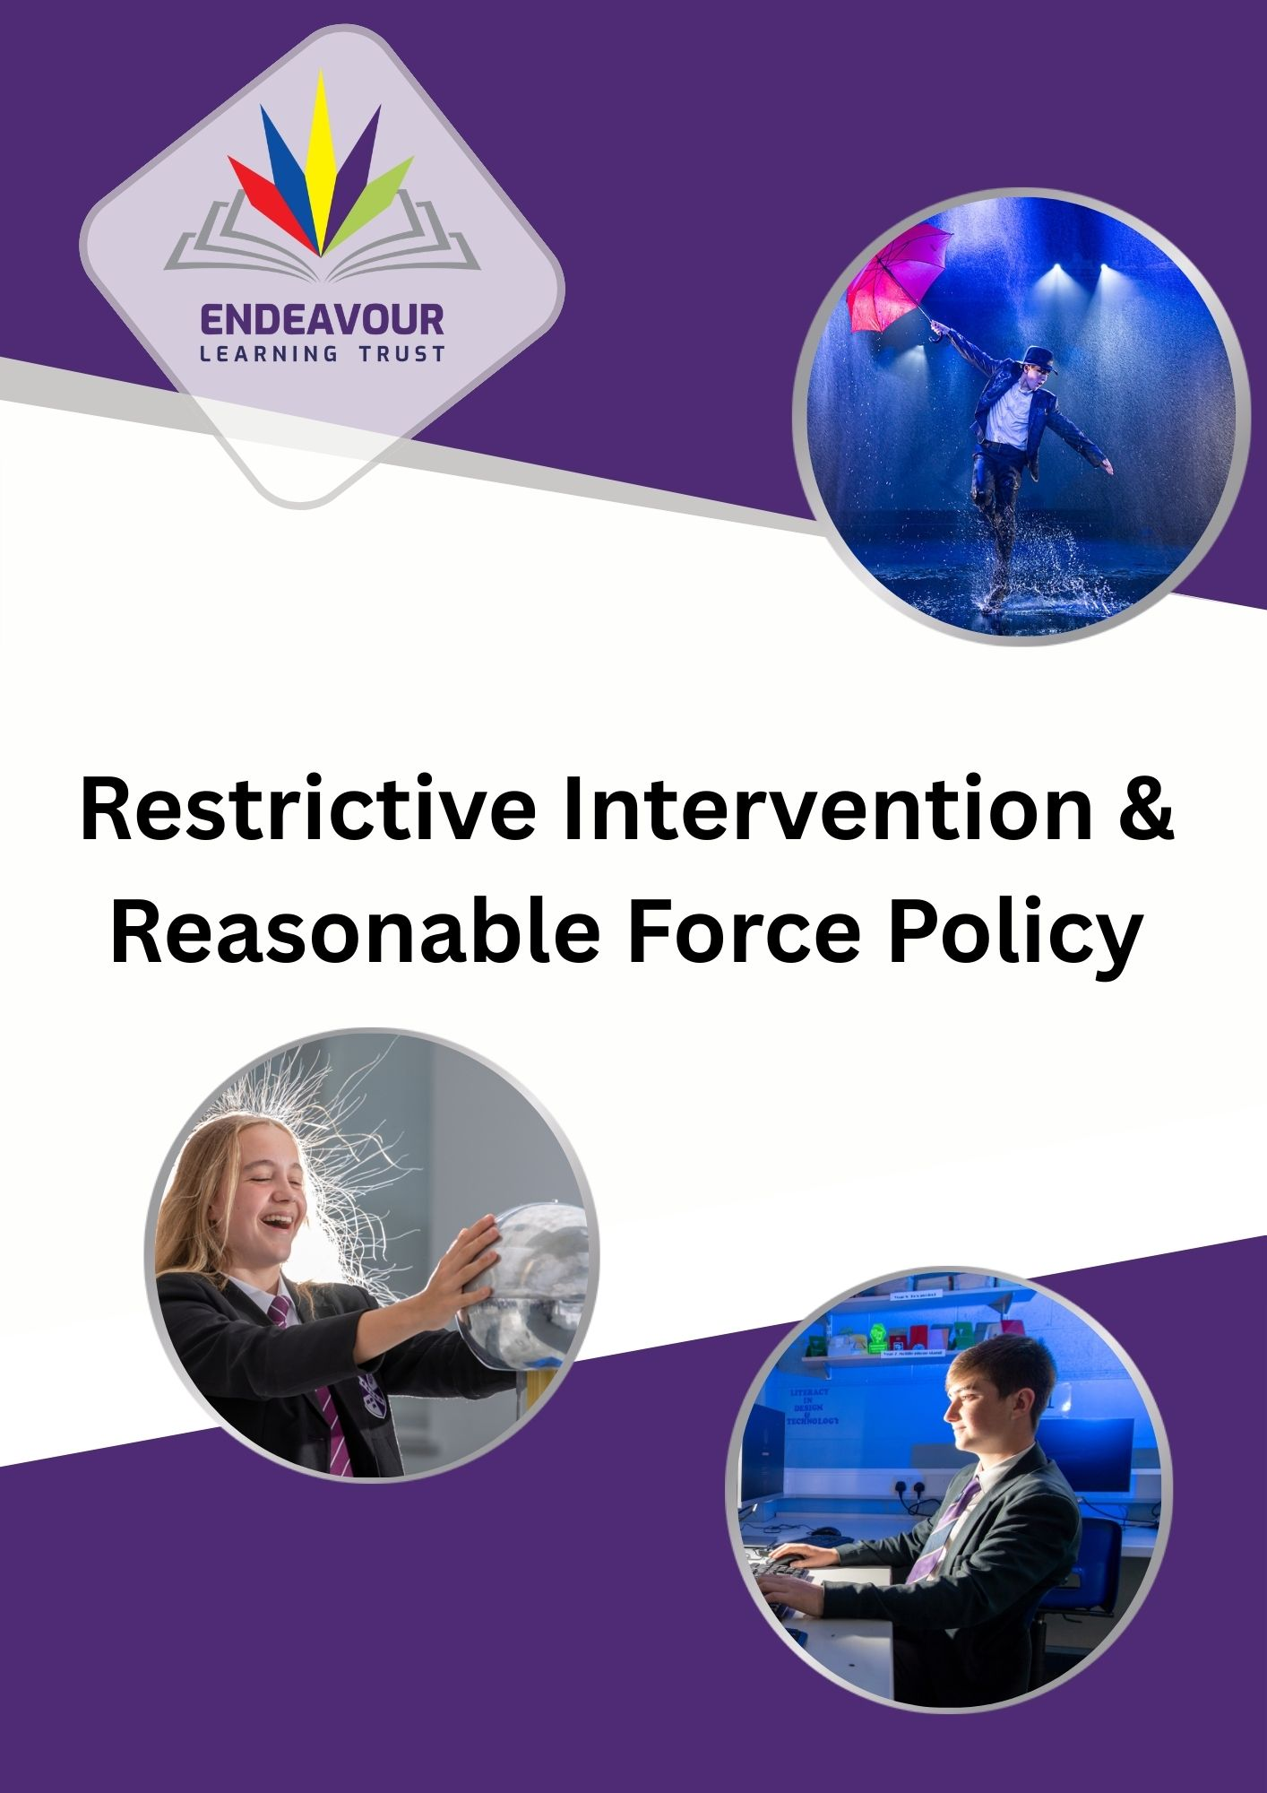

Contents
1. Introduction: 3
2. Legal framework: 3
3. Definitions: 4
4. De-escalation – preventing significant incidents 5
5. Using restrictive intervention 6
6. Seclusion 9
7. Unacceptable Use of Restrictive Interventions 10
8. Reporting and recording 10
9. Post-incident support and review 11
10. Monitoring and escalation 12

- Introduction:
Endeavour Learning Trust believes that all members of our communities have the right to a safe and positive educational environment where they can learn and thrive free from disruption, violence, discrimination, bullying and abuse. Every member of our Trust community has a responsibility to practice in a way which facilitates this, in line with our Trust values:
Belonging, People Centred, Togetherness, Transformational, Individuality
This policy sets out our approach to restrictive interventions, including the use of reasonable force, restraint and seclusion. Endeavour Learning Trust recognises that restrictive interventions can have a significant physical and psychological impact on pupils and staff. They should therefore only ever be used as a last resort, when necessary, proportionate and lawful, and where less restrictive measures have been attempted or assessed as inappropriate in the circumstances.
Endeavour Learning Trust is committed to:
- safeguarding the welfare, dignity and human rights of all members of our Trust communities
- preventing and minimising the need for restrictive interventions
- supporting staff to in meeting the needs of all children
- working at a threshold above compliance, exceeding statutory duties
- using data to continuously improve practice
*Throughout this document we have used the term ‘families’ to refer to our pupils’ parents, carers or those that hold parental responsibility (PR)’, including the Corporate Parent for those to whom that applies.*

- Legal framework:
The principal legislation and guidance to which this policy relates are:
- Education Act 2011
- the Education and Inspections Act 2006, especially sections 93 and 93A
- the Schools Regulations 2025 (Recording and Reporting of Seclusion and Restraint) (No. 2) (England)
- Health and Safety at Work etc. Act 1974
- Children Act 1989
- Human Rights Act 1998
- Equality Act 2010
- (DfE) Use of reasonable force and other restrictive interventions in schools: guidance for schools in England 2025
- (DfE) Behaviour in Schools; Guidance, advice for headteachers and school staff 2024
- (DfE) Keeping Children Safe in Education 2025
- (DfE) Working Together to Safeguard Children 2023
- Guidance for Safer Working Practice 2022

- Definitions:
This policy will use the following definitions:
Restrictive intervention: a means to prevent, restrict, or subdue movement of the body, or part of the body, of a pupil. This guidance uses ‘restrictive interventions’ as the umbrella term to describe both physical and non-physical actions aimed to restrain pupils in different ways.
Reasonable force: a term used in legislation which includes physical restrictive interventions. All members of school staff have the legal power to use reasonable force in limited circumstances. Reasonable means using no more force than is necessary for the least amount of time, the application of which will depend on the circumstances.
Seclusion: a non-disciplinary intervention involving keeping a pupil confined to a place away from others, and preventing them from leaving either by physical obstruction, blocking, or making them believe they will be punished if they try to leave.
Restraint: a term used in legislation referring to a non-disciplinary intervention which immobilises a pupil or limits their movement. This may or may not include direct physical contact. For example, holding a pupil’s arms to their sides or removing a pupil’s crutches would both be considered forms of restraint.
Endeavour Learning Trust recognises that all incidents meeting any of the definitions above are significant incidents, as defined below:
Significant incident: any incident where the use of force goes beyond appropriate physical contact between pupils and staff as described in ‘Other physical contact with pupils’ described below in this document. This includes when physical force is used to implement a non-physical restrictive intervention.
Other physical contact with pupils:
Endeavour Learning Trust does not implement a ‘no contact’ policy. A ‘no contact’ policy within any setting can leave children vulnerable due to adults not being able to intervene where reasonable to do so and in order to fully protect and safeguard our children.
There are circumstances when it is appropriate for staff to have some physical contact with pupils which does not give rise to any question over restrictive interventions, including use of reasonable force. This will depend on the circumstance, but examples of occasions when physical contact is generally appropriate include:
- To give first aid
- To guide or escort pupils, such as holding the hand of a pupil at the front/back of the line when going to assembly, when walking together around the school or on a school trip, or when helping a pupil to a space they have chosen to access to self-regulate
- To comfort a distressed child
- To congratulate or praise a child, for example a pat on the back or a handshake
- To demonstrate how to use a musical instrument
- To demonstrate exercises or techniques during PE lessons or sports coaching
In assessing whether physical contact is appropriate in a given situation, the adult should use their judgement and consider:
- All relevant Trust policies and guidance, including staff code of conduct and Guidance for Safer Working Practice
- The context of the situation, e.g. other adults present
- Child’s age and known additional vulnerabilities (including but not limited to SEND and experience of trauma)
- Whether other non-physical strategies can be used

- De-escalation – preventing significant incidents
All Trust schools prioritise whole school proactive strategies to minimise the need for restrictive interventions, including:
- Brain-based regulation strategies
- Consistent routines and expectations
- Trauma‑informed practice
- Environmental adaptations
- Adaptive teaching strategies
- Early identification of needs, including SEND
- Effective communication strategies
- Strong relationships between children, families and staff members
Individual support may include regulation plans, reasonable adjustments, sensory strategies and joint working with families and external agencies.
Children experiencing challenges that increase the likelihood of the need for restrictive interventions will be assessed using Endeavour Learning Trust pupil risk assessment matrix, and be supported by a co-produced regulation plan aimed at developing agreed proactive strategies to support children in maintaining regulation. These plans will include child voice, family views and external agency advice (where appropriate). These plans will be shared with families and relevant staff to ensure consistency of practice and reviewed regularly, minimum of half termly.
Each child has individual circumstances and each situation is different. Endeavour Learning Trust recognises that children with additional vulnerabilities, including but not limited to additional needs/SEND and experiences of adversity/trauma can experience triggers in a school environment which may increase their risk of dysregulation and likelihood of restrictive interventions. All staff will aim to prevent an incident of restrictive intervention through use of de-escalation strategies. All adults responding to children showing signs of dysregulation in their behaviour will respond to the presenting needs of the child and utilise training in de-escalation strategies and their pre-existing relational knowledge of what supports that child best. Where a child is supported by a regulation plan, the strategies in their plan will be implemented. Plans should be reviewed regularly and following a significant incident to consider any required changes.
Examples of de-escalation strategies may include, but are not limited to:
- Offer of distraction activity, including sensory activity and/or food/drink
- Remove any distressing stimuli
- Reassurance, verbal reminders of previous success and achievements
- Observe from a distance, providing personal space and processing time
- Change of staff supporting
- Relocating any other children to another space where safe to do so
- Calm and assuring body language/tone of voice
- Use of humour (where appropriate due to pre-existing relationship/knowledge of the child)
At times, staff may not be able to use de-escalation strategies due to the situation requiring dynamic intervention for immediate safety purposes.

- Using restrictive intervention

Statutory power to use reasonable force (Education and Inspections Act 2006)

Under section 93 of the Education and Inspections Act 2006, all members of school staff have a statutory power to use reasonable force in limited circumstances outlined in this policy.
This power applies while staff are lawfully in charge of children and extends to situations both on and off Endeavour Learning Trust school sites, including educational visits. Section 93 provides the legal basis for the use of reasonable force in schools, and any such use must be reasonable in the circumstances, meaning that it must be necessary and proportionate to the risks presented at the time.
In addition, section 93A of the Act places a statutory duty on governing bodies and proprietors to ensure that arrangements are in place for recording and reporting significant incidents involving the use of force. This policy reflects both the legal power under section 93 and the statutory recording and reporting duties under section 93A, and must be implemented in a way that is consistent with wider safeguarding, equality, human rights and health and safety obligations.
When restrictive interventions may be used
The decision on whether it is reasonable to use a restrictive intervention depends on the individual circumstances of each situation. Restrictive interventions should be a last resort and only used when other de-escalation strategies have been exhausted, or when the situation is deemed to require immediate intervention due to the presenting risk.
In line with the April 2026 Department for Education guidance, restrictive interventions may only be used to prevent a child from:
- causing injury to themselves or others
- committing a criminal offence
- causing serious damage to property
- causing significant disorder
The decision to use a restrictive intervention is a matter of professional judgement and must always be based on the specific circumstances at the time. Before using, or continuing to use, a restrictive intervention, staff must, wherever practicable, consider the following factors, which are drawn directly from the guidance:
Necessity
Staff should consider whether a restrictive intervention is required to reduce an immediate risk of harm and whether other less restrictive strategies, including de-escalation, redirection or support from other staff, are likely to be effective. Where a restrictive intervention is unlikely to successfully reduce risk, or is likely to escalate the situation further or cause more harm than the behaviour itself, it should not be used.
Proportionality
Any restrictive intervention must be the least restrictive option available, using the minimum amount of force for the shortest amount of time necessary to reduce the risk. If an intervention is not reducing risk or is escalating the situation, staff must reconsider their approach and seek to reduce or cease the intervention as soon as it is safe to do so.
Child welfare and dignity
Staff must consider the impact of any restrictive intervention on children’s physical and psychological wellbeing. Where possible, staff should seek to maintain children’s dignity, including consideration of the environment in which the intervention takes place, and should communicate calmly and clearly with the child about what is happening and why.
Vulnerabilities and SEND
Staff must have regard to the individual needs and circumstances of the child, including any special educational needs, disabilities, medical conditions, communication needs, sensory sensitivities, past trauma or other vulnerabilities. These factors may affect how a child experiences an intervention and must inform decision-making before, during and after any restrictive intervention.
Equality implications
Staff must consider relevant duties under the Equality Act 2010, including the need to avoid discrimination, make reasonable adjustments and ensure that responses do not disproportionately impact pupils who share protected characteristics.
Support during use of restrictive interventions
During all restrictive interventions adults must continually attempt to de-escalate the situation so the restrictive intervention can end. Adults must continually assess the child’s physical and emotional safety during a restrictive intervention and seek support from other staff members. This includes recognising that through initiating a restrictive intervention the child may become further dysregulated by the presence of the adult/s present at point of the intervention and a change of face can support de-escalation quickly, therefore support from other staff members should be sought swiftly.
Support following a restrictive intervention
Endeavour Learning Trust recognises that restrictive interventions carry an inherent physical and psychological risk. Following any restrictive intervention, adults must ensure that appropriate post-incident actions are taken in line with this policy, including recording and reporting, medical checks where appropriate, reflection and review.
This includes capturing the child’s voice and experience of the restrictive intervention in a safe and supportive environment, by, wherever possible, an adult who was not involved in the restrictive intervention, checking on their wellbeing and ensuring medical attention for any injuries.
Staff should be given time following involvement in a restrictive intervention to record information accurately, to receive any required support for their wellbeing and medical assessment for any injuries.
Following all restrictive interventions, a staff de-brief should take place and a review of the risk assessment/regulation plan in place to support the child.

Staff Training
Endeavour Learning Trust recognises that staff training is a critical component of preventing the need for restrictive interventions and ensuring that where they are used, they are applied safely, lawfully and proportionately.
Staff who are likely to work in situations where restrictive interventions will be required will be adequately trained in prevention and de-escalation strategies, as well as the safe and lawful use of reasonable force and other restrictive interventions.
Endeavour Learning Trust has committed to using PRICE Training (Protecting Rights in a Caring Environment). PRICE Training is compliant with the Restraint Reduction Network Training Standards.
Endeavour Learning Trust PRICE Training Lead and Instructor: Heather Fowler – Head of Safeguarding and Welfare
PRICE Training reflects the principles of the DfE guidance on Restrictive Interventions inc Use of Reasonable Force 2026 and will support staff to assess necessity and proportionality, understand risks to physical and psychological wellbeing, recognise the impact of trauma and SEND, and make defensible professional judgements, including in situations where decisions must be taken quickly.
Endeavour Learning Trust will ensure that training needs for each school are informed by the cohort, patterns and trends in incidents, and risk assessments. Endeavour Learning Trust will take reasonably practicable steps to ensure the health, safety and welfare of staff, including providing refresher training, access to advice and support, and additional guidance where staff regularly work with children who present a higher level of risk.
In a high-risk situation, it may be necessary for staff to intervene in a way that is outside of the PRICE framework or is not a risk-assessed PRICE technique as an emergency response on the basis of a dynamic risk assessment. Staff would need to evidence why this was necessary, and that the response was proportionate and reasonable to the risk it was trying to reduce.

- Seclusion
Seclusion is defined in statutory guidance as a non-disciplinary intervention involving keeping a child confined to a place away from others and prevented from leaving. It is a short-term safety measure and may only be used where a child is experiencing high levels of emotional or behavioural dysregulation and there is a serious and immediate risk of harm to the child or to others. Endeavour Learning Trust is clear that in such circumstances, a child is not acting with intent and the immediate objective is to support the child to regulate and reduce restrictive intervention.
Seclusion must never be used as a punishment, a sanction, a planned behaviour management strategy, or as a response to non-compliance where there is no immediate and significant risk.
Seclusion must only ever be used to reduce an immediate risk of harm and for the shortest time possible. It must not be used to coerce, threaten or control a child. It should not be implemented through the threat of punishment or the suggestion that negative consequences will follow if a child attempts to leave the space they are secluded.
Where seclusion is used, the place in which the child is confined must be safe, suitable and non-threatening, taking account of the child’s age, needs, vulnerabilities and sensory sensitivities. The environment must not present a risk to the child’s physical or psychological wellbeing and should allow the child to calm and regain regulation.
A child who is secluded must be continuously supervised at all times by a member of staff. Supervision must be active and purposeful, enabling staff to monitor the child’s physical and emotional wellbeing, communicate appropriately, and respond immediately if the child becomes distressed, unwell or at risk. Adults supervising/supporting a child in seclusion should continue to use de-escalation strategies to calm the child and minimise the risk and therefore time where seclusion is felt to be required.
Following any use of seclusion, appropriate post-incident actions must take place, including staff and child de-brief to check on welfare and review risk assessment and regulation plan.
All incidents involving seclusion must be treated as a significant safeguarding event.
All incidents of seclusion must be recorded and reported in line with statutory duties.

- Unacceptable Use of Restrictive Interventions
Endeavour Learning Trust is clear that restrictive interventions must only be used as a last resort, never be used as a punishment, a disciplinary sanction, or for the purpose of compliance, convenience or to manage behaviour where there is no immediate risk of significant harm. They must cease as soon as the immediate risk has reduced. Any use of force or restrictive practice for these purposes is unlawful.
Staff must not use any techniques or approaches that may restrict or interfere with a child’s airway, breathing or circulation. This includes, but is not limited to, applying pressure to the neck, throat, chest or abdomen, covering the mouth or nose, or positioning a pupil in a way that compromises respiration. Such practices present a serious and potentially fatal medical risk and are strictly prohibited. Additionally, children should not be lifted off the ground or carried unless in an emergency situation requiring immediate removal from an area to a place of safety where the risk cannot be supported through an alternative strategy. Using force to remove any item of children’s clothing, including children’s shoes is not acceptable, unless causing a critical and immediate risk that cannot be managed in an alternative way for example – restricting their breathing.
Staff must also be mindful that restrictive interventions can cause significant psychological distress. Interventions that humiliate, degrade, intimidate, threaten or deliberately cause emotional harm are unacceptable. Our responses to children at all times must seek to preserve their dignity and wellbeing, even in high-risk situations.
Any incident involving unacceptable practice, or where there is concern that an intervention may have compromised a child’s safety should be reported immediately in line with Endeavour Learning Trust’s for Policy for Allegations of Abuse Against Staff. School leaders will be supported by Central Team services to give consideration to reporting to external agencies, including police, Local Authority Designated Officer and/or Children’s Social Care.

- Reporting and recording
Endeavour Learning Trust recognises that incidents involving restrictive interventions are significant incidents.
Immediately following a significant incident, staff should verbally inform senior leaders that the event has taken place to allow for appropriate post-incident support for all involved/witness to the incident. All significant incidents involving the use of reasonable force, seclusion and non-force related restraint e.g. removal of walking aid, must be recorded in writing, as soon as is practicable after the event, and staff should endeavour to complete the reporting no later than the same day. This duty applies even if restrictive interventions have been agreed with families as part of a child’s regulation plan.
Endeavour Learning Trust use CPOMS to record all significant incidents. These will be logged under the category of restrictive interventions/use of reasonable force which includes a custom form for logging the following information:
- Time, date, location and duration of incident
- SEND status and if supported through a risk assessment
- Antecedents/triggers i.e. description of the circumstances before the incident
- De-escalation strategies used and rationale for restrictive intervention
- Description of the incident, type of intervention, degree of force
- Description of post-incident support including any injuries, medical assessments
Families will be informed of a significant incident in writing, through Arbor, the Management Information System used by all Trust schools. In addition to informing families in writing, where possible, schools will invite them to discuss the incident including any relevant triggers, the effectiveness of preventative strategies, and whether the child requires a regulation plan or risk assessment or where pre-existing, require review.
In circumstances where school feel that by reporting a significant incident to families would result in serious harm to the child, school are exempt from the duty to report. In this instance, the staff member must report the incident to any parent(s) who it can be reported to without resulting in significant harm or, if there are none, to the local authority within whose area the child is ordinarily resident. In this situation, school should follow their safeguarding policy and local safeguarding arrangements.

- Post-incident support and review
Following all restrictive interventions, schools will ensure that appropriate and timely actions are taken to safeguard the physical and emotional wellbeing of all those involved, to understand what happened and why, and to reduce the likelihood of future incidents.

Immediate welfare and medical checks
As soon as practicable after the incident, staff will check the child and any staff involved for signs of injury, distress or illness. Where appropriate, first aid will be administered and medical assessment or treatment sought. Any injuries or health concerns will be recorded in line with Endeavour Learning Trust health and safety procedures.

Emotional wellbeing and safeguarding support
Endeavour Learning Trust recognises that restrictive interventions can be distressing. Consideration will therefore be given to the emotional wellbeing needs of the child, any staff involved, and any children who may have witnessed the incident. Support may include access to pastoral staff, counselling services, trusted adults or other appropriate support mechanisms.

Reflective debrief and learning
Schools will hold reflective debrief conversations following incidents involving restrictive interventions. These discussions are intended to support wellbeing, enable learning and improvement, and reduce future risk. Where appropriate, debriefs will include:
- a factual review of what happened and rationale
- reflection on early warning signs and triggers
- consideration of what preventative and de-escalation strategies were used and their effectiveness
- identification of any alternative approaches that may reduce the likelihood of recurrence
Children’s voices will be sought as part of the de-brief process. Staff will ensure that children’s views are sought in ways which are appropriate to their age and stage of development, considering any additional need and/or protected characteristics. Where possible, debriefs should be facilitated by a member of staff who was not directly involved in the incident.
Following any restrictive intervention, schools will review risk assessments, regulation plans and need for further support. Changes will be made where necessary to better support the child, address underlying needs, and strengthen preventative measures.
All schools are committed to repairing and rebuilding relationships following incidents involving restrictive interventions. Where appropriate, restorative approaches will be used between children and staff, and promote a sense of safety, dignity and belonging.

- Monitoring and escalation
Use of restrictive interventions and all significant incidents will be monitored by school leaders for patterns, training needs and practice development. This process will be supported by Endeavour Learning Trust central team through a quality assurance process including oversight of all incident recordings through notification.
Individual school data on use of restrictive interventions will be shared with Local Academy Councillors in termly reports and Trust-wide data will be shared with trustees at termly board meetings. This is to allow governance to ensure leaders are monitoring incidents and post-incident actions to identify patterns, emerging risks or training needs. Where restrictive interventions occur repeatedly or where concerns arise, this will trigger further review, multi-agency engagement where appropriate, and escalation through safeguarding or SEND processes.

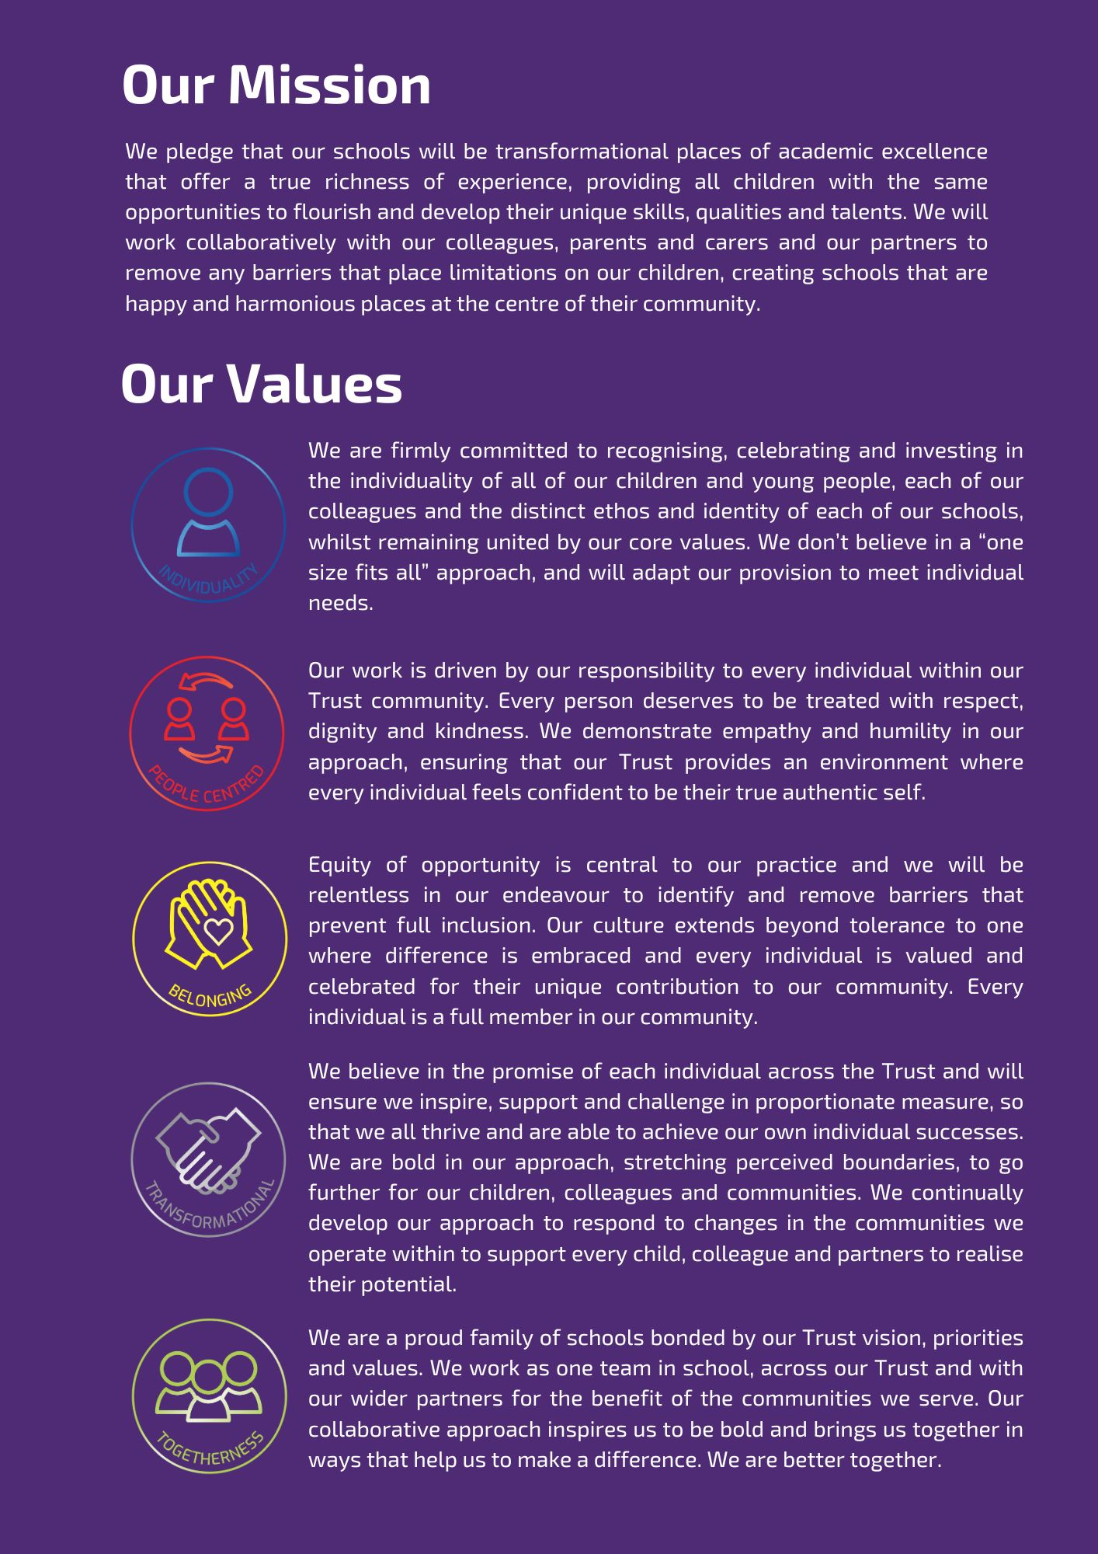

Education and Inspections Act 2006, Section 93 (reasonable force): https://www.legislation.gov.uk/ukpga/2006/40/section/93
(No. 2) (England) Regulations 2025 and section 93A of the Education and Inspections Act 2006.
In accordance with section 93A of the Education and Inspections Act 2006 and the Schools (Recording and Reporting of Seclusion and Restraint) (No. 2) (England) Regulations 2025. Where required, incidents will also be reported in accordance with health and safety reporting requirements.

