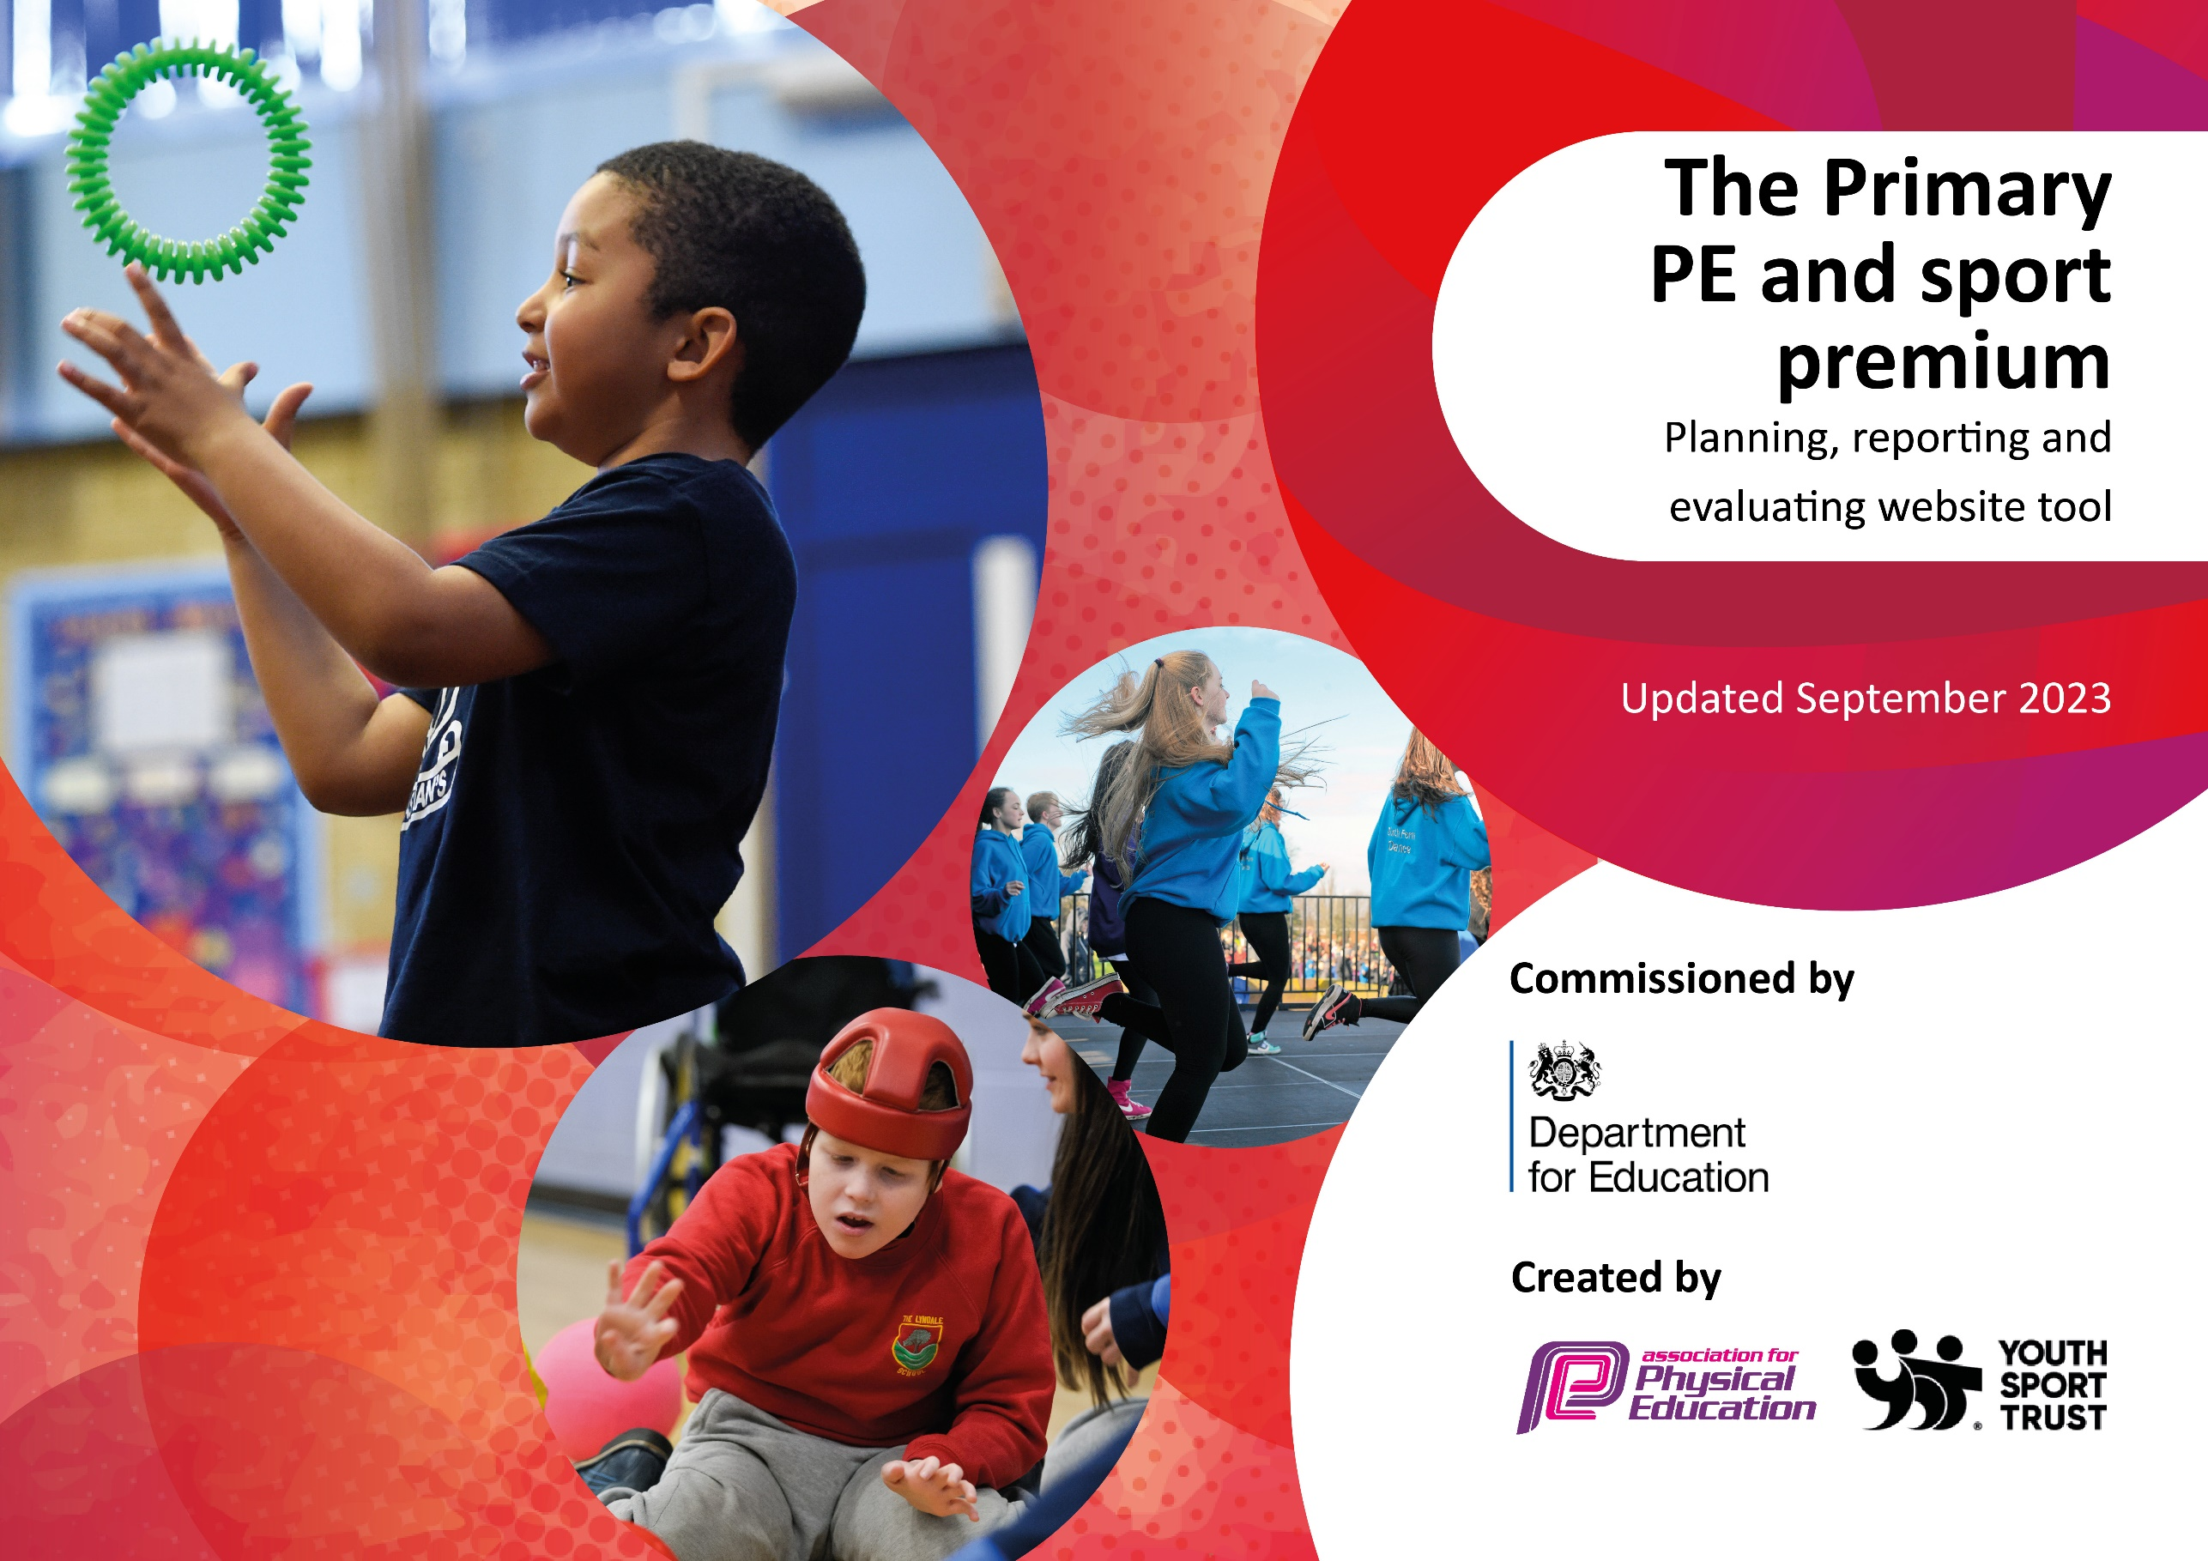

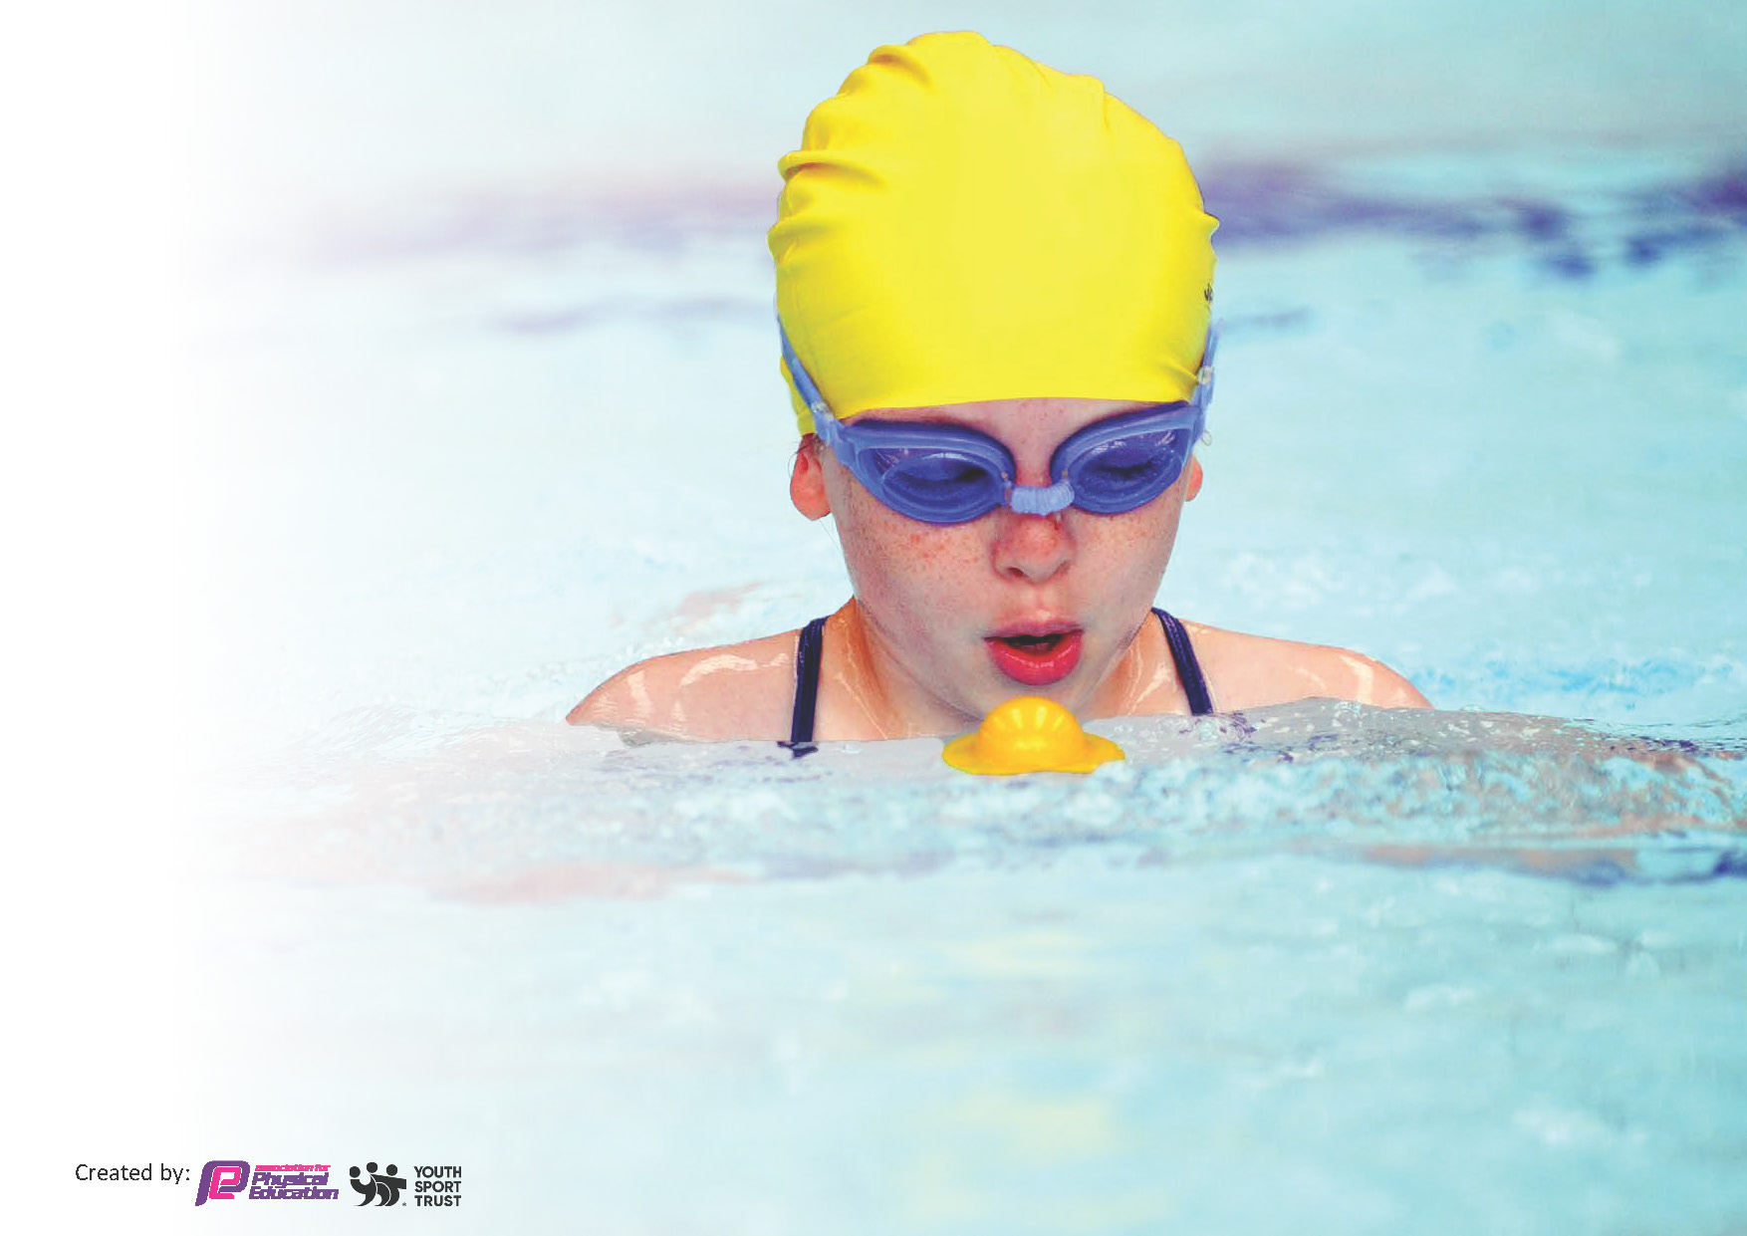
This template can be used for multiple purposes:
by:
- It enables schools to effectively plan their use of the Primary PE and sport premium
- It helps schools to meet the requirements (as set out in guidance) to publish information on their Primary PE and sport premium
- It will be an effective document to support Ofsted inspections enabling schools to evidence progress in Physical Education (PE) and evidence swimming attainment, which forms part of the PE National Curriculum. We would recommend schools consider
the Intent, Implementation and Impact of any spend, as examined within the Education Inspection Framework.

It is important that your grant is used effectively and based on school need.

Schools must use the funding to make additional and sustainable
improvements to the quality of the PE, School Sport and Physical Activity (PESSPA)
they offer. This means that you should use the Primary PE and sport premium to:

- Build capacity and capability within the school to ensure that improvements made now will benefit pupils joining the school in future years
- Develop or add to the PESSPA activities that your school already offers.

The Primary PE and sport premium should not be used to fund capital spend projects; the school’s core budget should fund these. Further detail on capital expenditure can be found in the updated Primary PE and sport premium guidance.

The Primary PE and sport premium guidance, outlines 5 key priorities that funding should be used towards. It is not

necessary that spending has to meet all the key priorities, you should select the priorities that you aim to use any funding towards.

Although completing this template is not a requirement for schools, schools are required to publish details of how they spend this funding. Schools must also outline what the impact this funding has had on pupils’ PE and sport participation and attainment and how any spending will be sustainable in the future. All funding must be spent by 31st July 2025.

The Department for Education has worked closely with the Association for Physical Education (afPE) and the Youth Sport Trust (YST) to develop this template and encourages schools to use it. This template is an effective way of meeting the reporting requirements of the Primary PE and sport premium.
Review of last year’s spend and key achievements (2023/2024)

We recommend you start by reflecting on the impact of current provision and reviewing your previous spend.

Activity/Action | Impact | Comments
Key indicator 1: The engagement of all pupils in inter and intra sporting competitions.  - To provide children with more opportunities to participate in sporting competitions,, e.g. through extra curricular clubs, competitions at the local high school, colour team tournaments, etc.  Key indicator 2: The profile of Forest Schools across the school and the development of a Forest School Learning Zone  Key indicator 3: Increase levels of fitness and wellness across the school with support from outside agencies (My Happy Mind).  Key indicator 4: Broader experience of a range of sports and activities offered to all pupils  Key indicator 5: To utilize staff expertise to provide wider sporting opportunities | Children have competed regularly in competitions hosted by the local high school. Children are given an opportunity to represent their school at a variety of events.  We plan to enhance this level of competition and provide more opportunities for children to participate in competitions.  Pupils use the outdoor environment to support the teaching of Mental Health and wellbeing.  The development of outdoor learning to be delivered across the school to improve problem solving, team building and resilience.  CPD for staff across school to develop their teaching and the delivery of Forest School  Children will have a greater knowledge of mental health awareness and how to deal with feelings and emotions whilst supporting themselves to sustain their well-being.  Children will be given the opportunity to learn new skills  Play Leaders to support physical activities and clubs during the school day  Children have a more positive attitude to physical health.  A wider range of sporting opportunities are delivered by a range of staff who can share their expertise and skills.  Children to develop skills and compete with children within school and in other settings. | Children have had a wide range of opportunities to take part in competitions ranging from Girls & Boys Football, Rounders, Quad Kids Athletics, Dodgeball, Badminton, Athletics and Multi-Skills. Links with the Wyre & Fylde Sports Partnership, Carr Hill and AFC Fylde have continued to be in place to support the participation of a wide range of tournaments where children have had the opportunity to compete against schools in our local cluster.  Curriculum PE for all children and a well-planned extra-curriculum timetable of sporting events has widened the offer of activities for children across all key stages.  The profile of outdoor learning within the curriculum has been raised with all children being provided with greater opportunities to take their learning outdoors.  Staff have been provided with CPD opportunities to support them in effectively using the school's outdoor space to support the effective delivery of the curriculum.  Strike Lane now has a fully qualified Forest School Leader who successfully delivers Forest School sessions. Children in EYFS and Year 1 have participated in a weekly Forest School session throughout the year with children from Years 2-6 participating in a half term of Forest School.  As part of our work alongside the Inclusion Hub, Forest School sessions were also held with Year 6 children from other settings to support them with their transition to high school. This work was supported by Carr Hill High School.  Weekly My Happy Mind sessions have been held across all year groups with this then continuing throughout all aspects of learning. Children have shown a greater awareness of how we learn, regulate emotions and develop mental awareness and resilience.  Children have a greater understanding about how they can best support their physical and mental health. They have a range of strategies which they use to support them in maintaining mental health, regulation and resilience including ‘happy breathing’ and the implementation of physical exercise.  Staff have been provided with CPD to raise their own awareness and ability to support the development of mental health awareness across the curriculum. CPD has also been provided to support the play leaders in successfully leading physical activities.  The children of Strike Lane continue to be provided with the opportunity to access a wide range of sporting opportunities provided by both school staff and those from outside of school who may offer specialised expertise.  Each term, an extra-curricular timetable is developed which harnesses the skills of staff to provide a wide range of sporting activities for children across all key stages.  Play Leaders are utilised to provide children with physical activities during the school day. They lead activities including football and hockey as well as providing opportunities and supporting children in setting up games which encourage the development of sporting ability too. Timetables are carefully planned and monitored to ensure that all children can participate in this wide range of sporting opportunities.  Clubs and activities are also provided by external groups/coaches to ensure a wider range of opportunities are provided too, these include cricket, paddle sports, wall-climbing, orienteering  As above, extra-curricular timetables are developed which utilises the expertise of staff in school to ensure that we provide a wider range of sporting opportunities which are led by staff with a particular level of expertise or interest.  The Schools Partnership provides a Sporting Calendar of events, and this influences the clubs that we provide. We support children in developing the skills needed to compete in competitions against other schools.

Key priorities and Planning
This planning template will allow schools to accurately plan their spending.

Action – what are you planning to do | Who does this action impact? | Key indicator to meet | Impacts and how sustainability will be achieved? | Cost linked to the action -
Provide children across both key stages with the opportunity to participate in a sporting competition whether in school or against children from another school. | Teachers  Teaching Assistants  Play Leaders  Children | - increasing engagement of all pupils in regular physical activity and sport  - increase participation in competitive sport  - increasing engagement of all pupils in regular physical activity and sport  - raising the profile of PE and sport across the school, to support whole school improvement | Children will have the opportunity to participate in a sporting competition (KS1 and KS2) whether that is in school are against schools from the local cluster.  Links continue to be in place with the Sports Partnership who’s offer continues to provide a calendar of sporting events.  These events are matched with extra-curricular clubs to support children in competing in these events.  Competitions are planned for and monitored to ensure there is a wide range of sporting opportunities provided. | 20%  Ensure opportunities are planned as part of the Yearly Calendar alongside Carr Hill events.  Provide opportunities for inter-school competition, e.g. Sports Day, Badminton, etc. Successes celebrated on social media, newsletters, etc.
To raise the Profile of Forest School and to further develop a Forest School Learning Zone which is accessed by the children of Strike Lane and, where possible, children from other local Primary Schools. | Forest School Leader  Teachers  Teaching Assistants  Children | - increasing all staff’s confidence, knowledge and skills in teaching PE and sport  - offer a broader and more equal experience of a range of sports and physical activities to all pupils | All children will have access to Forest School opportunities led by a fully trained Forest School Lead.  A Forest School Learning Zone will be developed to ensure that children have access to an area which supports the teaching of Forest Schools.  Teachers accompany the Forest School sessions as part of their CPD to that awareness and ability to lead outdoor learning can be embedded across the curriculum.  Other schools, where necessary, will be able to access our school's Forest School provision, for example as part of the Inclusion Hub to support Year 5 transition. | 30%  Ensure planned opportunities for all year groups in line with the National Curriculum.  Forest School Leader to have allocated planning time to incorporate Forest School learning into the wider curriculum.  Forest School opportunities to be added to curriculum planning/Medium Term Planning.
To increase the levels of mental and physical fitness and wellbeing across school. | Teachers  Teaching Assistants  Play Leaders  Children | - increase participation in competitive sport  - increasing engagement of all pupils in regular physical activity and sport  - offer a broader and more equal experience of a range of sports and physical activities to all pupils | Children will have a greater knowledge of mental health awareness, how to regulate feelings and emotions and how to support their own wellbeing.  A well-planned scheme is to be implemented (My Happy Minds) which supports teachers in delivering sessions focused on the positive development of Mental Health.  These sessions are clearly planned within the curriculum timetable and staff are provided with the necessary CPD for the effective delivery of My Happy Minds.  A wide range of extra-curricular clubs are planned on a termly basis which cater for the interests and skills of our children whilst also utilizing the expertise of staff to deliver these sessions. Where appropriate, external coaching is employed for extracurricular activities too. | 30%  My Happy Minds Program to be implemented within the Strike Lane curriculum.  Subject Leaders/SLT to monitor te impact of mental health and resilience across school.  CPD provides opportunities to support the implementation of raising mental health awareness across school.
To provide a broad range of sporting opportunities and experiences to all pupils and to utilize the expertise of staff and external coaches/groups to successfully deliver this provision. | Teachers  Teaching Assistants  Play Leaders  Children | - increasing engagement of all pupils in regular physical activity and sport  - increase participation in competitive sport  - increasing all staff’s confidence, knowledge and skills in teaching PE and sport  - raising the profile of PE and sport across the school, to support whole school improvement  - offer a broader and more equal experience of a range of sports and physical activities to all pupils | A wide range of extra-curricular clubs are planned on a termly basis which cater for the interests and skills of our children whilst also utilizing the expertise of staff to deliver these sessions. Where appropriate, external coaching is employed for extracurricular activities too.  Play Leaders run daily lunchtime clubs. | 20%  Events are planned at the beginning of each term.  Timetables are developed and shared which provide a wide range of sporting opportunities led by the appropriate levels of expertise.  External sporting opportunities and competitions are accessed and planned for with the relevant transport and communication to parents provided.  Play leaders provided with the appropriate CPD and support to successfully deliver lunchtime sessions.

Key achievements 2023-2024
This template will be completed at the end of the academic year and will showcase the key achievements schools have made with their Primary PE and sport premium spending.

Activity/Action | Impact | Comments

Swimming Data
Meeting National Curriculum requirements for swimming and water safety.
Priority should always be given to ensuring that pupils can perform safe self-rescue even if they do not fully meet the first two requirements of the National Curriculum programme of study

Question | Stats: | Further context  Relative to local challenges
What percentage of your current Year 6 cohort can swim competently, confidently and proficiently over a distance of at least 25 metres? | 74% | Children are given a full calendar year of swimming (Spring and summer term of Y4, Autumn of Y5). Half of the children who cannot swim a distance of 25 metres were either SEN or pupil premium.
What percentage of your current Year 6 cohort can use a range of strokes effectively [for example, front crawl, backstroke, and breaststroke]? | 71% | Similar reasonings are above, however some children found certain strokes slightly trickier – particularly backstroke.

What percentage of your current Year 6 cohort can perform safe self-rescue in different water-based situations? | 74% | All children were given the relevant water safety training in their penultimate session in Year 5.
If your schools swimming data is below national expectation, you can choose to use the Primary PE and sport premium to provide additional top-up sessions for those pupils that did not meet National Curriculum  requirements after the completion of core lessons. Have you done this? | No | The school budget has been used to pay for the sessions with an additional term also being paid for to provide children with additional swimming sessions.
Have you provided CPD to improve the knowledge and confidence of staff to teach swimming and water safety? | Yes | Year 5 teacher attended a “PED114 Teacher of School Swimming and Support Teacher Swim England Qualification” course in March 2022.

Signed off by:

Head Teacher: | Katherine Shuttleworth
Subject Leader or the individual responsible for the Primary PE and sport premium: | Simon Moulding
Governor: | Quality and Standards Committee
Date: | 15th July 2024

