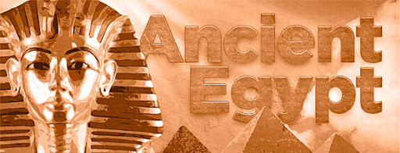

How terrifying?!

We will be looking at how the Egyptians mummified their dead. We will be mummifying our own fruit and explaining how the process works.

We will also be making our own Shaduf which is a hand operated device for lifting water.

**Why are artefacts so important?**

We will be looking at artefacts from Ancient Egypt and see what we can learn from them. What is it made from? What does it tell us about the ancient Egyptians at that time? What might have it been used for?

What is a ‘death mask?’

We will be looking at art from ancient Egypt and how they compared to each other. We will then be creating our own Egyptian style ‘death mask’ which were used to protect the dead person from evil spirits.

**English**

Diary entry

Fact files

Hieroglyph writing

**Maths**

Shaduf scales

Timelines

**Memorable Moments**

Watching Ancient Egyptians horrible histories

Making mummified fruit

Creating our own Egyptian death mask

**Why was the river Nile so important?**

We will be plotting Egypt on the map including all the surroundings such as the Desert, Seas, Giza and the Valley of the Kings. We will be plotting the route of the Nile and discussing how Ancient Egyptians used the Nile for travel and transport.

**What do we know about ancient Egypt?**

We will be looking at the past and plotting a timeline of events of the Ancient Egyptians. We will be comparing this to other historical time periods and comparing the challenges each group of people faced at that time.

**How were the pyramids created?**

What were they made from? Who made them? How long ago were they made? We will be looking at the different experiences of men, women and children during this time.