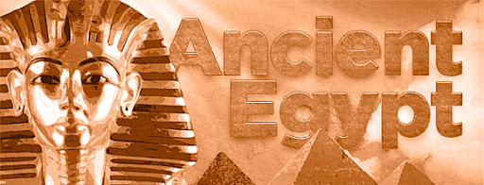

**Egyptian jewellery**

The Ancient Egyptians were famous for their beautiful jewellery and headdresses.

Can you have a go at creating your own version? You could use beads, painted pasta or other objects you find at home.

**A holiday to Egypt**

Go to a travel agent’s or research holidays to Egypt.

Can you design a leaflet to encourage people to visit Egypt? Think about what would be exciting about visiting? Why would people go there?

**Inventions**

The Ancient Egyptians created so many new things that we still use today.

Can you have a go at making your own replica of one?

**Homework**

Please choose two activities to complete. One this half term, one next half term.

Good luck and have fun!

**Homework**

*First piece due*

Monday 22nd May

*Second piece due*

Monday 10th July

I can’t wait to see them!

**Can you make a map of a Pharoah’s tomb?**

Draw a map of a Pharoah’s tomb.

Write a set of instructions on how to get safely through the tomb. Make sure you avoid any traps you might come across.

Try to use directional language (left, right, through, towards etc)

**Can you write in hieroglyphics?**

Research Ancient Egyptian writing, called hieroglyphics.

Can you write your name and some facts about Egypt using the letters?

**Ancient Egyptian recipes**

Research and find some Ancient Egyptian recipes. Can you have a go at following some recipes?

Write a food review about what you liked or didn’t like about it.