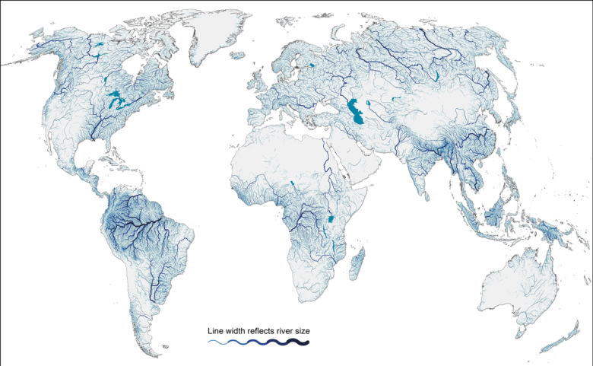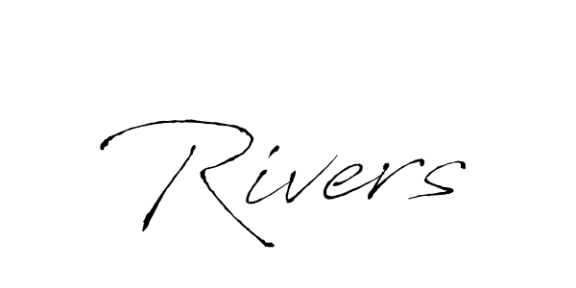

**Famous Rivers**

We will be using different types of maps, electronically and paper copies in order to identify rivers across the UK, Europe and Wider World.

We will be looking at the key features of the rivers and comparing different geographical locations.

**Where does our water come from?**

We will learn about the water cycle and the part is plays in creating and changing our water sources.

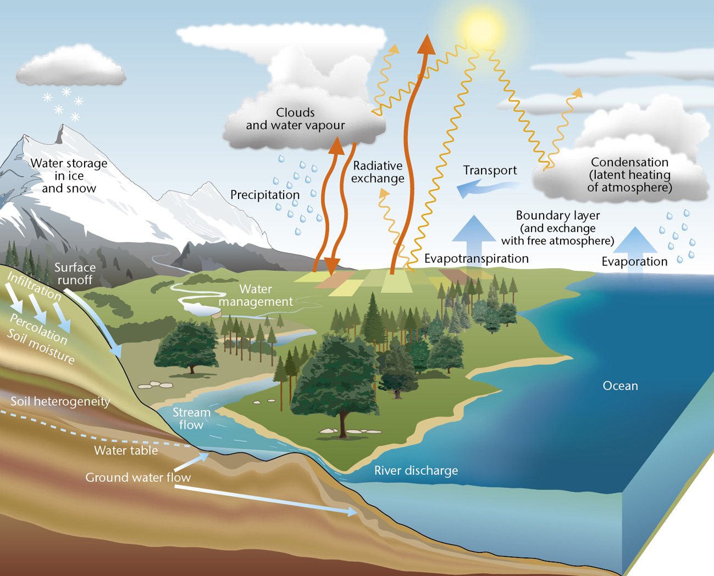

**Water resistance**

We will explore forces, focussing on how they react to different objects, Children will explore gravity when looking at waterfalls and water resistance to determine the best shape for a boat to travel down the water source.

**What are rivers used for?**

We will be exploring different mechanisms, using pulleys, gears and frames with the intention of researching, designing and creating our own (mini!) boat.

**How are rivers formed?**

We will be using technology to create an interactive product which clearly shows how rivers are formed.

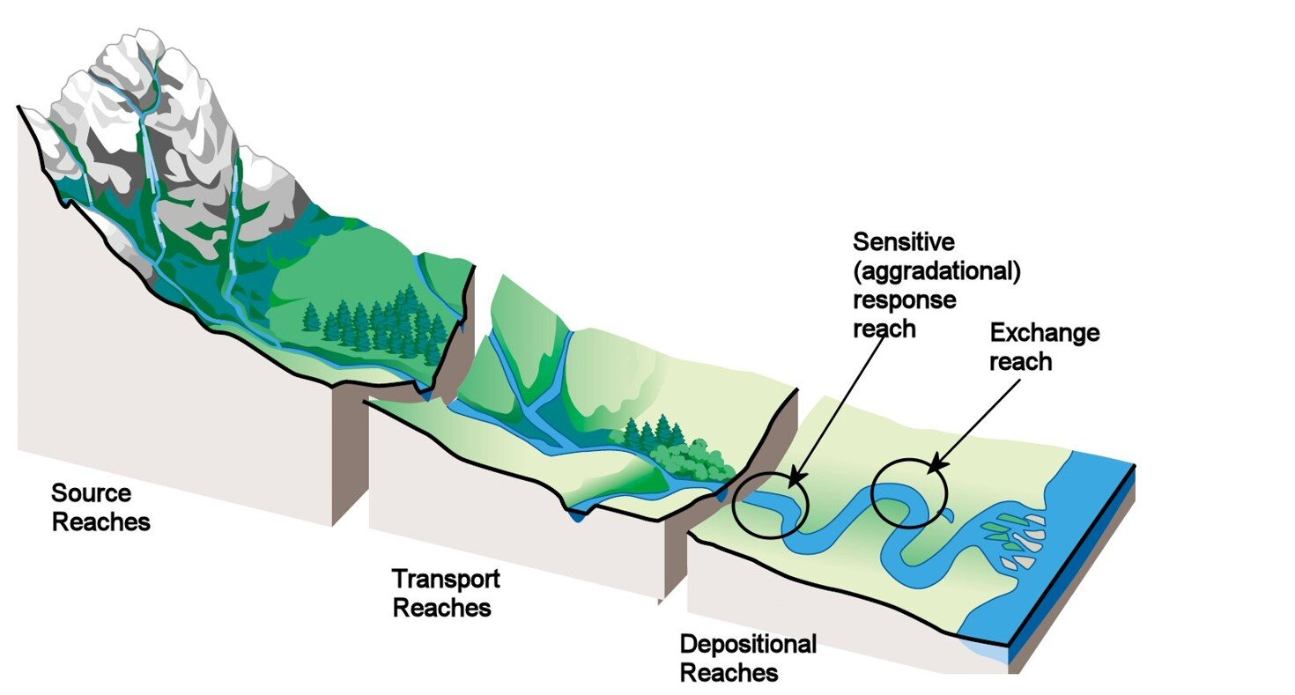

**Queen of the Falls**

We will be reading this book written about Annie Edson Taylor, who was the first person to travel over the Niagara Falls.

**Maths**

We will be using our mathematic and scientific skills to explore water resistance, gravity and making a working boat.

**How are rivers used?**

Looking deep into the history of significant rivers, we will discover a range of their many uses.

We will compare these uses to the local area and use of water ways to support leisure and industry.