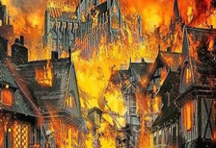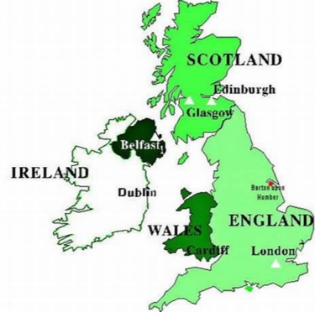

**History**

**Why do we remember the Great Fire of London?**

When and how did the fire start?

What do we know about the fire?

Why did the fire spread so quickly?

Exploring old/ new maps

Creating a timeline of main events

**Geography**

Where are the castles in the UK?

We will be identifying different castles within the UK and researching the key features of the location they are in, in order to say whether it is a city, town, village, coastal or rural area.

We will create our own map of Struay complete with a key to explain all the different physical and human features.

Use google Earth to explore and identify the main rivers, seas and oceans in the UK.

Miss O’Connor

Year 2

Autumn 2023

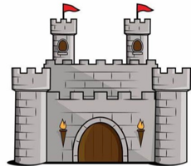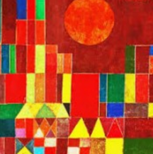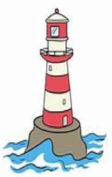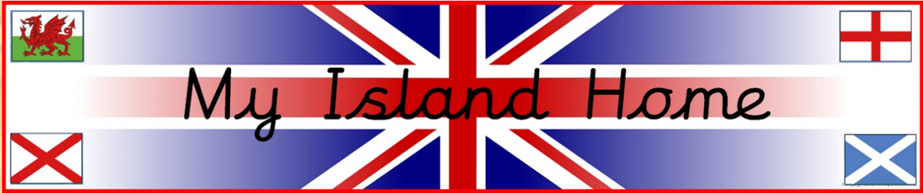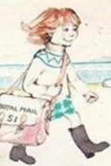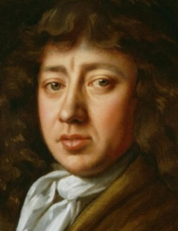

**Design and Technology**

Investigating freestanding structures such as castles, bridges and lighthouses.

We will be using our design skills to make our own freestanding structure.

**History**

What makes a castle?

We will be looking at Motte and Bailey castles and identifying their features.

Investigating how castles have changed?

What important jobs were there?

How did you become a knight?

**Maths Links**

Using 2d shapes in our artwork

Using simple co-ordinates to find different locations

**Art and Design**

Who was Paul Klee?

We will use Paul Klee’s artwork to inspire us to develop our own pieces of art, based in the ‘Castle and the Sun’ picture.

**Who was Andy Goldsworthy?**

We will use natural resources to create pieces of art inspired by nature. Using patterns and symmetry.

**Reading/ English links**

Who was Samuel Pepys?

To write letters and diaries in role.

Class Texts:

The Great Fire of London

Lighthouse Keeper Stories

Katie Morag series.