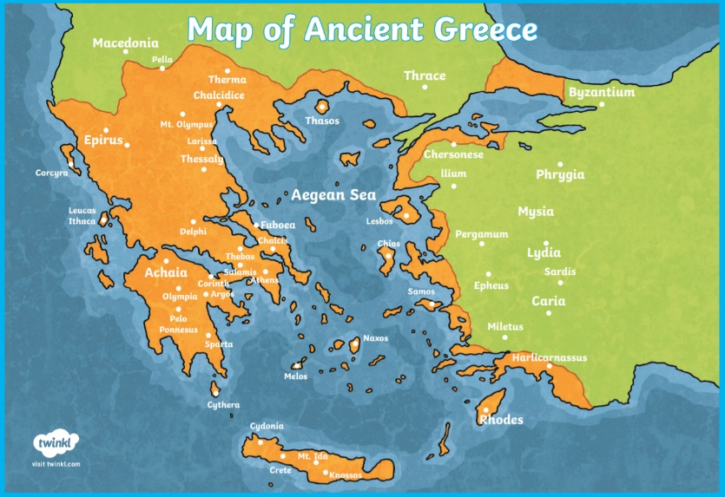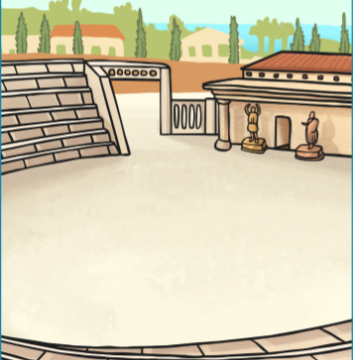

**Art**

We will be developing our knowledge of Ancient Greek pottery by designing and making printing blocks in a typical Ancient Greek pattern.

**D&T**

We will be designing and sewing a small cushion with a Greek pattern. We will be focusing on running stitch to join the material together.

**Where is Greece?**

We will be looking at Greece on the map and comparing this with the UK. We will plot historic Greek places and landmarks on our map.

**How did the Ancient Greeks change the world?**

We will be looking at what impact the Ancient Greeks had on the world. We will explore how democracy was invented and gain an understanding of what life was like before this.

**What do you know about the Olympics?**

The Olympic games began in a place called Olympia in Greece. We will be looking at when and how the Olympic games started and comparing them to how they are now.

**What was it like to live in Ancient Greece?**

We will be looking at how the Greeks lived. Some aspects we will explore are their housing, clothing and education. This will help us gain a picture of what life was like in Ancient Greece. We will also be looking at the different myths and legends of Ancient Greece.

**What events happened in Ancient Greece?**

To understand what happened in Ancient Greece we will be making a timeline of events. We will then compare this timeline to one of the UK and identify differences.

**Who Let the Gods Out?**