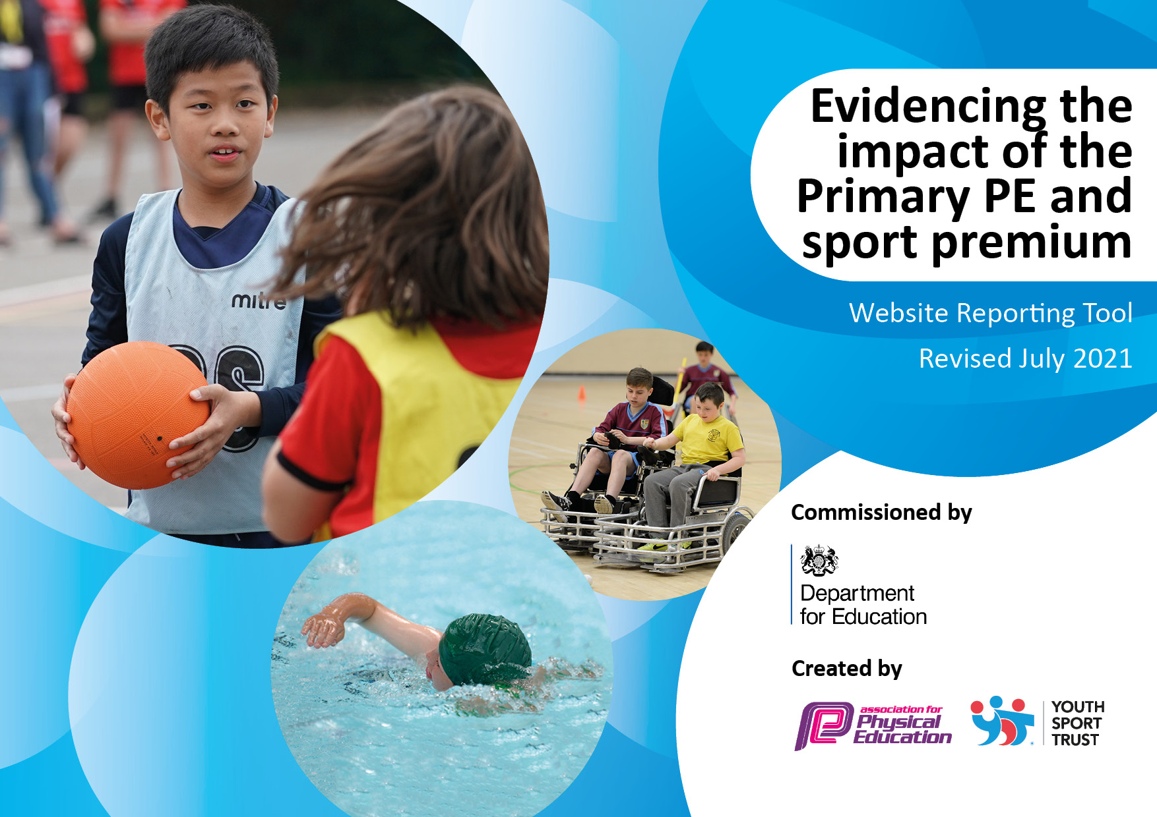
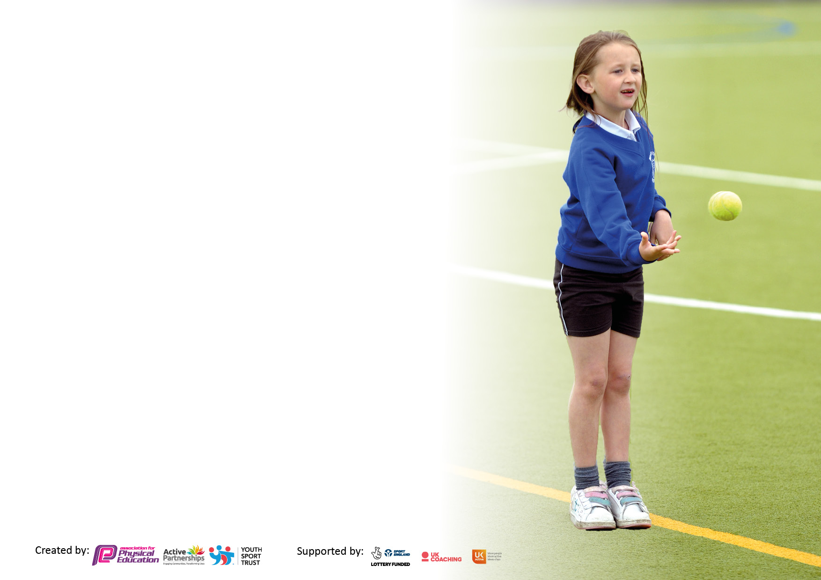

It is important that your grant is used effectively and based on school need. The Education Inspection Framework makes clear there will be a focus on ‘whether leaders and those responsible for governors all understand their respective roles and perform these in a way that enhances the effectiveness of the school’.

Under the Quality of Education Ofsted inspectors consider:
Intent - Curriculum design, coverage and appropriateness
Implementation - Curriculum delivery, Teaching (pedagogy) and Assessment
Impact - Attainment and progress

To assist schools with common transferable language this template has been developed to utilise the same three headings which should make your plans easily transferable between working documents.

Schools must use the funding to make additional and sustainable improvements to the quality of Physical Education, School Sport and Physical Activity (PESSPA) they offer. This means that you should use the Primary PE and sport premium to:

- Develop or add to the PESSPA activities that your school already offer
- Build capacity and capability within the school to ensure that improvements made now will benefit pupils joining the school in future years
- The Primary PE and sport premium should not be used to fund capital spend projects; the school’s budget should fund these.

Pleasevisitgov.ukfortherevisedDfEguidanceincludingthe5keyindicatorsacrosswhichschoolsshoulddemonstrate animprovement.Thisdocumentwillhelpyoutoreviewyourprovisionandtoreportyourspend.DfEencouragesschools to use this template as an effective way of meeting the reporting requirements of the Primary PE and sport premium.

We recommend you start by reflecting on the impact of current provision and reviewing the previous spend.

Schools are required to publish details of how they spend this funding, including any under-spend from 2019/2020, as well as on the impact it has on pupils’ PE and sport participation and attainment. All funding must be spent by 31st July 2022.

We recommend regularly updating the table and publishing it on your website throughout the year. This evidences your ongoing self-evaluation of how you are using the funding to secure maximum, sustainable impact. Final copy must be posted on your website by the end of the academic year and no later than the 31st July 2021. To see an example of how to complete the table please click HERE.
Created by: Supported by:

Details with regard to funding
Please complete the table below.

Total amount carried over from 2020/21 | £0
Total amount allocated for 2021/22 | £ 17,430
How much (if any) do you intend to carry over from this total fund into 2022/23? | £ 0
Total amount allocated for 2022/23 | £ 17,430
Total amount of funding for 2022/23. To be spent and reported on by 31st July 2023. | £ 17,430
Swimming Data
Please report on your Swimming Data below.

Meeting national curriculum requirements for swimming and water safety.

N.B. Complete this section to your best ability. For example you might have practised safe self-rescue techniques on dry land which you can then transfer to the pool when school swimming restarts.
Due to exceptional circumstances priority should be given to ensuring that pupils can perform safe self rescue even if they do not fully meet the first two requirements of the NC programme of study
What percentage of your current Year 6 cohort swim competently, confidently and proficiently over a distance of at least 25 metres?  N.B. Even though your pupils may swim in another year please report on their attainment on leaving primary school at the end of the summer term 2023.  Please see note above | 73.3%
What percentage of your current Year 6 cohort use a range of strokes effectively [for example, front crawl, backstroke and breaststroke]?  Please see note above | 100%
What percentage of your current Year 6 cohort perform safe self-rescue in different water-based situations? | 73.3%
Schools can choose to use the Primary PE and sport premium to provide additional provision for swimming but this must be for activity over and above the national curriculum requirements. Have you used it in this way? | No

Action Plan and Budget Tracking
Capture your intended annual spend against the 5 key indicators. Clarify the success criteria and evidence of impact that you intend to measure to evaluate for pupils today and for the future.

Academic Year: 2022/23 | Total fund allocated: £17,430 | Date Updated: July 2023
Key indicator 1: The engagement of all pupils in regular physical activity – Chief Medical Officers guidelines recommend that primary school pupils undertake at least 30 minutes of physical activity a day in school |  |  |  | Percentage of total allocation:
 |  |  |  | 15.77%
Intent | Implementation |  | Impact | Real PE scheme
Your school focus should be clear what you want the pupils to know and be able to do and about  what they need to learn and to  consolidate through practice: | Make sure your actions to achieve are linked to your intentions: | Funding allocated: | Evidence of impact: what do pupils now know and what can they now do? What has changed?: | Sustainability and suggested next steps:
Real PE scheme implementation:  Rationale: It is our intent to develop behaviours as well as fundamental movement skills: a broad and holistic approach that improves personal, social, cognitive, and creative behaviours as well as teaching health & fitness and applying it to physical activity. There is a specific focus on motor competence, breaking down skills to ensure basic skills of ABC (Agility, Balance, Control) are understood before adding it to a sport setting to understand rules, strategies and tactics. All children will take part in a physical module and a fitness module, which helps them to understand the importance of ‘healthy participation’. Through engagement in PE, we strive to develop in children a lifelong love of physical activity, whether it is competitive sport or an enjoyment in keeping active and healthy. Children will experience a wide variety of sports and outdoor activities to develop their physical confidence, their skill in using their body and their understanding of the sporting values. | Each week children access a minimum of two hours of high quality structured physical activity. Children develop age-appropriate PE skills through a series of stimulating lessons which are planned, with clear knowledge and skills-based learning objectives and subject-specific vocabulary. Children have the opportunity to develop competence in a broad range of physical skills. There is a focus on a greater development of fundamental movement skills at an early age. This will support with transferring these skillsets into other competitive sports, building a lifelong love of physical exercise. These include locomotor skills, object control skills and stability skills. Therefore, every PE lesson incorporates developing aspects of these fundamentals. In the EYFS and KS1 pupils develop ‘automacity’ i.e. being able to complete practical components that are isolated and practised. As they progress into KS2, pupils go through the process of ‘internalisation’ whereby they re-encounter direct knowledge and start to make connections independently and build in complexity and opportunities such as tactical awareness and expending or conserving energy. This means that some of the scaffolding is removed. By the end of KS2, pupils have enough direct knowledge to draw on their schema and to participate skilfully. Pupils can self and peer-review and practise in order to progress at their own pace in developing skills using personalised goals set out through clear pathways. | £2748 | The PE curriculum educates pupils with the correct physical techniques for reasons of improving safety and physical understanding. The children can reflect on their own performance and development. Pupils can apply their skillsets and their knowledge of what they have learnt at school in a life-long love and commitment to sport and exercise to maintain a physically and mentally healthy lifestyle. Their confidence, social skills, and resilience through participating in physical activity enables pupils to develop their whole self. | Continually monitor the scheme whilst assessing children’s progress.  Pupil voice to be registered consistently to consider the enjoyment of physical education.  Scheme of work to be reviewed yearly to see if it is still fit for purpose.  Continue staff CPD to develop confidence in delivery of scheme. Further development using Real PE scheme.
Key indicator 2: The profile of PESSPA being raised across the school as a tool for whole school improvement |  |  |  | Percentage of total allocation:
 |  |  |  | 20.08%
Intent | Implementation |  | Impact | MJSF affiliation
Your school focus should be clear what you want the pupils to know and be able to do and about  what they need to learn and to  consolidate through practice: | Make sure your actions to achieve are linked to your intentions: | Funding allocated: | Evidence of impact: what do pupils now know and what can they now do? What has changed?: | Sustainability and suggested next steps:
Real PE scheme:  Using technology throughout PE, using ipads via the Real PE scheme.  CPD for staff on using technology for assessment.  Develop curriculum maps to identify opportunities to link healthy bodies and healthy minds to other curriculum areas. Linking Real PE scheme to holistic child and ensuring sports skills are linked into further progression of sports.  New equipment bought to support Real PE and competitive sports.  Commando Joes:  Commando Joes used throughout the school to build situation based tasks for children to build on softer skills. |  | £500.00  £3000 |  | Continue to develop teacher CPD including new staff and ECTs.  Ensure Ipads are updated regularly.  Continue to develop curriculum map as children’s skills develop. KS1 is a focus on multi-skills whilst the scheme is developing, move to offering more sports throughout the year.  Continue to monitor the impact of Commando Joe’s via assessment and pupil voice.

Key indicator 3: Increased confidence, knowledge and skills of all staff in teaching PE and sport |  |  |  | Percentage of total allocation:
 |  |  |  | 0%
Intent | Implementation |  | Impact
Your school focus should be clear | Make sure your actions to | Funding | Evidence of impact: what do | Sustainability and suggested
what you want the pupils to know | achieve are linked to your | allocated: | pupils now know and what | next steps:
and be able to do and about | intentions: |  | can they now do? What has
what they need to learn and to |  |  | changed?:
consolidate through practice:
CPD for staff through Real PE. |  | £ | PE is being delivered to a high quality and this has been monitored by PE lead and SLT throughout the year. | PE lead to continue to support staff with CPD via observation. Train new staff in scheme of work and offer online CPD through RealPE.
Key indicator 4: Broader experience of a range of sports and activities offered to all pupils |  |  |  | Percentage of total allocation: 61.03%
Intent | Implementation |  | Impact
Your school focus should be clear | Make sure your actions to | Funding | Evidence of impact: what do | Sustainability and suggested
what you want the pupils to know | achieve are linked to your | allocated: | pupils now know and what | next steps:
and be able to do and about | intentions: |  | can they now do? What has
what they need to learn and to |  |  | changed?:
consolidate through practice:
Provide a number of after school and lunch time club opportunities to ensure a wide and high-quality provision of clubs available for our pupils. Subsidised where necessary. Including dance and gymnastics and outdoor pursuits.  Develop outdoor/adventurous activities.  Ensure curriculum covers all elements of sport e.g. outdoor activity, athletics, swimming etc.  Swimming across a number of year groups for life saving skills.  Playground equipment to support play and learning. | Variety of clubs offered to all age ranges - timetabled  High quality resources available for the children to engage in physical activity. Continued year group focussed sport  Developing the environment further to offer more opportunities – orienteering, Forest Schools  Termly swimming across UKS2 and Y4.  Daily active time | £2784 – ASM clubs  £1750 – Dance provider  £4140 – Coach for swimming.  £2000 | Children are engaging in clubs with all clubs at full capacity.  EYFS has been completing OOA as well as OOA as part of the curriculum.  73.3% of Y6s can now swim 25m and support in life saving skills. Y5 is currently at around 60% with further support to be added next year.  Children are active at numerous times of the day. | More clubs to be offered next year. Children with low participation to be targeted.  Orienteering course to be set up before Summer 24.  Swimming to continue and top up lessons to be offered for Y5 (transitioning to Y6) who cannot meet the requirements.  Continue to add playground leads to get activity and participation high.

Key indicator 5: Increased participation in competitive sport |  |  |  | Percentage of total allocation:
 |  |  |  | 1.43%
Intent | Implementation |  | Impact
Your school focus should be clear | Make sure your actions to | Funding | Evidence of impact: what do | Sustainability and suggested
what you want the pupils to know | achieve are linked to your | allocated: | pupils now know and what | next steps:
and be able to do and about | intentions: |  | can they now do? What has
what they need to learn and to |  |  | changed?:
consolidate through practice:
Participate in local competitions and those within SBMAT | Engage with all opportunities to participate in tournaments and competitions. | £250 | Participation in competition has risen from previous years. | Get more opportunities for all children to be involved in competitive sports.  Invest in travel.

Signed off by
Head Teacher: | L Davis
Date: | July 2023
Subject Leader: | V Beeston
Date: | July 2023
Governor: | M Weller
Date: | July 2023

