WEEKLY INFORMATION SHEET – 10th JANUARY 2025

 | STAR AWARD WINNERS
Reception | Mitchell
Year 1 | Max
Year 2 | Noah
Year 3 | Bobby R
Year 4 | Rylee
Year 5 | George
Year 6 | Lara

CLASS | % ATT | LATES
REC | 60.50 | 1
YEAR 1 | 65.79 | 0
YEAR 2 | 85.83 | 1
YEAR 3 | 83.15 | 2
YEAR 4 | 95.83 | 0
YEAR 5 | 87.08 | 4
YEAR 6 | 85.95 | 5
HOUSE WINNERS
ULLSWATER

HEAD TEACHER’S THOUGHTS FOR THE WEEK
"May the Epiphany remind us of the good news of Christ"


Happy New Year and welcome to 2025! I hope you all had a fabulous Christmas and enjoyed spending time with family and friends.
Firstly, thank you for all the cards, gifts and good wishes over the festive season it really is appreciated. We have started our Spring term under a blanket of snow and ice.
Thanks to Mr Williams for creating pathways around our school and to you all for taking extra care around Bent Spur Road. Hopefully, the weather will improve over the weekend and help clear the playground for next week.
In worship we have been celebrating the epiphany which was on 6th January. The children have been exploring the journey of the 3 wise men and the presents they gave to the baby Jesus. We explored their Resilience and Perseverance which fits beautifully with our new value of Faith.
We have had lots of illness throughout school since returning including chicken pox, flu, coughs and colds and not forgetting the good old sickness bug! Please make sure you inform school before 9am if your child isn't attending school. Please telephone the office, or use the absence notification.

A big welcome to Mrs Wall our new Office Assistant. She has been a busy lady getting to know lots of children and parents and has spoken to many of you on the phone! As always, please try to get your child to school as soon as they are well enough, as we know every day lost at school has a detrimental effect on their progress.
Next week we start our after school clubs, make sure you have brought back your slip to the office to guarantee your child's place. Please also make sure you are aware of the finishing time for collection as our coaches go onto coach at other schools afterwards!
The new Reception application deadline is Wednesday 15th January. Please let your friends and family know about our brilliant school as we want as many children as possible in our new Reception class.
Please make sure you are parking legally and respectfully on Bent Spur Road. Please ensure you keep the yellow zig zag lines clear at all times and do not block any driveways. We want to keep good relations with our friends and neighbours.
Have a wonderful weekend. Stay warm.
Paul Puckey
Head Teacher


WELCOME
Mrs Jasmin Wall, Office Administrator
A new friendly face in the office, happy to help with any queries Parents/Carers may have. Mrs Wall has a wealth of administration and customer service experience, as well as being a parent herself to a student at this school. She has settled in great this week an believe she will be a great asset to the School.
Background experience includes administration, finance, compliance and education. Moving from working with teenagers at Canon Slade School to being the first point of contact for Parents/Carers at St Stephen's.

I look forward to meeting you in the near future.

RECEPTION ADMISSIONS
We still have places available for our 2025 Reception intake. All applications will close on Wednesday 15th January. To apply, please visit the Bolton Council Citizen Portal - https://www.bolton.gov.uk/admissions/apply-online-school-place
We also still have places available in our current Reception, Year 1 and Year 3 classes. Please promote our wonderful school to your friends and family. To apply for a space in these classes, please visit the Bolton Council Citizen Portal.

WINTER ILLNESSES
There are currently a few winter bugs going around school. Please see the NHS guidelines in regards to when students are able to return to school.
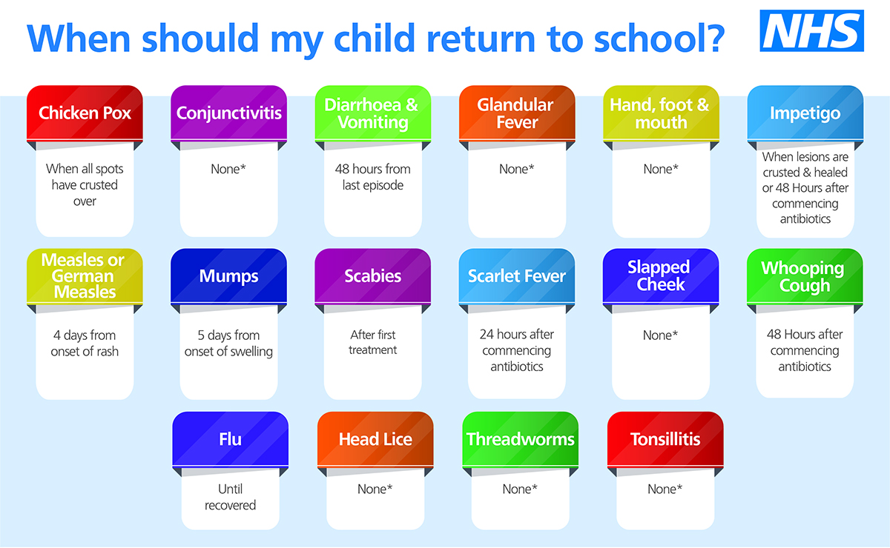
YEAR 2 GREAT FIRE OF LONDON WORKSHOP
To support our topic this half term, Delyth Bannister will deliver a workshop to Year 2 on the morning of Thursday 16th January. The workshop will focus on why the fire spread so quickly and how people tried to stop it. The students will have the opportunity handle artifacts, look at costumes and be involved in role play to bring the topic to life.

CLUBS SPRING TERM 1
Rees Sports will be in on Tuesdays and Thursdays delivering after school sports clubs for students in Year 1 and Year 2 for 5 consecutive weeks.
From Tuesday 14th - Gymnastics Club
From Thursday 16th - Multi Skills Club
Mr Haslam will be delivering a Boys Football Club for Year 3 an Year 4 commencing Tuesday 14th at Kearsley Academy for 5 consecutive weeks, with the last session taking place on Tuesday 11th February.

DANCING FEET
There are still places available with Dancing Feet Cheerleading, offered to all students from Reception to Year 6. The cost is £20 to 5 weeks.
If interested, please contact Carol directly on 07730 565 096.

DATES FOR YOUR DIARY
 | Event
Monday 13th January | KS2 Dodgeball  3:15pm-4:15pm
Tuesday 14th January | KS1 Gymnastics  3:15pm-4:15pm  Y3 & Y4 Football  3.30pm-4.3pm
Wednesday 15th January | Dancing Feet – Cheerleading  3:15pm-4:15pm
Thursday 16th January | KS1 Multi Sports  3:15pm-4:15pm


