WEEKLY INFORMATION SHEET – 13th DECEMBER 2024
CLASS | % ATT | LATES
REC | 95.83 | 3
YEAR 1 | 87.37 | 0
YEAR 2 | 92.00 | 3
YEAR 3 | 87.39 | 8
YEAR 4 | 95.33 | 1
YEAR 5 | 94.33 | 1
YEAR 6 | 94.19 | 1
STAR AWARD WINNERS 13th DECEMBER
Reception
Year 1
0Year 2
Year 3
Year 4
Year 5
Year 6

HOUSE WINNERS | GOLDEN RULE WINNERS

HEAD TEACHER’S THOUGHTS FOR THE WEEK
"May hope, peace, joy and love fill your home and your heart. Have a wonderful time."
Hello and welcome to the very last newsletter before Christmas! It's been a very festive week in school, leading up to our Church Service next Friday. Firstly, massive congratulations to our wonderful Reception Class for their Nativity! Their production of a 'Miracle in Town' was a tremendous success. It was amazing to see so many parents and carers joining us for the show and enjoying the mince pies and a brew! Very well done Reception and a big thank you to Miss Wild and Miss Smith for co-ordinating such a lovely Nativity. This week Reception, Year 1, 2 and 4 have all visited the Panto in Bolton. It's always great to see the children's reactions to a live show and they all thoroughly enjoyed it. Big thanks to all the staff and volunteers for helping take the children on the buses and creating memories!
Our amazing choir snag beautifully at Tesco Farnworth on Friday, raising much needed funds and entertaining many customers too! Thanks to all our parents who came to support them, I hope you are now feeling the Christmas spirit! The choir continued with their singing for FOSSS Coffee, Carols and Cakes in the afternoon! Again, thanks for such an amazing turnout and well done to all our Choir children and the Choir team of Miss C Clegg, Miss Y Clegg and Mrs Raisbeck!
Next week we look forward to our Christmas Dinner, Class Parties, Disco and our Christmas Service in church! A jam-packed week, but sure to be exciting!
Finally, some sad news. As many of you know, our wonderful Office Manager Mrs Bonnar, will be retiring at Christmas and enjoying exploring the world without the confines of School Holidays! We are so lucky to have had Mrs Bonnar being front of house for 17 years and helping thousands of children and parents in that time. I know many of you will want to give your good wishes to Mrs Bonnar before we finish next Friday, so don't hesitate to pop in the office and make her smile! She can't quite believe this is her final ever newsletter! We are delighted to announce that Mrs

Wall will be taking over in the office from January and I know you will give her every support as she learns her new role especially with having such big shoes to fill!
I hope to see you in church next Friday 20th December for our Christmas service at 9.15 am.
Have a wonderful Christmas. May the joy of the angels, the eagerness of the shepherds, the perseverance of the wise men, the obedience of Mary and Joseph, and the peace of the Christ Child be yours this Christmas.
Take care.
Paul Puckey
Head Teacher

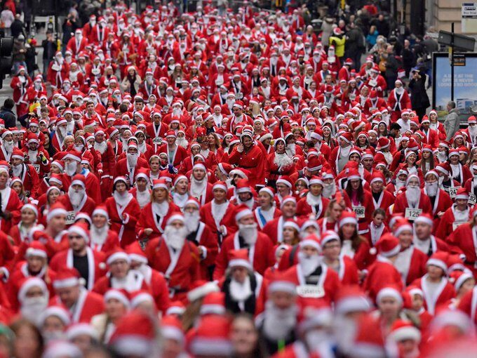
SANTA DASH
St Stephen's children (and maybe a few members of staff!!) will be taking part in a Santa Dash on Monday 9th December. For a donation of £1 towards School Fund, the children may wear a Santa hat or outfit while running around our Daily Mile and embrace the holiday spirit. As always, thank you for your continued support.

YEAR 3 PANTOMIME
To celebrate the run up to Christmas we will be taking Year 3 to The Victoria Hall in Bolton to watch 'Aladdin' on Tuesday 17th December. The pantomime is a family favourite and promises lots of laughs and thrills along the way. The children will travel to and from Bolton by bus.

CHRISTMAS PARTIES
Your child will have the opportunity to join in with their Class Christmas party on the afternoon of Wednesday 18th December. There will be games, Christmas songs and some refreshments to enjoy. Children may come to school dressed in their party clothes, but please remember there will still be playtimes throughout the day, so they should have something warm to wear to go outside. There may even be a special visitor joining our Key Stage 1 festivities.
We would like to take this opportunity to thank FOSSS (Friends of St Stephen's School) for ensuring every child will take home a Christmas present.

CHRISTMAS DINNER
Next Thursday 19th December is our whole school Christmas Dinner. Children and staff will sit down together for a real 'school family' occasion. There will be party hats, crackers and plenty of Christmas cheer.

FOSSS CHRISTMAS DISCOS
Our FOSSS Discos will take place on Thursday 19th December from 3.30 pm to 4.30 pm for KS1 and from 4.45 pm to 5.45 pm for KS2.
Children who are attending the KS1 Disco will come ready on that day and be handed over to the disco at 3.30 pm, so there is no need to go home or get changed! You may collect you child from the top yard.
The KS2 Disco will start at 4.45 pm to 5.45 pm and children should enter through the Main Entrance.
Children in KS2 should also be collected from the top yard.
KS1 children should bring £1 in a named envelope and given to the Class Teacher while KS2 children can

pay on arrival at the door. There will be sweets, drinks and gifts to purchase at the disco. Please bring some small change. Thank you.
If your child brings a mobile phone to the disco, they will need to hand it to a member of staff for the duration of the disco. It will be returned to them on leaving school. Thank you.

CHRISTMAS CAROL SERVICE
We are very much looking forward to seeing you all in Church for our Carol Service at 9.15 am on Friday 20th December. Children from Reception to Year 6 will lead the service with readings they have written themselves. Please come along to celebrate Christmas with us and enjoy the Nativity Tableau which will be presented by our Year 1 children. Please can your Year 1 child come to school in their PE kit.

CHRISTMAS DIARY DATES
 | Event
Wednesday 18th December | Christmas Parties in School
Thursday 19th December | Christmas Dinner  FOSSS Discos KS1 3.30 – 4.30 pm  KS2 4.45 – 5.45 pm
Friday 20th December | Carol Service in Church 9.15 am  Break for Christmas Holiday 3.10 and 3.15 pm

The staff and children would like to take this opportunity to wish you all a very Merry Christmas and a Happy New Year. We would like to thank you for your support throughout 2024 and look forward to working with you next year. The term starts on Tuesday 7th January 2025.

