WEEKLY INFORMATION SHEET – 6th DECEMBER 2024
CLASS | % ATT | LATES
REC | 74.36 | 3
YEAR 1 | 90.53 | 0
YEAR 2 | 94.00 | 0
YEAR 3 | 86.96 | 7
YEAR 4 | 95.11 | 1
YEAR 5 | 91.33 | 2
YEAR 6 | 89.35 | 0
 | STAR AWARD WINNERS 6th DECEMBER
Reception | Corah
Year 1 | Hania
0Year 2 | Leilah
Year 3 | Chloe & Annie
Year 4 | Annie
Year 5 | Lilly M
Year 6 | Jacob

HOUSE WINNERS | GOLDEN RULE WINNERS
CONISTON | YEAR 2

HEAD TEACHER’S THOUGHTS FOR THE WEEK
"Peace isn't the absence of something.....it's the presence of someone."
Hello and welcome to our Advent newsletter. We started this week by lighting our first candle on our Christmas wreath. We looked at what each candle represents and the children were very knowledgeable recognising Love, Joy, Peace and Hope and then Jesus himself. Throughout the build up to Christmas we will be looking for children showing these values on a daily basis. Sometimes the mad rush of Christmas preparations can be frantic and we can forget the real reason of celebrating the birth of Jesus Christ together.
It was fantastic seeing us all together in a packed out St Stephen's church on Wednesday afternoon for our Christingle service. Massive well done to our Year 3 children for delivering the service and thanks to everyone who helped with sending in oranges and lighting the candles!
Year 6 had a fabulous day at Lancashire Cricket Club on Monday in their Development Centre. The children were great ambassadors and Mrs Kerr was incredibly proud of the children's behaviour and effort. Hopefully we have the next England Cricket Captains in our midst!
Year 5 and Year 6 had a wonderful theatre trip on Friday to watch Jungle Book at the Octagon Theatre Bolton. It was an amazing experience for the children and the production was amazing! Thanks to all the staff for helping on the trip, I really enjoyed seeing the children's faces light up! We have other classes going out to the panto next week, we hope you enjoy it and not forgetting the Reception Nativity!
Finally, keep spreading the word about Reception places for September and spaces available in Years 1 and 3.
Have a lovely weekend. Stay dry!
Paul Puckey
Head Teacher


SELECTION BOX RAFFLE
Thank you to all of you who donated selection boxes for our raffle. Please continue to send your donations into school. Tickets for the raffle are now on sale for 10p a ticket from the Class Teacher.

PANTOMIME TRIPS
To celebrate the run up to Christmas we will be taking Key Stage 1 to The Victoria Hall in Bolton to watch 'Aladdin.' Year 1 will attend the performance on Tuesday 10th December, and Year 2 on Wednesday 11th December. The pantomime is a family favourite and promises lots of laughs and thrills along the way. The children will travel to and from Bolton by bus.

RECEPTION NATIVITY
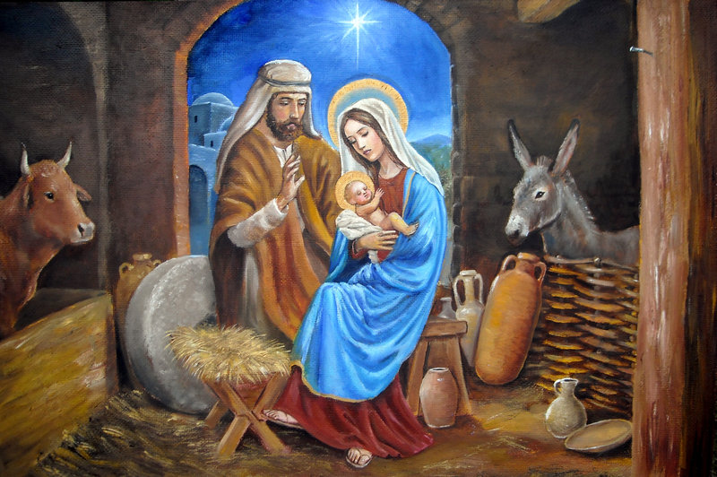
The Reception Nativity will take place on Thursday 12th December at 9.15 am Parents, friends and relatives are very welcome to come along to watch the children present their version of the Christmas story and stay for coffee and Christmas treats. Please note the taking of photographs and videos is not permitted. Please ensure the Reception children are in school for 8.40 am to allow enough time for the staff to get all the children ready in their costumes. Thank you for your support. children will take part in the Christingle Service and be dismissed from school as normal.
We will be making our Christingles in school. Please can your child bring in an orange to assist with this on Monday 2nd December and we will do the rest at school. Please can you return the filled Christingle envelopes to school before our Christingle service. Thank you for your support.

RECEPTION PANTOMIME
Reception Class will be enjoying their pantomime 'Rapunzel' on the morning of Friday 13th December at The Albert Halls in Bolton. After a fun filled morning, they will return to school for a late lunch. Oh yes they will!!!!

CHOIR VISIT TO TESCO
Members of our lovely choir will visit Tesco in Farnworth on the morning of Friday 13th December to sing a selection of Christmas songs and carols to the community. We are sure they will do us proud and provide a bit of festive cheer for busy shoppers.

FOSSS COFFEE, CAROLS AND CAKES
FOSSS (Friends of St Stephen's School) are holding a Coffee Afternoon in the School Hall on Friday 13th December at 2.00 pm. They would like to invite all of you to come along and enjoy a coffee and cake whilst listening to our wonderful School Choir prior to collecting your child at the end of the school day. There will be a raffle and during the afternoon your child will be allowed out of class for a short time to join you for a cake.

GENERAL KITCHEN ASSISTANT VACANCY
School Meals are looking to appoint a General Kitchen Assistant based at St Stephen's but with capacity to cover local schools. The position is advertised on the Greater Jobs website or for more details contact Justine on 07789 031784.

CHRISTMAS DIARY DATES
 | Event
Thursday 12th December | Reception Nativity 9.15 am
Friday 13th December | FOSSS Coffee, Cakes and Carols 2.00 pm
Wednesday 18th December | Christmas Parties in School
Thursday 19th December | Christmas Dinner  FOSSS Discos KS1 3.30 – 4.30 pm  KS2 4.45 – 5.45 pm
Friday 20th December | Carol Service in Church 9.15 am  Break for Christmas Holiday 3.10 and 3.15 pm

