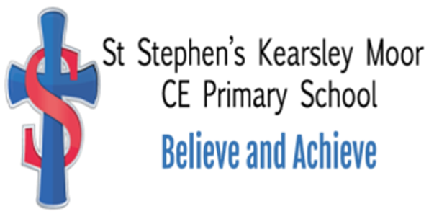

Art Policy

St Stephen’s (Kearsley Moor)
C E Primary School

Reviewed 2022

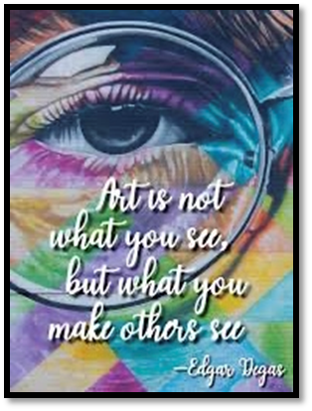

Mission Statement: St Stephen’s aims to develop its children and staff to reach their full potential in a happy and caring environment, enshrined in our Key Christian Values of Love, Faith and Trust.
St Stephen’s Statement of Intent for the Curriculum: Our aim is to provide a stimulating, creative and exciting curriculum which inspires, challenges and motivates; giving every child the opportunity to achieve. It is built around a range collaborative and self-directed activities which extend and develop individual interests and talents and prepares children to be valued and responsible members of society

INTENT

Art embodies some of the highest forms of human creativity. A high-quality art education should engage, inspire and challenge pupils, equipping them with the knowledge and skills to experiment, invent and create their own works of art. As pupils progress, they should be able to think critically and develop a more rigorous understanding of art. They should also know how art both reflect and shape our history and contribute to the culture, creativity and wealth of our nation.

In the EYFS we aim to ensure that all pupils:
- Safely use and explore a variety of materials, tools and techniques, experimenting with colour, design, texture, form and function.
- Use what they have learnt about media and materials in original ways, thinking about uses and purposes.
- Represent their own ideas, thoughts and feelings through art
IMPLEMENTATION

Art will be taught through PlanBee units of work. There are 3 units of work per year group and each meet the National Curriculum objectives and allow the children to develop their skills in the following areas: -
- Exploring visual, tactile & sensory qualities of materials & processes
- Drawing – line, pattern and texture
- Painting, printing and colour
- Collage, sculpture and 3D art
- Responding to artwork and using a sketchbook- developing observational skills with an attention to detail.
We aim to develop the children’s spiritual, moral, social and cultural development through thought provoking activities and time for reflection. We try to establish an appreciation of Artwork through trips to galleries and exhibitions. Celebrate and exhibit their own work to build a sense of pride and recognition of creativity.
Each art project will be taught once weekly or in a week’s block dependent on the length of each project, this is up to each class teacher’s discretion. Some units of work are inspired by artists, which our children will learn about during their journey through St Stephen’s.

Role of the Subject Leader

The subject leader will:
- Inspire learning by implementing a new scheme PlanBee, which will enable the children to feel purposeful and motivated to upskill themselves through each unit of work.
- Ensure high quality resources and equipment is available for each class.
- Purchase, organise and maintain equipment to make them easily accessible for colleagues.
- Monitor and evaluate the learning and teaching of art through PlanBee within the school and its impact.
- Devise an action plan to show future developments and review progress.
- Attend courses and cluster meetings for CPD and report back to staff.
- Organise, alongside other curriculum leads, three hall displays per school year.
- Encourage parents to be involved in their children’s learning in art.

In the EYFS children begin learning about art through our creative area. They can use a variety of materials and tools to experiment and adapt their work. As well independent activities the children also access adult led activities, that show skills and ways of recording, designing and applying. Children are encouraged to ‘have a go’ independently and take risks with the equipment that has been previously modelled. Children draw a self-portrait each term to show their developmental stages of drawing and these are displayed in the classroom.

IMPACT

Assessment
Each class teacher will assess using the National Curriculum objectives that cover each unit. Class teachers will also informally assess the children as the unit progresses, using the PlanBee assessment sheets. At the end of each unit of work the children will use the ‘responding to artwork and using a sketchbook’ statements to show their achievements as well as helping them to identify areas that need improvement.
Work can be displayed in the classroom and photographs shared with the subject leader on class Dojo.

Display and Presentation of Art
At St Stephen’s we believe our displays should be visually stimulating and increase the children’s visual literacy and awareness. It is important to us that each child has some of their achievements celebrated publicly. Displays should be changed regularly.

Special Educational Needs and Differentiation
Art education is one particular area of the curriculum which allows a great deal of pupil creative expression and non-verbal communication. Therefore, we aim to use the area of Art as a means of supporting children with SEN to develop their own learning skills and levels of personal self-esteem.
Each teacher will make every effort to adapt all areas of the Art Curriculum to suit the individual needs of the children in their class. Children with any form of Special Educational Need will be able to access the Art Curriculum with great success. If any teacher is unsure about adapting their Art planning to suit the needs of the children in their class, then they are encouraged to speak the Art co-ordinator or to the SEN co-ordinator. The demands of the tasks and choices can be changed to meet individual needs, such as fine motor difficulties.

Equal Opportunities
It is our intention to provide each and every child with a broad and balanced Art Curriculum. A curriculum which also approaches those key issues associated with multi-culture and gender. It is our belief that all children, regardless of their own particular ethnic group, have the same entitlement to a broad and varied multi-cultural Art education, an education which provides a unique sight into the historical and contemporary traditions of both their own culture and that of other nationalities. In addition, every effort is made to seek out ways of reinforcing sexual equality within the classroom where both sexes are treated fairly and are provided with the same educational opportunities.

Health and Safety
In teaching certain practical elements of Art to children, we recognise that safety is a key issue. All precautions must be taken. This is done by recognising health and safety in the classroom organisation and by giving the children guidance on how to use the equipment provided. Monitoring the children in small groups helps to overcome the problems of safety when using potentially dangerous Art equipment. Children will be introduced to the correct techniques for handling Art equipment and will develop these techniques as they progress through the school/ The co-ordinator is always available to guide staff in the safest ways of using various equipment.

