Pupil premium strategy statement

This statement details our school’s use of pupil premium (and recovery premium for the 2023 to 2024 academic year) funding to help improve the attainment of our disadvantaged pupils.

It outlines our pupil premium strategy, how we intend to spend the funding in this academic year and the effect that last year’s spending of pupil premium had within our school.

School overview
Detail | Data
School name | St Stephen’s Kearsley Moor
Number of pupils in school | 191
Proportion (%) of pupil premium eligible pupils | 55 (29%)
Academic year/years that our current pupil premium strategy plan covers (3 year plans are recommended) | 2021-24
Date this statement was published | Dec 23
Date on which it will be reviewed | Sept 24
Statement authorised by | Chair of Governors
Pupil premium lead | P Puckey
Governor / Trustee lead | D King

Funding overview
Detail | Amount
Pupil premium funding allocation this academic year | 59 (Oct Census 2022 FSM Ever 6) x £1455 = £85,845  Post LAC children = £2530  Total = £88,375
Recovery premium funding allocation this academic year | 60 x £145 = £8,700  LAC Recovery Premium = £2735  Total = £11,435
Pupil premium funding carried forward from previous years (enter £0 if not applicable) | £0
Total budget for this academic year | £99,810

Part A: Pupil premium strategy plan

Statement of Intent
As a school, we pride ourselves on our family feel and strive for all the children in our care to reach their potential. Our Vision of ‘Our Faith can move Mountains’ underpins our approach to education, where everyone can move their own mountains through our 4 key Values of:
Love, Hope, Faith and Trust.
The high expectations of staff and dedication to the children ensure our pupils feel secure, loved and cared for.
Our Aims:
- To educate the children intellectually, socially, morally, aesthetically, physically and spiritually based on Christian principles
- To promote the highest academic standards in all aspects of the curriculum by ensuring that all children develop to their best potential in acquiring and understanding the skills upon which they can build in the secondary stage of education
- To encourage learning by providing a welcoming, friendly and supportive environment in which Christian values are central to the ethos of the school and its teaching
- To stimulate in children a sense of curiosity and excitement about the world and to encourage them to search for truth, meaning and purpose in life and to provide an opportunity to search for a faith by which to live
- To show concern and care through a strong sense of Christian values for all members of the school community and to show respect for the code of conduct and discipline of the school
- To encourage children to think as individuals and to explore, discriminate and discover things for themselves
- To ensure that children have a good moral and spiritual awareness to fit them for the world in which we live, preparing them for the opportunities, experiences and responsibilities of the outside world
- To nurture links and to establish good secure relationships between children, staff, parents, governors and members of the church, parish and local community
- To use the financial resources at our disposal to provide good accommodation and surroundings and the highest possible levels of staffing and equipment
- Based on Indices of Multiple Deprivation 2023- 72.8% of children live in a Lower Super Output Area (LSOA) in Bolton which is one of the most deprived 20 to 30% (or worse) in England with a third living in the most deprived 10-20% (or worse). This is 10.3% higher than Bolton average.
- Indices also show that 71.7% of pupils come from households in the bottom 30% for Education, Skills and Training (over a quarter – 33.8% - are in the lowest 10%).

Challenges

This details the key challenges to achievement that we have identified among our disadvantaged pupils.
Challenge number | Detail of challenge
1 | Attendance of disadvantaged children (91.84%) is less than non-disadvantaged children (94.99%). Poor attendance can negatively impact academic achievement
2 | Language skills less developed especially on entry to school, which hinders reading, writing and phonics attainment in Reception and KS1
3 | Limited support at home with reading or home learning and access to technology
4 | Mental Health and well-being after Covid due to stressful home environment and chaotic lifestyles
5 | Limited cultural experiences due to less opportunity to engage in enrichment activities
6 | Children suffer from lack of active lifestyles leading to increased health issues
7 | Behaviour for learning is less established on entry to school for disadvantaged pupils compared to non-disadvantaged pupils

Intended Outcomes
This explains the outcomes we are aiming for by the end of our current strategy plan, and how we will measure whether they have been achieved.
Intended outcome | Success criteria
Increased self-esteem, confidence and resilience | Having a positive mind set and showing resilience in learning
Equipped to face challenges with a positive mind-set and to understand how to manage their emotions | KS2 outcomes in line with National and progress of disadvantaged children will improve
Reduce the gap between disadvantaged children and non-disadvantaged children | Gap between the two diminishes especially in KS2 outcomes.
Greater levels of oracy through communication and language | Being able to talk with greater confidence regarding learning and home life. Greater ability to communicate using appropriate and age-related vocabulary
Enriched experiences away from school | Cultural Capital enrichment
Improved attendance and punctuality | Improvement in attendance and lateness
Improved physical and mental health | Children accessing extra-curricular and sporting opportunities
Improved progress and attainment across the curriculum, particularly those attaining greater depth | Improvement in data
Greater parental support/community support | Parents supporting children in and out of school
Children in KS1 make accelerated progress in reading due to increased opportunities to read, focusing on phonics | KS1 phonics data to be at least in line with national

Activity in this academic year
This details how we intend to spend our pupil premium (and recovery premium funding) this academic year to address the challenges listed above.

Teaching (for example, CPD, recruitment and retention)
Budgeted cost: £3,000
Intended outcome | Activity | Cost | Evidence that supports this approach | Challenge number(s) addressed
Children in KS1 make accelerated progress in reading due to increased opportunities to read, focusing on phonics | Phonics Spend  Subscription including books | £1000 | EEF Pupil Premium Guidance | 2 and 3
Improved progress and attainment across the curriculum, particularly those attaining greater depth | CPD: Staff trained in Therapeutic teaching and self-regulation for children | Schoot £118 x 12 = £1,416  Total CPD = £2,000 | EEF Pupil Premium Guidance | All

Targeted academic support (for example, tutoring, one-to-one support structured interventions)
Budgeted cost: £82,483
Intended outcome | Activity | Cost | Evidence that supports this approach | Challenge number(s) addressed
Increased self-esteem, confidence and resilience  Equipped to face challenges with a positive mind-set and to understand how to manage their emotions  Greater parental support/community support  Improved attendance and punctuality | Learning Mentor and TA’s to support with targeted interventions | £24635 + 20% on costs = £29,562 | The role of Learning Mentor is a key position in school and helps to overcome a range of barriers to learning experienced by disadvantaged children (and others)  Data analysis shows that in some subjects and in some cohorts there is a significant gap between the achievement of disadvantaged children and their peers.  Analysis of the impact of well targeted interventions shows that misunderstandings can be effectively addressed through the use of 1:1 and small group sessions. | All
Reduce the gap between disadvantaged children and non-disadvantaged children  Greater levels of oracy through communication and language | Increase TA support to facilitate additional 1:1 and small group support through a range of targeted intervention programmes. | 13 hours additional support per week £10,611  Additional TA  £15,824 | Due to a variety of factors including home circumstances, many of our children experience barriers to learning including lack of confidence and low self-esteem | 1, 2, 3, 4 and 7
Children in KS1 make accelerated progress in reading due to increased opportunities to read, focusing on phonics  Greater levels of oracy through communication and language | Reading Ambassador for lower KS2 children to continue to support children with gaps in knowledge from KS1 | £15,066 | Language skills less developed especially on entry to school, which hinders reading, writing and phonics attainment in Reception and KS1.  Increased opportunities to read and speak in front of an audience. | 2 and 3
Reduce the gap between disadvantaged children and non-disadvantaged children | SENCo Release time | TLR2b £5,350 + 20% on costs = £6,420 | EEF Pupil Premium Guidance | All
Improved progress and attainment across the curriculum, particularly those attaining greater depth | Online subscriptions | Time Table Rockstar’s  Spelling Frame  Spag.com  SATS Companion  Purple Mash  White Rose  Nessy  £5,000 | EEF Pupil Premium Guidance | 2, 3, 4 and 7

Wider strategies (for example, related to attendance, behaviour, wellbeing)
Budgeted cost: £20,113
Intended outcome | Activity | Cost | Evidence that supports this approach | Challenge number(s) addressed
Enriched experiences away from school | Experiences trips and visits | Residentials = £2,100  Total £3,500 | EEF Pupil Premium Guidance | 4, 5 and 7
Improved physical and mental health | Forest Schools | 3 hours per week for 38 weeks = £4833 + 20% on costs = £5,800 | EEF Pupil Premium Guidance | 4, 5, 6 and 7
Enriched experiences away from school | Access to music | 5 children given one-hour music lesson (£6 each) including instrument hire = £1,140 | EEF Pupil Premium Guidance | 4 and 5
Improved physical and mental health | Extra-Curricular clubs  Swimming Boosters | £30 x 39 weeks = £1,170  £2,403 | EEF Pupil Premium Guidance | 4, 5, 6 and 7
Increased self-esteem, confidence and resilience  Equipped to face challenges with a positive mind-set and to understand how to manage their emotions | Education Psychology SLA | 2 x days at £550 = £1,100 | EEF Pupil Premium Guidance | 4 and 6
Increased self-esteem, confidence and resilience  Equipped to face challenges with a positive mind-set and to understand how to manage their emotions | Behaviour Support SLA | 40 hours = £3,500 | Children with social and emotional or mental health barriers to learning are identified and provided with targeted to increase their capacity to engage with learning. | 1, 3 and 7
Improved progress and attainment across the curriculum, particularly those attaining greater depth | Additional resources to enhance provision e.g. LBQ | LBQ Licenses = £1,500 | EEF Pupil Premium Guidance | 1, 2 and 3
Total budgeted cost: £ 105,596

Part B: Review of outcomes in the previous academic year

Pupil premium strategy outcomes
This details the impact our pupil premium activity had on pupils in the 2022 - 2023 academic year.
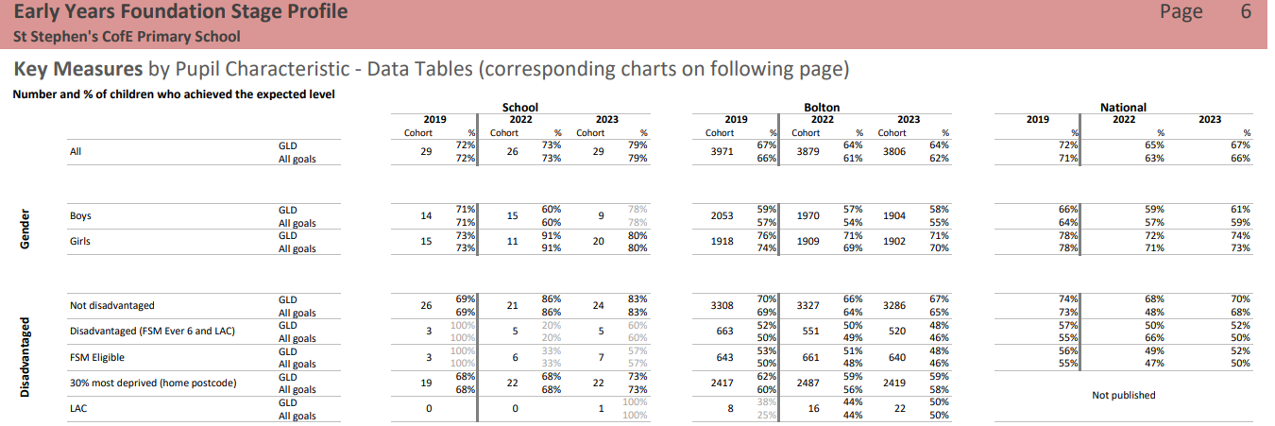
Impact:
30% most deprived continue to outperform Bolton + 14% and National
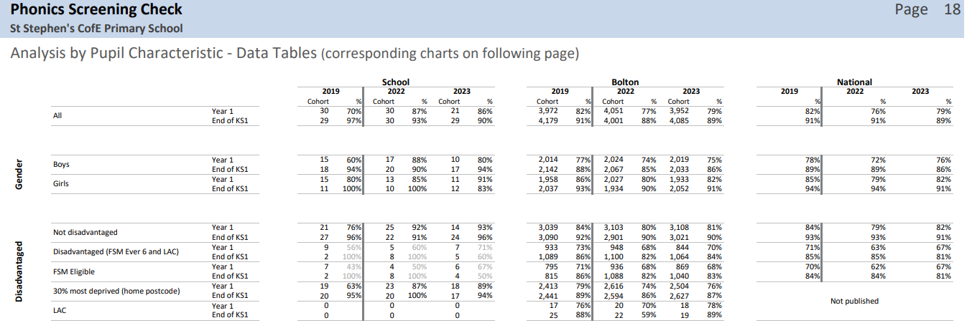
Impact:
30% most deprived continue outperform Bolton +13% and National in Year 1
30% most deprived continue to outperform Bolton +7% and National at end of KS1
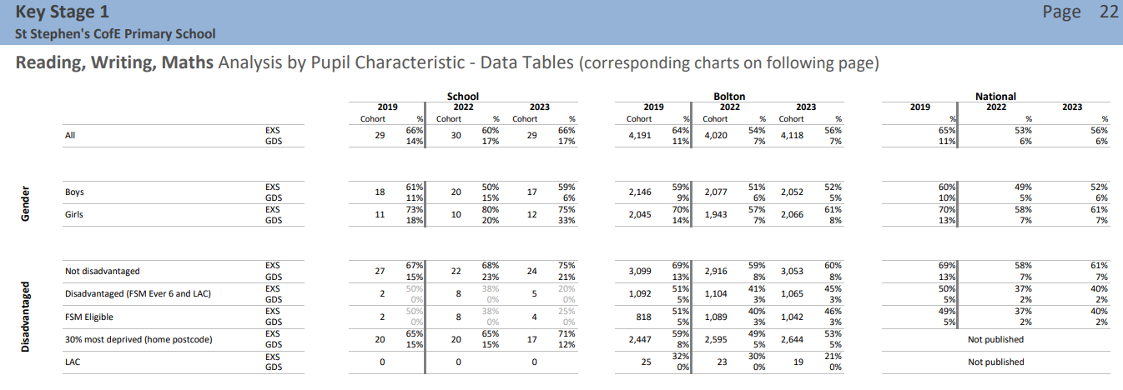
Impact:
30% most deprived continue to outperform Bolton +18% and National at KS1

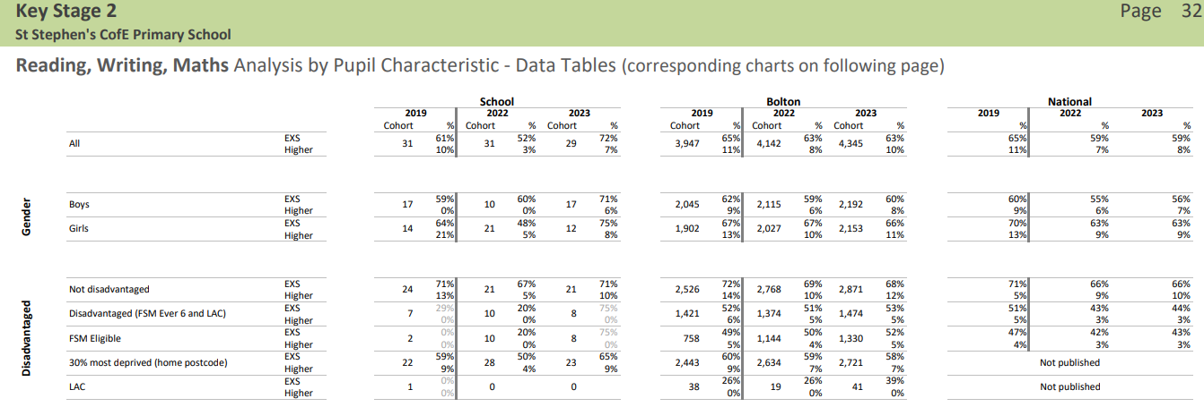
Impact:
30% most deprived continue to outperform Bolton +7% and National at combined KS2 expected +2% Higher level.
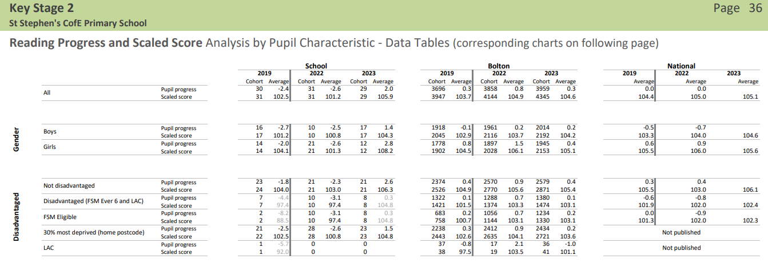
Impact:
30% most deprived outperform Bolton in reading scaled scores and progress is+1.3

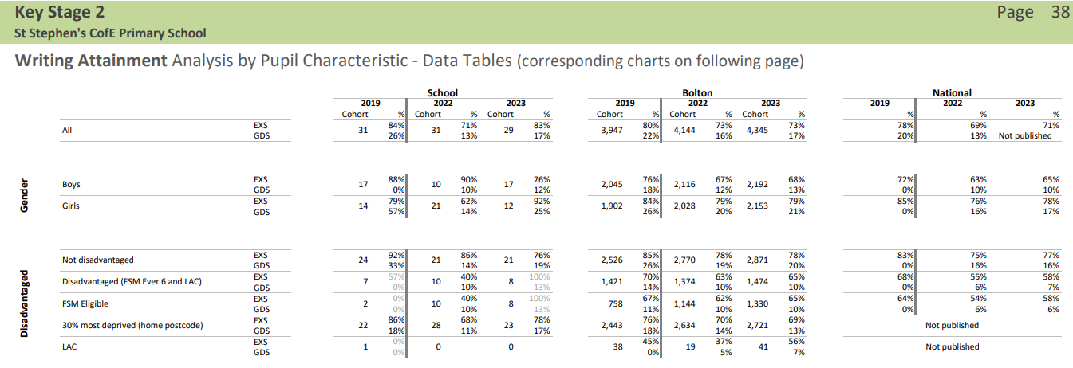
Impact:
Writing :30% most deprived outperform Bolton +9% Expected and +4%at Higher Level
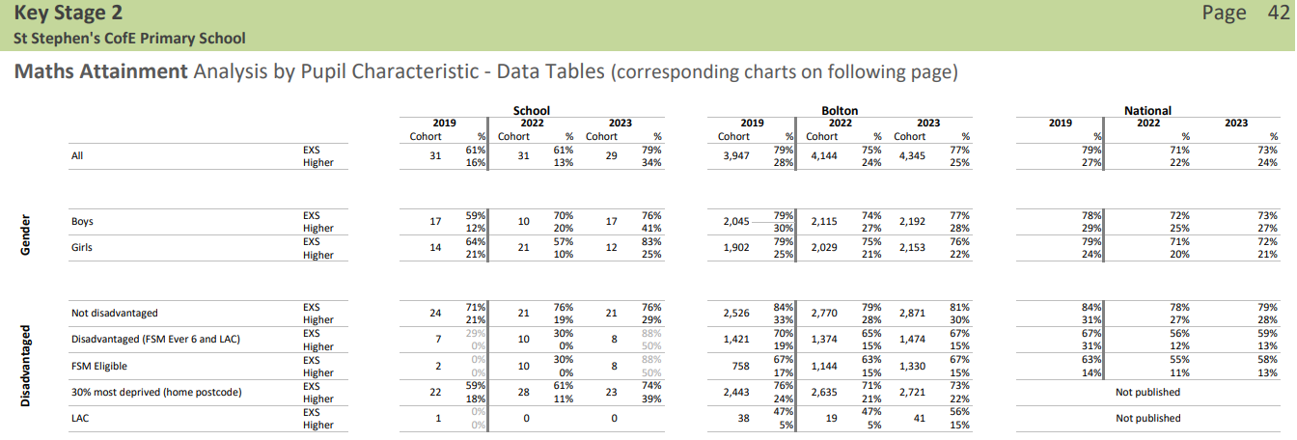
Impact:
Maths: 30% most deprived above Bolton +1%Expected and +17% at Higher level.
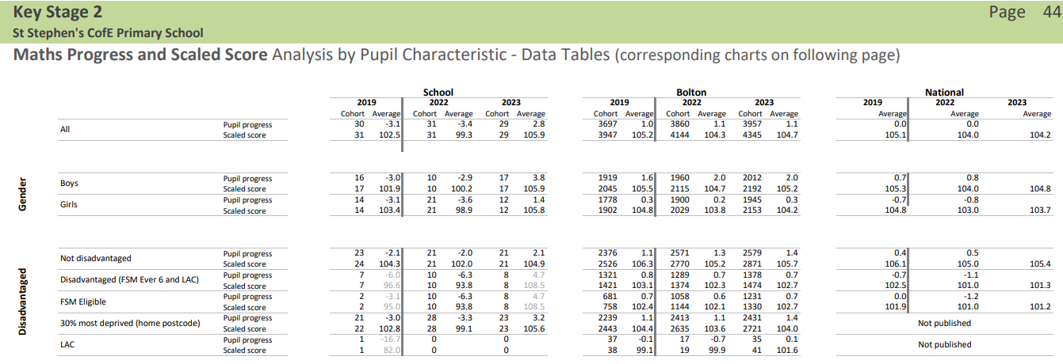
Impact:
Maths progress has rapidly increased for 30%most deprived. +1.8 above Bolton. Scaled score +1.6.
Summary
The above data shows the pupil premium strategy is very effective and school target priorities are achieved.

