Forest School Policy

St Stephen’s (Kearsley Moor)
C E Primary School

Reviewed 2022

Contents
1. Our Aims For Forest School Sessions
2. The Role of the Forest School Leader
3. Health and Safety
4. Behaviour Management
5. Equality and Inclusion
6. Children with Special Needs (SEND)
7. Clothing
8. Hygiene and Food Preparation

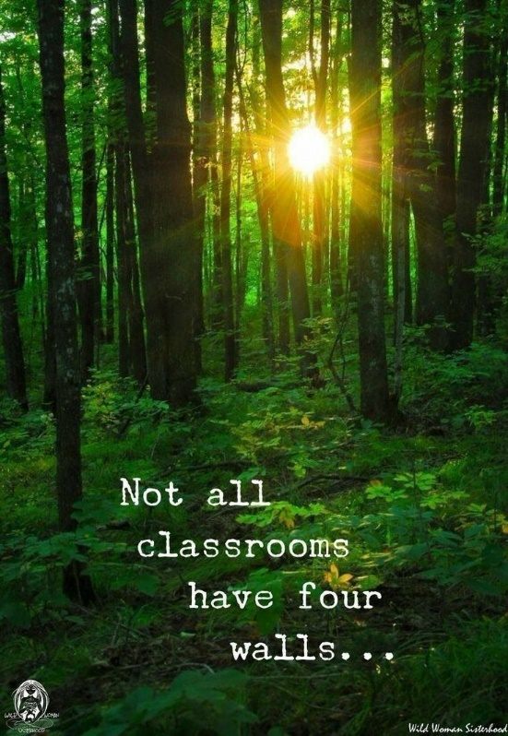

1. Our Aims For Forest School Sessions:
• To celebrate our outdoor space and rich learning that can take place within it.
• For all children to use the outdoor area as a context for learning throughout the year.
• For all children to develop skills and independence in a widening range of environments
• For all children to develop their curiosity and understanding of their physical and human world.
• To provide a safe, stimulating outdoor environment where space is used effectively to enable children to explore a broad and balanced curriculum using a range of interesting resources suitable to their individual needs.
• To raise awareness of environmental issues and encourage children to care for their environment.
• That the children are provided with a range of experiences that help develop key life skills, including personal learning, enquiry and thinking skills.
• For all children to have the opportunity to explore, grow and nurture plants.
• For all children to have the opportunity to engage with imaginative, investigative and creative play using the outdoors.
• That the children are supported in taking risks within a safe and secure environment
• For all pupils to receive a wide range of opportunities to develop socially and emotionally as well as academically through outdoor learning and play.

2. The Role of the Forest School Leader
The Forest School Leader:
• will carry out a detailed safety check prior to each session and comply with the Health and Safety Risk Assessment.
• will carry the welfare/emergency pack at all times.
• is responsible for all equipment and will ensure that it is checked before use and returned to the resource area after use.
• has the responsibility of ensuring all those participating are kept safe at all times.
• will complete accident forms when necessary
• will hold an up to date First Aid certificate.
• will plan and deliver a full and varied programme to KS 1 and 2 as well as liaising with the EYFS team.
• will incorporate a range of different learning styles to promote independence during the activities.
• will maintain a safe environment in order to maximise the learning experience in the woodland setting.
• will ensure that during all Forest School sessions all persons will be treated equally regardless of ability, age, gender, culture or race.
• will ensure all persons will be included in all activities in a nurturing and caring environment.
• will promote the value of working together harmoniously respecting others views and ideas.

3. Health and Safety
• Forest School sessions are to be held on the school field and in the Eco Garden. (Grid Ref-SD 75306 04534 What3Words-allows.bride.person
Postcode-BL4 8PB)
• For each Forest School session the adult to child ratio will be 1: 5.
• A site risk assessment will be carried out prior to each session.
• A general risk assessment, covering all activities, will be written in line with planning and will be reviewed termly.
• The weather will be assessed prior to each session by the Forest School Leader. If extremely windy or cold and it is deemed unsafe eg a storm, the session will be cancelled.
• Appropriate clothing to be worn, eg waterproof trousers, coat, hat, gloves. Parents to be notified prior to the start of a forest school session as to what essential clothing will be needed via Dojo.
• Warm water and soap is available each session for children to wash their hands.
• A member of the Forest School team to carry a mobile phone at all times in case of emergency.

In Case of Injury
• The Forest School Leader will hold an up to date First Aid certificate and will be in charge of first aid arrangements.
• The First Aid kit is to be taken to all sessions and positioned for all adults to see.
• In case of an accident requiring further assistance, the school office will be contacted via mobile phone.
• Emergency contact details, directions and national grid reference for emergency services will be in the First Aid kit.
• In accordance with school procedure an incident/accident form must be completed.
ALL INHALERS/EPI PENS TO BE TAKEN TO WOODLAND AREA FOR FOREST SCHOOL SESSIONS AND ADMINISTERED AS REQUIRED.

During the Forest School Session
• Before staff/volunteers and children leave school a headcount will be taken and throughout the session whilst in the woods.
• Identifying boundaries to Forest School are discussed at the start of each session along with the Forest School guidelines and safety rules.
• If children move to explore hidden areas, an adult should also move into the cover deep enough to be able to see the children but allowing the children the freedom to move independently
Lighting a Fire
• When lighting a fire, the Forest School Leader will take control of the operation and all accompanying adults will be briefed before the start.
• A lit fire will not be left unattended at any point.

• A fire may not be lit until it has been confirmed that all safety equipment is in place.
• All open fires will be built within the ‘Fire Circle’
Picking up and Playing with Sticks
• Children can carry sticks shorter than their arm’s length but are encouraged to think about how close they are to other children. Longer sticks may be dragged or carried with the help of another person when each person is at either end.
• Sticks must not be thrown.
• Sticks must not be pulled from living trees.

4. Behaviour Management
• At St. Stephen’s we are committed to establishing a learning environment in which children develop self-discipline and self-esteem as they take increasing responsibility for themselves and their actions, and as they consider the well-being of others.
• We actively promote positive behaviour, where children are encouraged to treat each other with care and respect.
• Forest School encourages positive behaviour by focusing on activities that require sharing, negotiation and co-operation.
• We encourage responsibility in caring for others and for the environment which includes showing respect to plants, tress and animals.
• We support children’s self-esteem by encouraging them to be successful,

• When children behave in unacceptable ways, we help them to see what is wrong and how to cope more appropriately.
• Children who misbehave are given, where possible, one-to-one adult support in understanding what is wrong and in working towards a more desirable behaviour. • Expectations of behaviour will be set by the Forest School Leader and discussed with the children.
• Children will also help set rules, which will be revisited at every session. These include: ‘No pick, no lick, ‘be careful how you carry a stick’, staying within the designated areas at all times, etc.

5. Equality and Inclusion
During a Forest School session:
• all children and adults will be treated equally regardless of ability, age, gender, culture or race.
• where possible, adjustments will be made to accommodate children with allergies, medical conditions or behavioural issues.
• all children will be included in all activities in a nurturing and caring environment.
• a range of different learning styles will be used to help promote independence during the activities.
• All those participating will be made to feel that their experiences and contributions are worthwhile.
• the value of working together harmoniously will be promoted, respecting others views and ideas.

• Forest School is a child led experience and wherever possible the children will be allowed to follow their own interests providing they show respect for each other and the woodland area.
• inclusion and equality will run through all forest school activities

6. Children with Special Needs (SEND)
As a school, we ensure that all children including those with special needs can participate in forest school sessions as its aim is to provide an appropriate learning opportunity for all children providing an environment in which all children are supported to reach their full potential. This aim complements the whole school policy on Children with Special Needs (SEND), a copy of which can be found on the school website.

7. Clothing For Forest School
Forest School sessions will take place in all weathers unless deemed unsafe by the Forest School Leader.
‘There is no such thing as bad weather, just bad clothing’
Suitable clothing is essential for all to be able to participate.
Children should have:
• Long sleeved t shirt
• Trousers, to reduce the risk of bites, stings and scratches
• Waterproof over trousers or dungarees and jacket (supplied by school if necessary)
• Long socks, wellies or old trainers (in very hot dry weather)
• During the summer, a sunhat and sunscreen should be supplied

• During the colder months, extra layers such as a fleece, leggings, tights, hats and gloves etc. are required.

8. Hygiene and Food Preparation
• Anti-bacterial wet wipes will be available
• During snack time or cooking activities, food hygiene regulations will be strictly adhered to.
• Children will wash hands using hot water and soap and sit in the designated area when consuming any food or drink.
• Drinking water will be supplied.

