Key Vocabulary:

Continent - any of the world's main continuous expanses of land (Europe, Asia, Africa, North and South America, Australia, Antarctica).

Equator - a line notionally drawn on the earth equidistant from the poles, dividing the earth into northern and southern hemispheres and constituting the parallel of latitude 0°.

Pangea - The Earth is 4.5 billion years old. Pangaea was the single continent, which over time broke up into the continents we have today.

Volcano – a mountain or hill, typically conical, having a crater or vent through which lava, rock fragments, hot vapour, and gas are or have been erupted from the earth's crust

Lava - hot molten or semi-fluid rock erupted from a volcano or fissure, or solid rock resulting from cooling of this.

Earthquake - a sudden violent shaking of the ground, typically causing great destruction, as a result of movements within the earth's crust or volcanic action

Seismograph - an instrument that measures and records details of earthquakes, such as force and duration.

Tsunami - a long, high sea wave caused by an earthquake or other disturbance

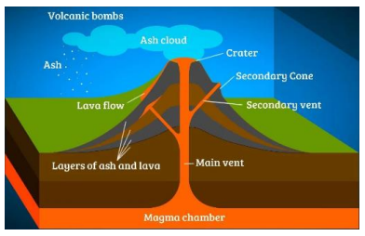

Inside a Volcano

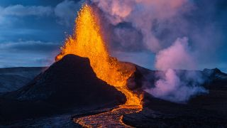

Fagradalsfjall volcano in Grindavik,Iceland

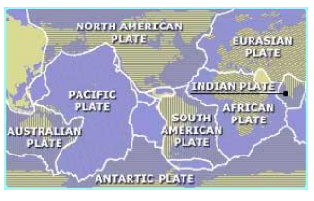Tectonic Plates

Enquiry Questions:

1. What does the Earth look like on the inside?

2. Has our planet always looked the same?

3. What happens along the boundaries of the Earth’s plates?

4. What are volcanoes and what happens when they erupt?

5. What are earthquakes and what happens when they occur?

**Just How Powerful is the Earth?**

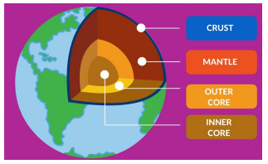The Layers of the Earth

