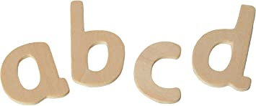 | Read individual letters by saying the sounds for each of them. | 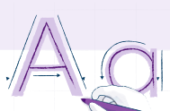 | Write lower-case and capital  letters correctly.
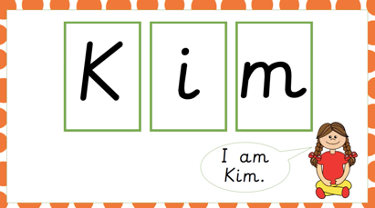 | Blend sounds into words. |  | Read and re-read books to build up their confidence in word reading, fluency, understanding and enjoyment.
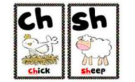 | Read some letter groups that each represent one sound. | 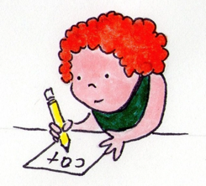 | Spell words by identifying the sounds and then writing the sound with the letter/s.
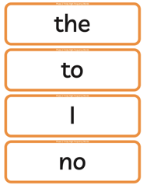  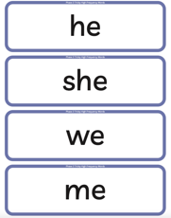 | Read some high frequency tricky words. | 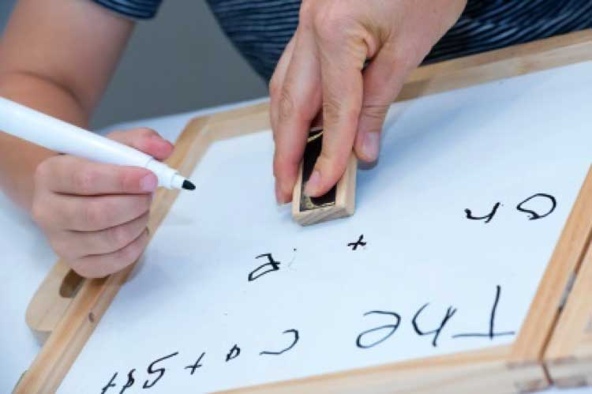 | Write short sentences using a capital letter and a full stop.
 | Read simple phrases and sentences. | 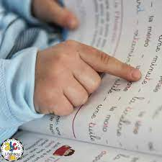 | Re-read what they have written to check that it makes sense.

