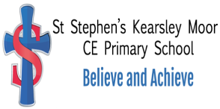

Litter Policy

St Stephen’s (Kearsley Moor)
C E Primary School

Reviewed 2023

ST STEPHEN’S (KEARSLEY MOOR) C E ScHOOL

LITTER POLICY

St Stephen’s (KM) CE Primary School seeks to be a litter free area where the whole school and local community respect the school buildings and site. The school strives to teach respect both for the environment and for the possessions of others both through the curriculum and through the ethos of the school.

It is the aim of the school to work together to keep the school and grounds free from litter and to maintain a sustainable environment for future generations.

Aims
- To provide a clean and healthy environment in which pupils can learn
- To create a litter free environment for staff and pupils
- To recycle waste wherever possible
- To apply these standards outside the school gate to include the area around the school
- To allow all members of the school the right to suggest ways to improve the school environment

Actions
All members of the School Community have a responsibility:
- To not drop litter
- To pick up litter lying around
- To use recycling bins, paper and food, wherever possible
- To assist the Site Manager in maintaining a clean site

All Staff have a collective responsibility:
- To support pupils and help them deal with litter problems
- To use recycling bins for paper and recycle other waste appropriately
- To educate pupils on the consequences of dropping litter

The Eco Team has a responsibility:
- To provide an adequate number of waste bins
- To listen and respond to questions and comments from members of the School Community
- To ensure anti-litter education is part of the school curriculum

