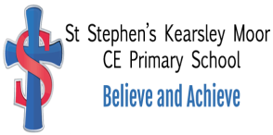

Mathematics Policy

St Stephen’s (Kearsley Moor)
C E Primary School

Reviewed March 2025

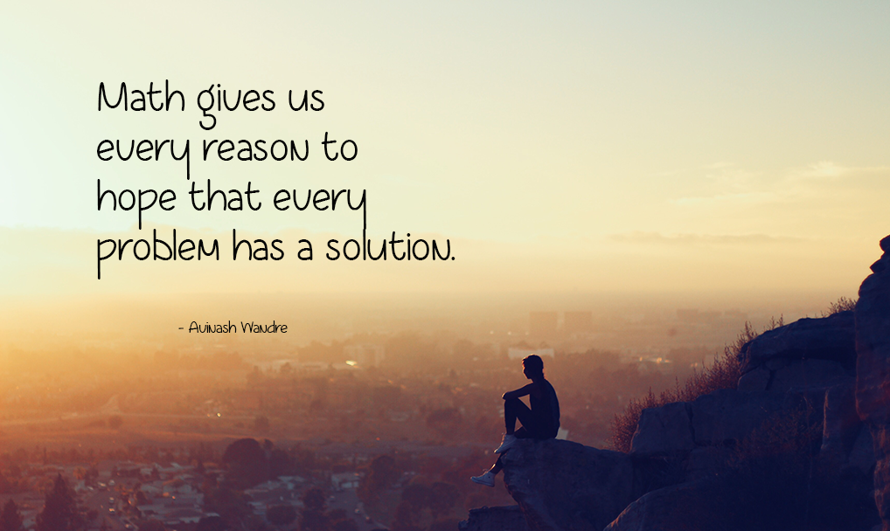

Contents:
Statement of intent
- Legal framework
- Roles and responsibilities
- Early years provision
- The national curriculum
- Cross-curricular links
- Teaching and learning
- Planning
- Assessment and reporting
- Resources
- Special Educational Needs
- Equal opportunities
- Monitoring and review

Statement of Intent
At St. Stephens we intend to provide a Maths curriculum which allows children to reason mathematically through creative and engaging lessons. We want children to make rich connections across mathematical ideas to develop fluency, mathematical reasoning and competence in solving increasingly sophisticated problems. As our pupils progress, we intend for our pupils to be able to understand the world, have the ability to reason mathematically, have an appreciation of the beauty and power of mathematics, and a sense of enjoyment and curiosity of the subject.

Aims
Through the teaching of Mathematics, we aim to:
- develop a positive attitude to maths as an interesting and attractive subject in which all children gain some success and pleasure;
- develop mathematical understanding through systematic direct teaching of appropriate learning objectives;
- develop the children’s mathematical fluency and ability to reason and problem solve;
- encourage the effective use of maths as a tool in a wide range of activities within school and at home and, subsequently, adult life;
- develop an ability in the children to express themselves fluently, to talk about the subject with assurance, using correct age-appropriate mathematical language and vocabulary;
- develop an appreciation of relationships within maths;
- develop the ability to think clearly and logically with independence of thought and flexibility of mind;
- develop an appreciation of creative aspects of maths and awareness of its aesthetic appeal;
- develop mathematical skills and knowledge alongside the quick recall of basic facts.

Objectives
The children will be given the opportunity to:
- Develop the appropriate mathematical language associated with all aspects of the maths curriculum;
- Use and apply mathematics in practical tasks, in real life problems and in acquiring further knowledge, skills and understanding in the subject itself;
- Understand and use the four operations of number in relevant contexts; becoming fluent in the fundamentals of Mathematics.
- Reason mathematically, understanding the relationships between numbers, learn basic number facts and develop a range of computational methods;
- Understand place value in our counting system and understand how it can be extended into numbers below zero;
- Solve problems by applying their mathematics to a variety of routine and non-routine problems with increasing sophistication.
- Collect, interpret and represent data in tabular, graphical and diagrammatic form;
- Develop mental methods of calculation
- Recognise, describe and represent shapes and patterns in terms of their properties, location and movement;
- Measure quantities including length, area, volume/capacity, angle, temperature, time and mass;

1. Legal Framework
This policy has due regard to statutory guidance including, but not limited to, the following:
- DfE (2021) ‘National curriculum in England: Mathematics programmes of study’
- DfE (2021) ‘Statutory framework for the early years foundation stage’
- DfE (2021) ‘Teaching mathematics in primary schools’

2. Roles and Responsibilities
The subject leader is responsible for:
- Preparing policy documents, curriculum plans and schemes of work for the subject.
- Reviewing changes to the national curriculum and advising on their implementation.
- Monitoring the learning and teaching of maths, providing support for staff where necessary.
- Ensuring the continuity and progression from year group to year group.
- Encouraging staff to provide effective learning opportunities for pupils.
- Helping to develop colleagues’ expertise in the subject.
- Organising the deployment of resources and carrying out audits of all maths-related resources.
- Liaising with teachers across all phases.
- Communicating developments in the subject to all teaching staff.
- Leading staff meetings and providing staff members with the appropriate training.
- Organising, providing and monitoring CPD opportunities in the subject.
- Ensuring common standards are met for recording and assessing pupil performance.
- Advising on the contribution of maths to other curriculum areas, including cross-curricular and extra-curricular activities.
- Collating assessment data and setting new priorities for the development of maths in subsequent years.
The classroom teacher is responsible for:
- Acting in accordance with this policy.
- Ensuring progression of pupils’ mathematical skills, with due regard to the national curriculum.
- Planning lessons effectively, ensuring a range of teaching methods are used to cover the content of the national curriculum.
- Liaising with the subject leader about key topics, resources and support for individual pupils.
- Monitoring the progress of pupils in their class and reporting this on an annual basis to parents.
- Reporting any concerns regarding the teaching of the subject to the subject leader or a member of the SLT.
- Undertaking any training that is necessary in order to effectively teach the subject.
The SENCO is responsible for:
- Liaising with the subject leader in order to implement and develop maths throughout the school.
- Organising and providing training for staff regarding the maths curriculum for pupils with SEND.
- Advising staff how best to support pupils’ needs.
- Advising staff on the inclusion of mathematical objectives in pupils’ individual education plans.
- Advising staff on the use of teaching assistants in maths lessons.

3. Early Years Provision
Activities and experiences for pupils will be based on the seven areas of learning and development, as outlined in the DfE’s ‘Statutory framework for the early years foundation stage’.
Provision for early years pupils focusses on the following (but is not limited to):
- Literacy
- Maths
- Understanding the world
- Expressive arts and design
Activities will provide pupils with the opportunity to develop and improve their skills in counting, understanding and using numbers, calculating simple addition and subtraction problems, and describing shapes, spaces and measurements.
All activities will adhere to the objectives set out in the framework.
Children will learn how to:
- Count confidently.
- Develop a deep understanding of the numbers to 10.
- Understand the relationship between numbers and the patterns within those numbers.
- Develop a secure base knowledge of vocabulary from which mastery of mathematics is built.
- Develop their spatial reasoning skills across all areas of mathematics including, shape, space and measures.
- Develop positive attitudes and interests in mathematics.
- Look for patterns and relationships.
- Spot connections.
- Talk to adults and peers about what they notice and not be afraid to make mistakes.

4. The national curriculum
The below demonstrates the ‘ready-to-progress’ criteria across all year groups and is not exhaustive of everything children will learn through the curriculum.

In Year 1, pupils will be taught to:

Number and place value
- Count within 100, forwards and backwards, beginning with any number.
- Reason about the location of numbers to 20 within the linear number system, including comparing using < > and =.
Number facts
- Develop fluency in addition and subtraction facts within 10.
- Count forwards and backwards in multiples of 2, 5 and 10, up to 10 multiples, beginning with any multiple and count forwards and backwards through the odd numbers.
Addition and subtraction
- Read, write and interpret equations containing addition, subtraction and equals symbols, and relate additive expressions and equations to real-life contexts.
- Compose numbers to 10 from two parts and partition numbers to 10 into parts, including recognising odd and even numbers.
Geometry
- Recognise and name common 2D and 3D shapes presented in different orientations and know that rectangles, triangles, cuboids and pyramids are not always similar to one another
- Compose 2D and 3D shapes from smaller shapes to match an example, including manipulating shapes to place them in particular orientations.

In Year 2, pupils will be taught to:

Number and place value
- Recognise the place value of each digit in two-digit numbers, and compose and decompose two-digit numbers using standard and non-standard partitioning.
- Reason about the location of any two-digit number in the linear number system, including identifying the previous and next multiple of 10.
Number facts
- Secure fluency in addition and subtraction facts within 10 through continued practice.
Addition and subtraction
- Add and subtract across 10.
- Recognise the subtraction structure of ‘difference’ and answer questions of the form “How many more?”
- Add and subtract within 100 by applying related one-digit addition and subtraction facts: add and subtract only 1s or only 10s to or from a two-digit number.
- Add and subtract within 100 by applying related one-digit addition and subtraction facts.
- Add and subtract any two-digit numbers.
Multiplication and division
- Recognise repeated addition contexts, representing them with multiplication equations and calculating the product, within the 2, 5 and 10 multiplication tables.
- Relate grouping problems where the number of groups is unknown to multiplication equations within a missing factor, and to division equations.
Geometry
- Use precise language to describe the properties of 2D and 3D shapes, and compare shapes by reasoning about similarities and differences in properties.

In Year 3, pupils will be taught to:

Number and place value
- Divide 100 into 2, 3, 5 and 10 equal parts and read scales/number lines marked in multiples of 100 with 2, 4,5 and 10 equal parts.
Number facts
- Secure fluency in addition and subtraction facts that bridge 10, through continued practice.
- Recall multiplication facts and corresponding division facts, in the 10, 5, 2, 4 and 8 multiplication tables, and recognise products in these multiplication tables as multiples of the corresponding number.
- Apply place-value knowledge to known additive and multiplicative number facts.
Addition and subtraction
- Calculate complements to 100.
- Add and subtract up to three-digit numbers using columnar methods.
- Manipulate the additive relationship:
  - Understand the inverse relationship between addition and subtraction and how both relate to the part-part-whole structure.
  - Understand and use the commutative property of addition, and understand the related property for subtraction.
Multiplication and division
- Apply known multiplication and division facts to solve contextual problems with different structures, including quotative and partitive division.
Fractions
- Interpret and write proper fractions to represent one or several parts of a whole that is divided into equal parts.
- Find unit fractions of quantities using known division facts.
- Reason about the location of any fraction within one in the linear number system.
- Add and subtract fractions with the same denominator, within one.
Geometry
- Recognise right angles as a property of shape or a description of a turn, and identify right angles in 2D shapes presented in different orientations.
- Draw polygons by joining marked points and identify parallel and perpendicular sides.

In Year 4, pupils will be taught to:

Number and place value
- Know that 10 hundreds are equivalent to 1 thousand and that 1,000 is 10 times the size of 100 and apply this to identify and work out how many 100s there are in other four-digit multiples of 100.
- Recognise the place value of each digit in four-digit numbers using standard and non-standard partitioning.
- Reason about the location of any four-digit number in the linear number system including identifying the previous and next multiple of 1,000 and 100, and rounding to the nearest of each.
- Divide 1,000 into 2, 4, 5 and 10 equal parts and read scales/number lines marked in multiples of 1,000 with 2, 4, 5 and 10 equal parts.
Number facts
- Recall multiplication and division facts up to 12 x 12 and recognise products in multiplication tables as multiples of the corresponding number.
- Solve division problems, with two-digit dividends and one-digit divisors, that involve remainders and interpret remainders appropriately according to the context.
- Apply place-value knowledge to known additive and multiplicative number facts.
Multiplication and division
- Multiply and divide whole numbers by 10 and 100 and understand this as equivalent to making a number 10 or 100 times the size.
- Manipulate multiplication and division equations and understand and apply the commutative property of multiplication.
- Understand and apply the distributive property of multiplication.
Fractions
- Reason about the location of mixed numbers in the linear number system.
- Convert mixed numbers to improper fractions and vice versa.
- Add and subtract improper and mixed fractions with the same denominator, including bridging whole numbers.
Geometry
- Draw polygons, specified by coordinates in the first quadrant and translate within the first quadrant.
- Identify regular polygons, including equilateral triangles and squares, as those in which the side-lengths are equal and the angles are equal.
- Find the perimeter of regular and irregular polygons.
- Identify line symmetry in 2D shapes presented in different orientations.
- Reflect shapes in a line of symmetry and complete a symmetric figure or pattern with respect to a specified line of symmetry.

In Year 5, pupils will be taught to:

Number and place value
- Know that 10 tenths are equivalent to 1 one and that 1 is 10 times the size of 0.1.
- Know that 100 hundredths are equivalent to 1 one and that 1 is 100 times the size of 0.01.
- Know that 10 hundredths are equivalent to 1 tenth and that 0.1 is 10 times the size of 0.01.
- Recognise the place value of each digit in numbers with up to 2 decimal places and compose and decompose numbers with up to 2 decimal places using standard and non-standard partitioning.
- Reason about the location of any number with up to 2 decimal places in the linear number system, including identifying the previous and next multiple of 1 and 0.1 and rounding to the nearest of each.
- Divide 1 into 2, 4, 5 and 10 equal parts, and read scales/number lines marked in units of 1 with 2, 4, 5 and 10 equal parts.
- Convert between units of measures including using common decimals and fractions.
Number facts
- Secure fluency in multiplication table facts and corresponding division facts, through continues practice.
- Apply place-value knowledge to known additive and multiplicative number facts.
Multiplication and division
- Multiply and divide numbers by 10 and 100 and understand this as equivalent to making a number 10 or 100 times the size or 1 tenth or 1 hundredth times the size.
- Find factors and multiples of positive whole numbers, including common factors and common multiples and express a given number as a product of 2 or 3 factors.
- Multiply any whole number with up to four digits by any one-digit number using a formal written method.
- Divide a number with up to 4 digits by a one-digit number using a formal written method and interpret remainders appropriately for the context.
Fractions
- Find non-unit fractions of quantities.
- Find equivalent fractions and understand that they have the same value and the same position in the linear number system.
- Recall decimal fraction equivalents for , , and , and for multiples of these proper fractions.
Geometry
- Compare angles, estimate and measure angles in degrees and draw angles of a given size.
- Compare areas and calculate the area of rectangles using standard units.

In Year 6, pupils will be taught to:

Number and place value
- Understand the relationship between powers of 10 from 1 hundredth to 10 million and use this to make a given number 10, 100, 1,000, 1 tenth, 1 hundredth or 1 thousandth times the size.
- Recognise the place value of each digit in numbers up to 10 million, including decimal fractions, and compose and decompose numbers up to 10 million using standard and non-standard partitioning.
- Reason about the location of any number up to 10 million, including decimal fractions, in the linear number system and round numbers, as appropriate, including in contexts.
- Divide powers of 10, from 1 hundredth to 10 million, into 2, 4, 5 and 10 equal parts and read scales/number lines with labelled intervals divided into 2, 4, 5 and 10 equal parts.
Addition, subtraction, multiplication and division
- Understand that 2 numbers can be related additively or multiplicatively and quantify additive and multiplicative relationships.
- Use a given additive or multiplicative calculation to derive or complete a related calculation, using arithmetic properties, inverse relationships and place-value understanding.
- Solve problems involving ratio relationships.
- Solve problems with 2 unknowns.
Fractions
- Recognise when fractions can be simplified and use common factors to simplify fractions.
- Express fractions in a common denomination and use this to compare fractions that are similar in value.
- Compare fractions with different denominators, including fractions greater than 1, using reasoning, and choose between reasoning and common denomination as a comparison strategy.
Geometry
- Draw, compose and decompose shapes according to given properties, including dimensions, angles and area and solve related problems.

5. Cross Curricular Links
Wherever possible, the maths curriculum will provide opportunities to establish links with other curriculum areas.
English
Mathematics contributes significantly to the teaching of English in our school by actively promoting the skills of reading, writing, speaking and listening.
Mathematical terminology is used, where appropriate. Maths-based texts are sometimes used in English lessons and in reading sessions.
Science
Pupils’ data collection and analysis skills are further developed through the conduction of physical experiments, using units of measurement, calculating averages and interpreting results.
Pupils record their finding using charts, tables and graphs.

History and Geography
In history and geography children will collect data by counting and measuring and make use of measurements of many kinds. The study of maps includes the use of co-ordinates and ideas of angle, direction, position, scale and ratio. The pattern of the days of the week, the calendar and recurring annual festivals all have a mathematical basis. For older children historical ideas require understanding of the passage of time, which can be illustrated on a time line, similar to the number line that they already know
Computing
The effective use of ICT can enhance the teaching and learning of mathematics when used appropriately. When considering its use, we consider the following points:

- Computing should enhance good mathematics teaching. It should be used in lessons only if it supports good practice in teaching mathematics;
- Any decision about using Computing in a particular lesson or sequence of lessons must be directly related to the teaching and learning objectives for those lessons;
- Computing should be used if the teacher and/or the children can achieve something more effectively with it than without it.
Examples of how mathematics is used alongside computing include data handling (including making and interpreting graphs & charts), using algorithms, working on debugging, sequencing and logistical steps based tasks.

Art
Measurements are often needed in art. Many patterns and constructions are based on spatial ideas and properties of shapes, including symmetry. Designs may need enlarging or reducing, introducing ideas of multiplication and ratio.
Design and Technology
In Design & Technology children often need mathematical skills such as measuring, symmetry and multiplication. When a food unit is taught timings, costs and workings out must be precise to ensure the product is made correctly with little to none surplus ingredients/materials. Children continually use their mathematics knowledge through Design and Technology and therefore use their skills in practical real-life problems. This encourages the children to gather and recall their problem-solving skills in order to achieve the best outcome.

Physical Education
Athletic activities require measurement of height, distance and time, while ideas of counting, time, symmetry, movement, position and direction are used extensively in dance, gymnastics and ball games.
Music
Music lessons provide children with opportunities to count, recognise units of time and patterns. Children use their understanding of number to count the beats when listening to and creating music. They use their knowledge of pattern to perform music in time with music and others. Children who learn a musical instrument gain an understating of how fractions of time are represented through different musical notations.
MFL
The teaching of modern foreign languages provides many opportunities for children to demonstrate their knowledge of different areas of mathematics. Children learn to count in Spanish and use their knowledge of number to help them with number recognition and patterns. They also learn the days of the week, months of the year along with learning how to tell the time and working with shapes.
Forest Schools
During Forest School sessions children are reliant upon their mathematical knowledge and skills. Activities include a variety of mathematical aspects including, but not limited to,
- Number recognition - use of equipment, instructions, cooking methods,
- Counting- no. of children/ trees/birds/ legs on bugs etc. and lots of counting action songs,
- Measurement- trees/ each other/ leaves/ ropes/ cooking ingredients/ den tarps/ potion making
- Ratios- making the perfect mud mixture
- Estimating/prediction
- Mapwork /Co-ordinates
- Positions- making a den for teddy to hide in/under etc
- Patterns and shapes in nature
- Time- seasons

Personal, Social and Health Education (PSHE) and Citizenship
At St. Stephens we follow the SCARF scheme of work for PSHE. Within KS1 lessons opportunities are provided for children to work with money and different units of time (days, months). Children also experience placing events into chronological order. Within KS2 children develop their ability to use money and use their knowledge of money to solve problems within a practical context.

6. Teaching and Learning
Pupils will be taught to describe key characteristics and associated processes in common language, as well as understand and use technical terminology and specialist vocabulary.
Pupils will undertake independent work, and have the opportunity to work in groups and discuss work with fellow classmates.
Lessons will allow for a wide range of mathematical, enquiry-based research activities, including the following:
- Questioning, predicting and interpreting
- Pattern seeking
- Collaborative work
- Problem-solving activities
- Classifying and grouping
Lessons will involve the use of a variety of sources, including data, statistics, graphs and charts.
The classroom teacher, in collaboration with the subject leader, will ensure that the needs of all pupils are met by:
- Setting tasks which can have a variety of responses.
- Providing resources of differing complexity, according to the ability of the pupils.
- Setting tasks of varying difficulty, depending on the ability group.
- Utilising teaching assistants to ensure that pupils are effectively supported.
A maths mastery approach is taken to the curriculum, in which fluency comes from deep knowledge and practice. This means that structured questioning is used to ensure that pupils develop fluent technical proficiency and think deeply about the underpinning mathematical concepts.
Focus is put on the development of deep structural knowledge and the ability to make connections, with the aim of ensuring that what is learnt is sustained over time.
The school does not prioritise between technical proficiency and conceptual understanding, and we aim to develop these in parallel.

7. Planning
Throughout the school, maths is taught as a daily lesson following the age appropriate White Rose scheme of work (4 days per week), and as part of cross-curricular themes when appropriate. The fifth maths lesson has a focus on developing number knowledge, fluency and confidence (Fluency Day). These lessons are planned to included White Rose objectives, but to also ensure a constant re-visiting of key number facts. Each class is responsible for timetabling the four White Rose lessons and Fluency lesson.
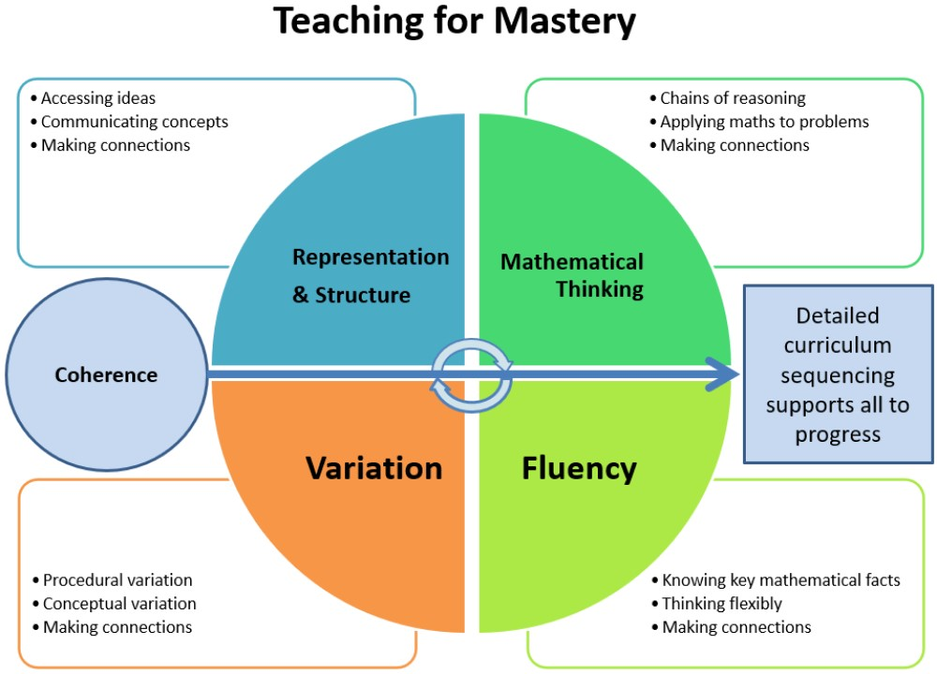

St. Stephens follows the White Rose scheme of work which has a focus on Teaching for Mastery.

What is fluency?
Fluency comes from deep knowledge and practice. This is the first stage of a pupil’s understanding.
Fluency includes conceptual understanding, accuracy, rapid recall, retention and practice.
Once children have developed mathematical fluency they start to apply to through reasoning and problem-solving tasks.
What is reasoning?
Reasoning demonstrates that the pupils understand the mathematics and can explain how an answer has been reached. Talk is an integral part of mastery as it encourages children to reason, justify and explain their thinking.
What is problem solving?
Problem solving allows children apply existing knowledge and skills to answer unfamiliar types of problems.

Teachers will use the plans included in the White Rose scheme of work and adapt them to suit the children’s needs. The ‘Small Steps’ are followed to ensure learning is built on and developed.

Lesson plans will demonstrate a balance of interactive and independent elements used in teaching, ensuring that all pupils engage with their learning. There will be a clear focus on direct, instructional teaching and interactive oral work with the whole class and targeted groups.

Long-term planning is used to outline the units to be taught within each year group.
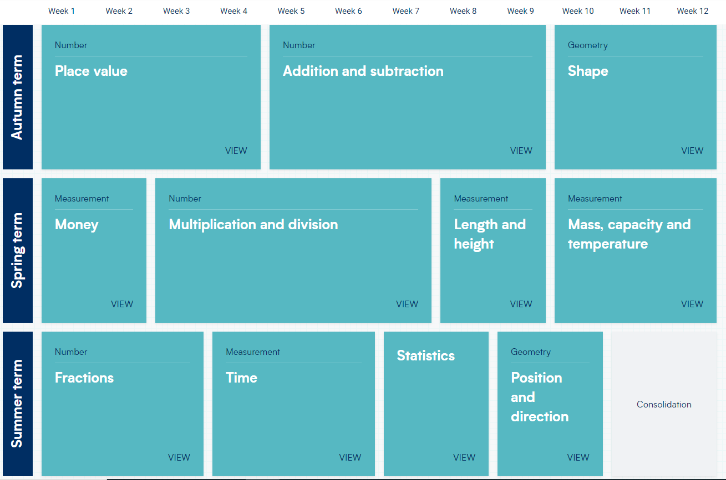

Example of how a long term plan maps out the units for a year group.

Medium-term planning is used to outline the vocabulary and skills that will be taught in each unit of work, along with identifying learning objectives, main learning activities and differentiation.

Short-term planning is used flexibly to reflect the objectives of the lesson, the success criteria and the aims of the next lesson. Short-term planning is the responsibility of the teacher. This is achieved by building on their medium-term planning, taking into account pupils’ needs and identifying the method in which topics could be taught.
All lessons will have clear learning objectives which have been taken from the Small Steps within a unit of work.
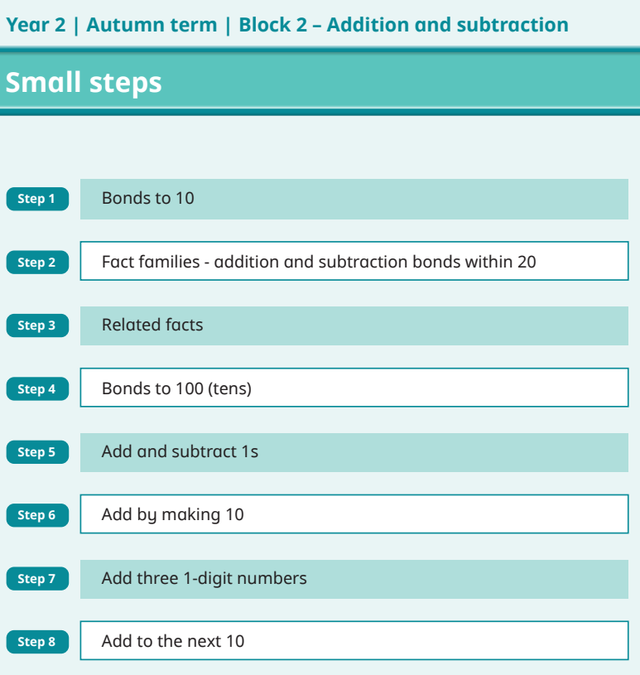

Example of how a unit of work is broken down into a sequence of steps, all of which build on prior learning.

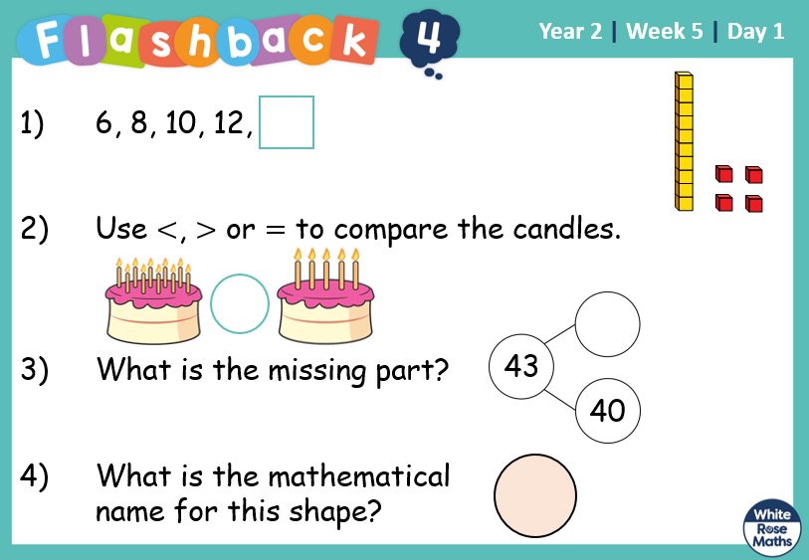

In addition to a daily maths lesson, Years 1- 6 complete Flashback 4 activities. These contain a mixture of questions based on different aspects of the maths curriculum. The aim being to help develop the children’s ‘sticky knowledge’.

All classes follow the White Rose calculation policy which has a concrete, pictorial, abstract (CPA) approach.
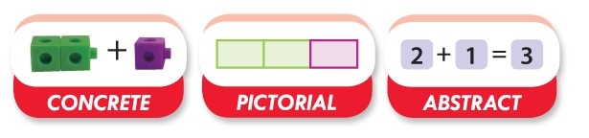

Homework in Years 1 – 6 will be set on a weekly basis and will provide more opportunities to apply previously taught areas of mathematics. Year 4 have a focus purely on times tables facts to help prepare them for the Multiplication check. Homework goes home on a Wednesday and is marked as a class the following Wednesday. This allows any mistakes and misconceptions to be modelled by the teacher.
Homework in the EYFS includes counting and learning rhymes to support in class learning. Sometimes, when appropriate, this is evidenced in the children’s Busy Books.

8. Assessment and Reporting
Pupils will be assessed and their progression recorded in line with the school’s Assessment, Reporting and Recording Policy.
An EYFS Profile will be completed for each pupil in the final term of the year in which they reach age five.
The progress and development of pupils within the EYFS is assessed against the early learning goals outlined in the ‘Statutory framework for the early years foundation stage’.
Throughout the year, teachers will plan on-going creative assessment opportunities in order to gauge whether pupils have achieved the key learning objectives.
Assessment will be undertaken in various forms, including the following:
- Talking to pupils and asking questions
- Discussing pupils’ work with them
- Marking work against the learning objectives
- Pupils’ self-evaluation of their work
- Classroom tests and formal exams
Formative assessment, which is carried out informally throughout the year, enables teachers to identify pupils’ understanding of subjects and inform their immediate lesson planning.

Summative assessments are carried out at the end of each term. Years 1 – 6 use the age appropriate Rising Stars assessments. Once these have been marked, the children’s scores are inputted into MARK and then used to update the children’s Pupil Progress reports. These are then shared with SLT and the Learning Mentor to identify any areas of concern and plan interventions and support where needed.
Children in Year 2 and Year 6 are also given the opportunity to experience SATs papers. These are completed when deemed appropriate by the class teachers.
At the end of every unit of work the children will complete the White Rose assessment for that unit. This is then used to identify any particular objectives which may need re-visiting.
Parents will be provided with a written report about their child’s progress during the Summer term every year. These will include information on the pupil’s attitude towards maths, understanding of mathematical terminology, investigatory skills and the knowledge levels they have achieved.
Verbal reports will be provided at parent-teacher interviews during the Autumn and Spring terms.
The progress of pupils with SEND will be monitored by the SENCO.

9. Resources
The subject leader is responsible for the management and maintenance of maths resources, as well as for liaising with the SBM in order to purchase further resources.
Maths resources will be stored in each classroom.
Resources which are not required regularly, and those in relation to key whole-school topics, will be stored in the Teacher’s Room.
Display walls will be utilised and updated regularly, in accordance with the area of maths being taught at the time.
Maths equipment and resources will be easily accessible to pupils during lessons.
The subject leader will undertake an audit of maths equipment and resources on an annual basis.

10. Special Educational Needs
At St Stephens we aim to provide a broad and balanced education to all children. Effective tracking enables identification of children who may benefit from early ‘intervention’ at an appropriate level. Wherever possible we aim to fully include SEND children in the daily mathematics lesson so that they benefit from the emphasis on oral and mental work and by listening and participating with other children in demonstrating and explaining their methods. Where necessary teachers will, in consultation with the SENCO, draw up a Support Provision Map for a child. If a child's needs are particularly severe they will work on an individualised programme written in consultation with the appropriate staff. Through planning teachers will address the child's needs through simplified or modified tasks or by the use of support staff and resources. We also recognise, and aim to make provision for, children who have a particular ability in mathematics. They can be extended through differentiated work, to use and apply mathematics and to solve problems.

11. Equal Opportunities
In accordance with the school’s Equal Opportunities Policy, all pupils will have equal access to the maths curriculum.
Gender, learning ability, physical ability, ethnicity, linguistic ability and/or cultural circumstances will not impede pupils from accessing all maths lessons.
Where it is inappropriate for a pupil to participate in a lesson because of reasons related to any of the factors outlined above, the lessons will be adapted to meet the pupil’s needs and alternative arrangements involving extra support will be provided where necessary.
All efforts will be made to ensure that cultural and gender differences will be positively reflected in all lessons and teaching materials used.
The school aims to provide academically more able pupils with the opportunity to extend their mathematic thinking through extension activities such as reasoning and problem solving, investigative work and research of a mathematic nature.

12. Monitoring and Review
This policy will be reviewed on an annual basis by the subject leader.
The subject leader will monitor teaching and learning in the subject at St. Stephens, ensuring that the content of the national curriculum is covered across all phases of pupils’ education.
A named member of the governing body is briefed to oversee the teaching of numeracy, and meets regularly with the subject leader to review progress.
Any changes made to this policy will be communicated to all teaching staff.

