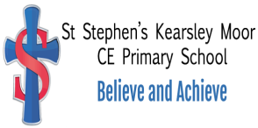

Music Policy

St Stephen’s (Kearsley Moor)
C E Primary School

Reviewed 2023

ST STEPHEN’S (KEARSLEY MOOR) C E ScHOOL

MUSIC POLICY

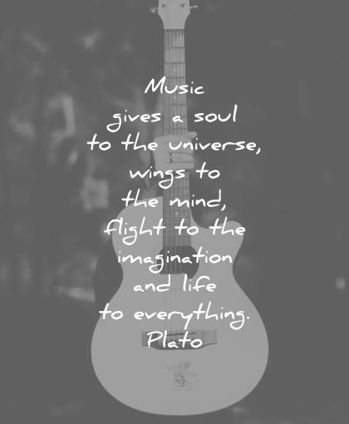

General Statement
Music is an important part of life in St Stephen’s. It is used in most subject in some form and is also taught explicitly in each class.
Intent
Aims
Through the teaching of music we aim to:
- To develop aesthetic sensitivity and creative ability in all children.
- To provide opportunities to promote spiritual, moral, social and cultural development.
- To foster children’s sensitivity to, and understanding and enjoyment of, Music through an active involvement in performing, composing, listening and appraising.
Statutory Requirements
Statutory requirements for the teaching and learning of Music are laid out in the National Curriculum Document (2014) and The Early Years Framework (2012).
Objectives
To develop :-

- performing skills - controlling sounds through singing and playing.
- composing skills - creating and developing musical ideas.
- appraising skills - responding and reviewing.
- listening and applying knowledge and understanding.

Children of all levels of ability should be able to develop these skills and capacities, gain understanding of musical elements and realise their creativity by engaging in musical activities in a planned and structured way.
Implementation

Musical elements are the materials out of which any piece of music may be formed:-

Pitch, Duration, Dynamics, Tempo, Timbre, Texture, Structure

Music is taught in Key Stage 1 by class teachers with access to Oak Academy to aid and supplement their teaching.

Breadth of Study
Pupils should be taught the knowledge, skills and understanding through :-

- a range of musical activities that integrate performing, composing and appraising.
- responding to a range of musical and non-musical starting points.
- working on their own, in groups of different sizes and as a class.
- using ICT to capture, change and combine sounds.
- a range of live and recorded music from different times and cultures.

Children’s understanding and enjoyment of music should be developed through the interrelated skills of performing, composing and appraising.

Links with Other Curriculum Areas
Music has close links with Dance and Movement. It also features prominently through school worship and performances. Music provides opportunities to develop the key skills of communication, application of number, use of ICT and Science. It involves working with others, improving own learning and performance and problem solving.

Resources
A Catalogue of Artefacts has been compiled for all resources. Instruments are inspected and replaced as required and several new instruments have been purchased, providing a range of instruments for the children to experience and use.

Special Educational Needs
Basic skills should be revisited regularly in order to assist those children who experience difficulty in regard to Music.

Children who are potentially very able in Music need to be identified in time to allow their ability to develop and flourish. A responsibility remains with the teacher to identify and to make special provision for these children.

Some pointers to exceptional potential include:-

- "Getting it right" first time
- Exceptional quickness in memorising music
- An instinctive rhythmic perception
- The possession of an acute sense of pitch
- A spontaneous and authentic creative impulse in performing and composing, making exceptionally fast progress in those areas.
- Exceptional and sustained inner motivation for making music
- Exceptional affinity to an instrument
- An individual expressive personality
- A high level of musical activity carried on out of school

Impact

Music is valued at St Stephen’s School by staff and pupils and standards in music are good. This is demonstrated in the use of termly assessments by our specialist music teacher (see assessment policy) and is made up of observations of pupils, recording of work (performances) and questioning. Pupil voice shows that children enjoy music, have an age appropriate grasp of concepts and technical vocabulary and some of developed hobbies around this outside of school.
Role of the subject leader
The Music subject leader is responsible for improving the standards of teaching and learning in Music through:
- Monitoring of lessons, learning environments
- Auditing and supporting colleagues in their CPD
- Purchasing and organising resources
- Keeping up to date with recent Music developments

Assessment
At the end of each Term class teachers and Musioc specialist will assess the children’s ability and decide if each is working towards, working at the expected level or working at a greater depth. They will then submit their teacher’s assessment to the subject leader.

Equal Opportunities
All children are to be treated equally and be given equal opportunity to achieve their full potential.

Musical Activities

EYFS/Key Stage 1
In and Key Stage 1, children are given the opportunity to sing and play instruments to aid their learning across all learning. They also lead the school Easter assembly.
The EYFS and key Stage 1 teachers follow the Oak Academy scheme of Learning. This enables the children to learn the specific vocabulary and musical techniques in preparation for KS2 curriculum led by Minshull music.
Key Stage 2
In Key Stage 2, pupils are given the opportunity to learn to play a brass instrument provided by Minshall Music Ltd. This company also provide opportunities outside of school for children in the school choir.

In Key stage 2 we provide a brass scholarship of private lessons for 5 Pupil Premium children who are showing a keen interest or high potential in playing a brass instrument. These are delivered by our Music Specialist at Minshall Music.

The children have also benefited from opportunities to experience the work of other musicians and vocalists.

A varied selection of music is played in Assembly each day. This includes music from different times and cultures, by well known composers and performers past and present.
The children are encouraged to listen carefully, developing an understanding of the music. The children are encouraged to respond and learn about the music.

A School Choir has been established open to any child in Key Stage 2 who is interested in singing.
The Choir are developing well musically and are encouraged to attend training days outside school, accompanied by the staff. On these occasions, they can meet children from other schools, singing with a massed choir, under the direction of choral experts.

They also provide an opportunity to perform in an auditorium before a large audience. The choir attend the Young Voices concerts https://www.youngvoices.co.uk/

Young Voices has staged the largest children's choir concerts in the world. Over 2 million children have taken part in a Young Voices concert and we believe passionately in inspiring the next generation to find their love for music.
Each night, between 5,000-8,000 children perform as a single choir to a sold-out audience of family and friends.

The School Choir performs regularly, contributing to Church Services and Assemblies. They have also recently performed on the wards at Bolton Hospital and in the local supermarket.

