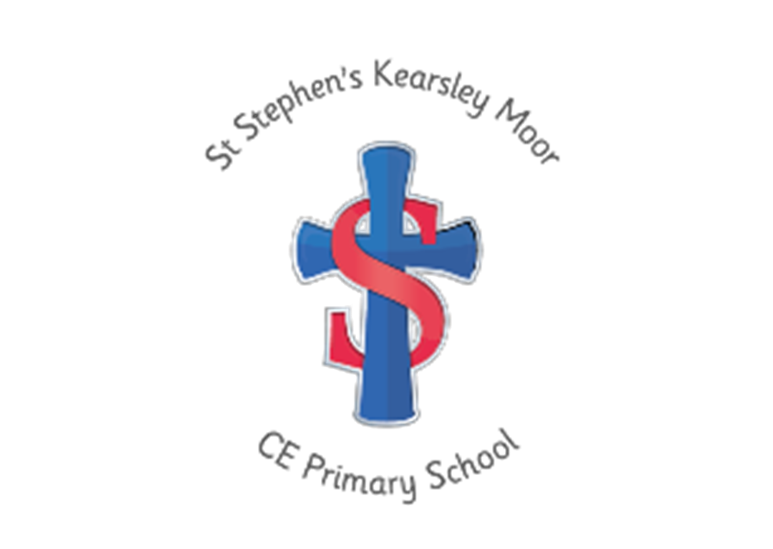
Welcome to the Early Years Foundation Stage at St Stephen’s
Welcome to St Stephen’s
We are glad you have chosen our school and hope your child is happy here and makes good progress to become a trusted, valued member of our family. We hope that you, as parents, enjoy the time you are connected with school. During the first few years of your child’s life, you have been the teacher. You have taught him/her to walk and talk – two of the most vital areas of our development. So, with your help we hope to continue that good work and build upon the strong foundations you have laid down.
Starting school should be an exciting adventure for both children and parents. If you have a positive approach and make sure your children are able to help themselves as much as possible, then starting school should be a pleasurable experience for us all.
Children can worry about seemingly small things and if we can sort that worry out between us, they will be much more relaxed and receptive to the new ideas of school. There are many ways that you, as parents, can help to make starting school easier for your children and we hope this booklet will support their transition to our school.



Meet Our Early Years Team
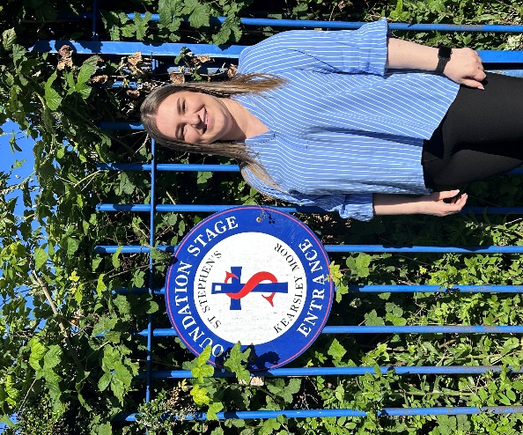
Miss Wild
Class Teacher
EYFS Lead

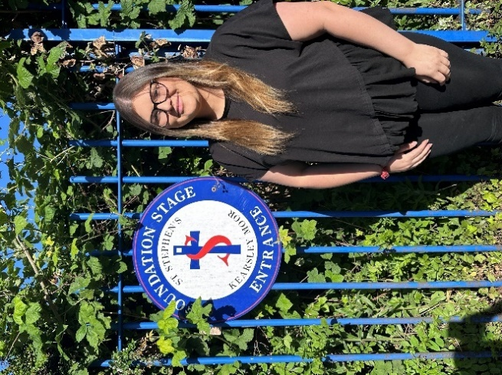
Miss Smith
Teaching Assistant

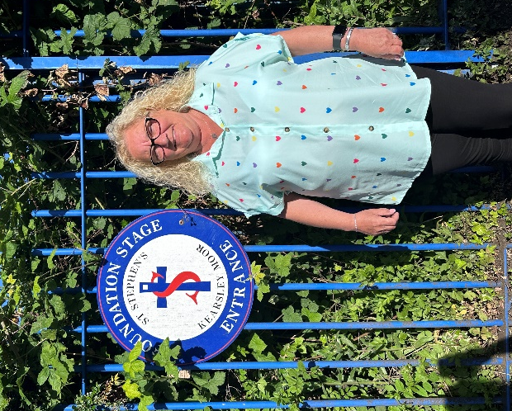
Mrs Leach
School Meal Supervisor

The Early Years Foundation Stage
At St Stephen’s we believe no job is more important than working with children in the Early Years.
We use Development Matters to help design an effective Early Years curriculum which enables us to build on the strengths and meet the needs of all the children we work with.
Our Curriculum consists of everything we want the children to experience, learn and be able to do. It also meets the requirements of the statutory framework for the Early Years Foundation Stage (EYFS).
There are four guiding principles which shape our Early Years, these are:
- Every child is a unique child, who is constantly learning and can be resilient, capable, confident and self-assured.
- Children learn to be strong and independent through positive relationships.
- Children learn and develop well in enabling environments with teaching and support from adults, who respond to their individual interests and needs and help them to build their learning over time. Children benefit from a strong partnership between parents and/or carers.
- Importance of learning and development. Children develop and learn at different rates.
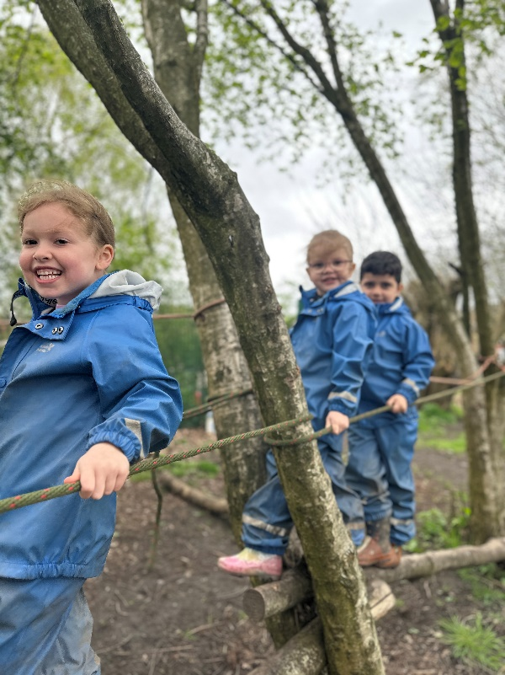
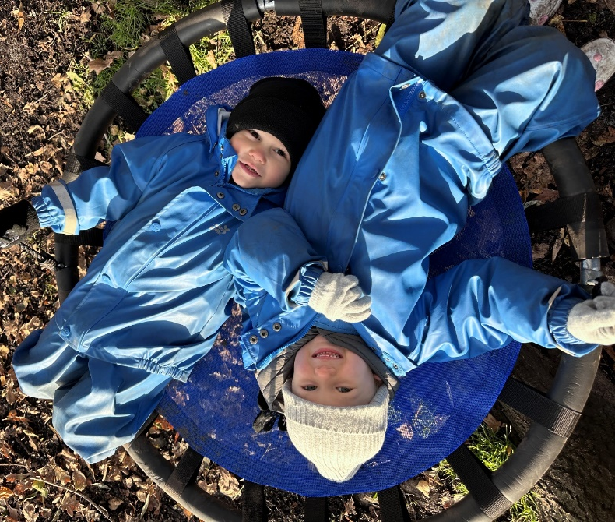
Learning and Development in the Early Years

The EYFS framework outlines the learning and development requirements which structure our Early Years and enables our children to build good stable foundations, ensuring they are ready for Year 1.
There are seven areas of learning and development, all of which are important and inter-connected:
Prime Areas:
These are important for building children’s curiosity, enthusiasm for learning, forming relationships and thriving.
Communication and Language | Physical Development | Personal, Social and Emotional Development
Specific Areas:
These are important for children’s life-long love of reading, developing a deep understanding of maths, making sense of the world around them and developing an artistic and cultural awareness.
Literacy | Mathematics | Understanding the World | Expressive Arts and Design
For each of these areas there is an Early Learning Goal (ELG’s).
This is the level of development which children are expected to achieve by the end of their year with us in Reception at the end of the EYFS.
These goals set out by the EYFS statutory framework and support us in making a holistic judgement in our children’s development and readiness for Year 1 (see the goals on the next page in more detail).
All parents will receive information on a regular basis about your child’s development. This may be through a Parents’ Evening or discussed at the end of the school day. In July, parents will be informed if your child has achieved the Early Learning Goal in an end of year report.
Early Learning Goals
In EYFS we often refer to children’s progress at the end of Reception as Good Level of Development (GLD).
This means at the end of Reception your child has achieved the Early Learning Goal’s (ELG’s) in the prime areas stated previously, including Literacy and Mathematics.
Throughout your child’s time here at St Stephen’s, staff will assess your child’s development against observational checkpoints guided by Development Matters. This enables us to gauge the specific needs of your child, how they learn best and what they need to continue to making good developmental steps.

What Does This Mean For My Child?
When discussing each child’s development, we will use the terms “ON TRACK” and “NOT ON TRACK”.
ON TRACK – Your child has achieved the Early Learning Goals. They are ready for their next journey in Year 1 and will access the National Curriculum for KS1.
NOT ON TRACK – Your child is still working towards the Early Learning Goals. They will continue on their journey in Year 1 and will access specific parts of the Early Years Framework.
They may have a particular identified need or may be close to reaching the expected level.
If your child is NOT ON TRACK, staff will have communicated this with yourself prior to any meetings e.g., Parents’ Evenings.
We will work closely together to ensure we can provide what your child needs to be able to achieve the best outcomes for them.

What Does Being “On Track” Look Like?
Here are the statutory Early Learning Goals for each area of development which your child will be assessed on and should be expected to achieve at the end of their journey with us in Reception.

Communication and Language
Listening, Attention and Understanding:
- Listen attentively and respond to what they hear with relevant questions, comments and actions when being read to and during whole class discussions and small group interactions
- Make comments about what they have heard and ask questions to clarify their understanding
- Hold conversation when engaged in back-and forth exchanges with their teacher and peers
Speaking:
- Participate in small group, class and one-to-one discussions, offering their own ideas, using recently introduced vocabulary
- Offer explanations for why things might happen, making use of recently introduced vocabulary from stories, non-fiction, rhymes and poems when appropriate
- Express their ideas and feelings about their experiences using full sentences, including use of past, present and future tenses and making use of conjunctions, with modelling and support from their teacher
Personal, Social and Emotional Development
Self-Regulation:
- Show an understanding of their own feelings and those of others, and begin to regulate their behaviour accordingly
- Set and work towards simple goals, being able to wait for what they want and control their immediate impulses when appropriate
- Give focused attention to what the teacher says, responding appropriately even when engaged in activity, and show an ability to follow instructions involving several ideas or actions
Managing Self:
- Be confident to try new activities and show independence, resilience and perseverance in the face of challenge
- Explain the reasons for rules, know right from wrong and try to behave accordingly
- Manage their own basic hygiene and personal needs, including dressing, going to the toilet and understanding the importance of healthy food choices
Building Relationships:
- Work and play cooperatively and take turns with others
- Form positive attachments to adults and friendships with peers
- Show sensitivity to their own and to others’ needs

Physical Development
- Gross Motor Skills:
- Negotiate space and obstacles safely, with consideration for themselves and others
- Demonstrate strength, balance and coordination when playing
- Move energetically, such as running, jumping, dancing, hopping, skipping and climbing
Fine Motor Skills:
- Hold a pencil effectively in preparation for fluent writing- using the tripod grip in almost all cases
- Use a range of small tools, including scissors, paint brushes and cutlery
- Begin to show accuracy and care when drawing
Literacy
Comprehension:
- Demonstrate understanding of what has been read to them by retelling stories and narratives using their own words and recently introduced vocabulary
- Anticipate – where appropriate – key events in stories
- Use and understand recently introduced vocabulary during discussions about stories, non-fiction, rhymes and poems and during role-play

Word Reading:
- Say a sound for each letter in the alphabet and at least 10 digraphs
- Read words consistent with their phonic knowledge by sound-blending
- Read aloud simple sentences and books which are consistent with their phonic knowledge, including some common exception words

Writing:
- Write recognisable letters, most of which are correctly formed
- Spell words by identifying sounds in them and representing the sounds with a letter or letters.
Write simple phrases and sentences which can be read by others
Mathematics
Number:
- Have a deep understanding of number to 10, including the composition of each number
- Subitise (recognise quantities without counting) up to 5
- Automatically recall (without reference to rhymes, counting or other aids) number bonds up to 5 (including subtraction facts) and some number bonds to 10, including double facts.
Numerical Patterns:
- Verbally count beyond 20, recognising the pattern of the counting system
- Compare quantities up to 10 in different contexts, recognising when one quantity is greater than, less than or the same as the other quantity
- Explore and represent patterns within numbers up to 10, including evens and odds, double facts and how quantities can be distributed equally.

Parents in Partnership
Throughout the EYFS we understand children do not all take the same path in their learning; each child learns at a different rate and in a way which is unique to them.
In the first term, assessments will be carried out. This will indicate where your child is in their development and allows us to be sensitive towards individual needs. These assessments are carried out regularly throughout the year.
We truly pride ourselves on our working partnership with parents/carers. We realise children spend a greater amount of time at home than they will spend in school with us. Together, we are accountable for your child’s development and with this in mind we have enclosed an initial assessment for your child’s social and emotional development (ASQ – Ages and Stages Questionnaire). Please carry this out at home in a relaxed environment and respond with complete honesty to the scenarios given.
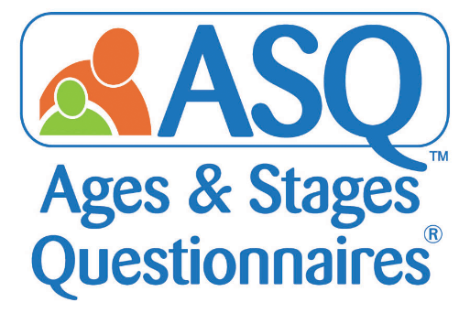

This will need to be returned to the school office along with all other completed forms by Wednesday ^{1st} July.
Parents’ Evenings
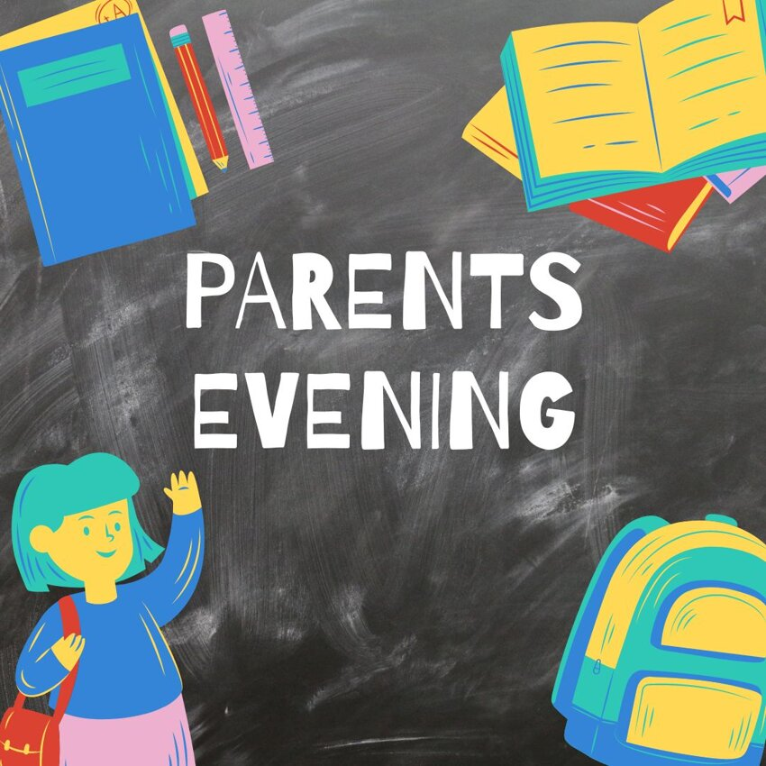
At St Stephen’s we enjoy sharing each child’s progress with parents/carers. At several points throughout the year there will be opportunities for staff and parents to come together and talk about your child’s development and learning.
This may include, Parents’ Evening, Stay and Play sessions and updates via our school Dojo App.
On some occasions it may be an informal chit-chat at a transition time such as dropping off in the morning or picking up at home time, where general conversations may lead to staff sharing a special moment or a moment of pride about your child from that day.

Class Dojo

Dojo is our whole school online learning portal where we will share precious moments with family members.
Dojo allows you to upload pictures and videos onto your child’s individual learning profile. You will also be able to view and comment on any “WOW” moments we upload onto your child’s profile.
We will update you regularly on the class story with kind reminders, upcoming events and share our achievements and celebrations.
Dojo also has a messaging facility which enables you to contact us via a message.

Other family members can have access to your child’s online portfolio too. Please ask a member of the Reception Team if you wish to add additional adults, such as, grandparents.
Please note, however, for safeguarding purposes, we kindly ask you DO NOT take screen shots of any photographs on Dojo and post them on Social Media.
Inside this pack is a dojo code for you to join our new Reception class.
This code will expire, please join before ASAP.
For display only

Learning Journey

In order to track your child’s progress & development throughout the areas, we provide the children with an individual Learning Journey. It is made up of photographs, anecdotes and evidence of independent and adult led activities including any “WOW” moments and achievements. These will be shared with you via your child’s Dojo profile, which can be accessed via a tablet, phone or computer.
In addition, you may access the School Website:
www.ststephenskearsley.co.uk
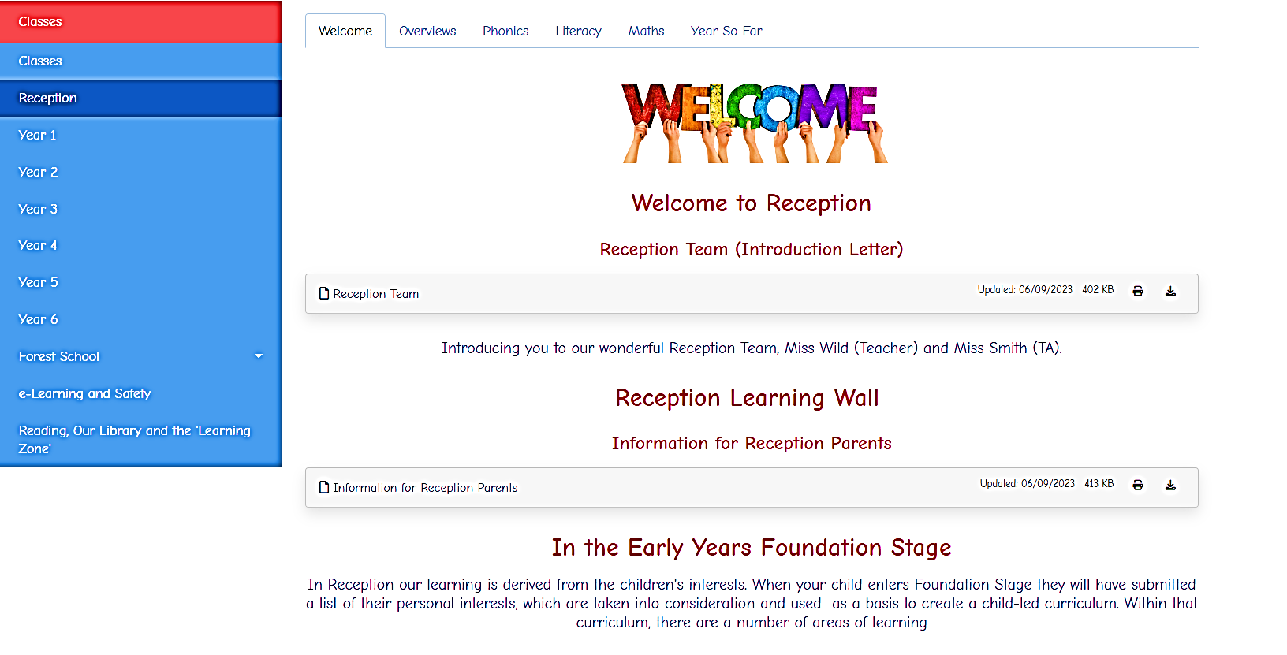
Where you will find out lots of information both about the school and about Reception Class. We also upload our memorable moments onto the website under ‘Year So Far’, accessible from our Reception class page on the website.
Outdoor Learning in EYFS
Learning through our natural environment is a key part in the curriculum we offer at St Stephen’s. We believe children reach their maximum potential through first-hand experiences and real-life learning.
Forest School
Forest School is our outdoor classroom. We intertwine Forest School with our learning, to provide enhanced experiences for children to develop through the real world.
All children access Forest School on a weekly basis where we learn to look after nature, learn vital outdoor skills, develop our confidence and self-esteem in a woodland environment.
Forest School provides our children with the freedom to use rope swings, climb trees, scale balancing beams through trees, building fires and dens and to ignite their natural curiosity and imagination.
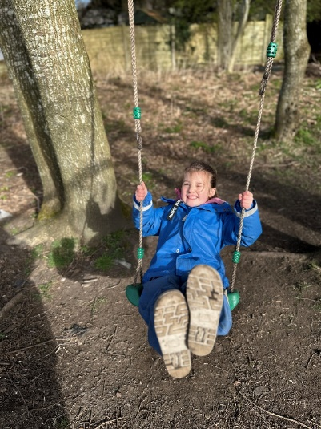
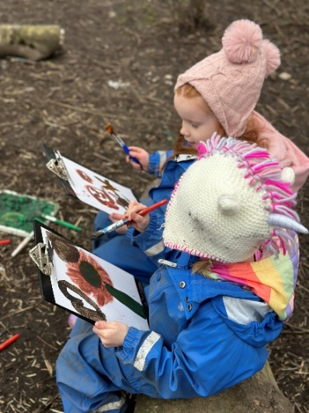
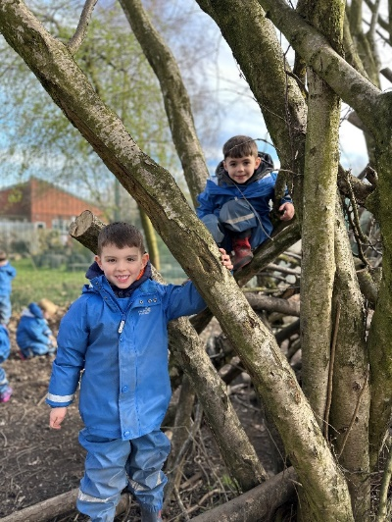
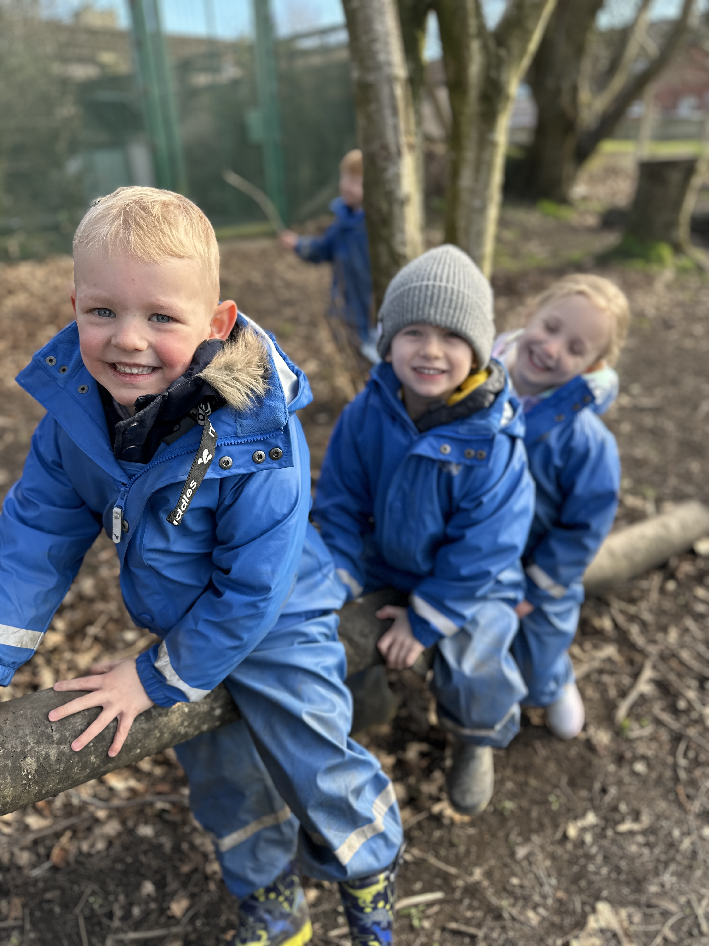All children will be required to bring a pair of wellies into school in the first half term, with their name clearly labelled inside.
These will then stay in school throughout the year.
The blue waterproof dungarees and coat suits are provided by school, you may want to purchase a thin waterproof coat that will fit underneath the suit.

Snack Time
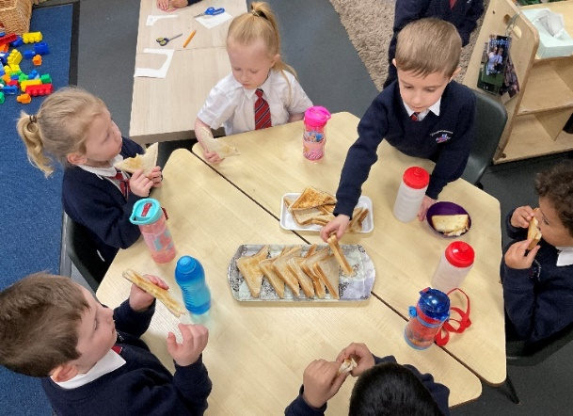
In Early Years the children have access to snack. The snack is created and sometimes prepared with the children. Snack time plays an important role in many aspects of our personal and social learning. For this reason, we expect all children to participate. Children who are 4 years old will receive free school milk until their 5th birthday. The cost of snack is £10.00 payable half termly. Currently this is a cash only payment.
This is payable to a member of the Reception Team on the gate.
We will ensure children with any dietary requirements are also included.
Dinner Time
Lunch times in a bigger environment can cause anxieties for some children. We will be using part of our transition induction programme to introduce your child to the School Hall. This is so the EYFS team and dinner staff will have time to alleviate any worries.
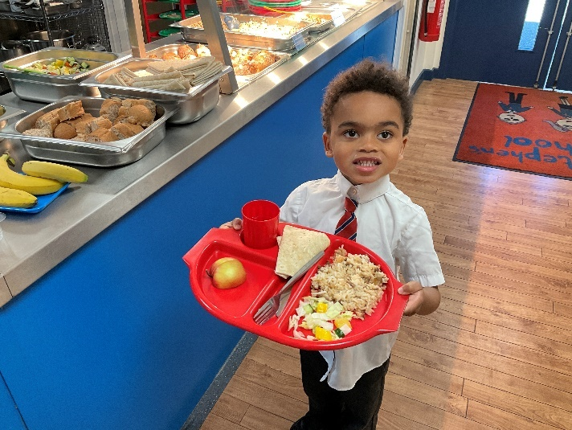
We find when children eat together they are better at trying unfamiliar foods. We recommend every child begins on free school meals at first, after all they are FREE!
At St Stephen’s we are flexible in our approach to dinners and offer plenty of options to suit all children.
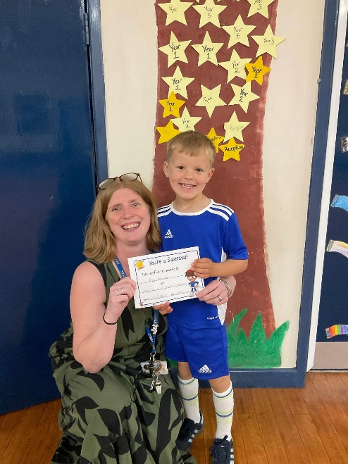

Star of the Week
Every week a ‘Star of the Week’ is chosen for a variety of reasons. Their names are announced during our Celebration Assembly which takes place on Fridays. We also celebrate any wonderful pieces of work created throughout the week on our WOW Table.
Mountaineers Club
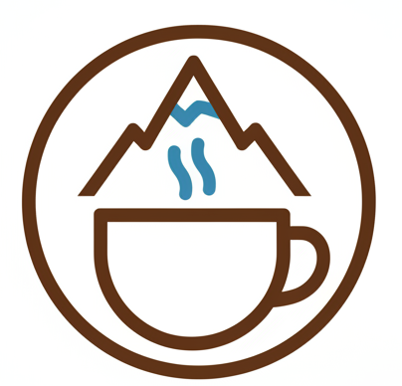
Our Mountaineers club recognises those children who have tried their best all week, been a Good Samaritan, a Super Learner and had Brilliant Behaviour.
All children who are eligible for Mountaineers Club have their names put into a hat and the child who has their name drawn out has the opportunity to have a drink, a few biscuits and a chinwag with our Headteacher on a Friday.
They are joined by a Mountaineer from each class and these children are able to spend some time sharing their week with each other.

Medical Conditions
If your child has a medical condition, please make sure we are fully aware of its implications.
If your child suffers from asthma, please provide us with a prescribed inhaler and large spacer. A parent or carer will need to sign a permission letter at the School Office authorising staff to administer the medication when required.

If for any reason your child has to take medication during school hours, please note we are only able to administer prescribed medicine with a dosage of four times a day at lunch time. Permission to administer the medicine must be signed at the School Office.




Our First Week at School

In order to welcome your child into the St Stephen’s family, we feel it is beneficial for the children to get to know their Key Worker colour group.

Yellow Group | Red Group
Chiara  Isabella  Antonio  Sofia  Logan | Jovanna  Brayden  Hurr  Theo H  Fizza
Green Group | Blue Group
Solomon  Lilah  Areen  James | Theo S  Roman  Ernie  Ellie  Ada

From Wednesday 2nd September your child will attend school full time. You may drop your child at school between 8.40 am and 8.55 am and collect them from the Early Years gate at 3.10 pm. We look forward to welcoming you. If you have any queries please do not hesitate to contact us.

A Day in Reception Class
08.40 am | Gates are opened and children are welcomed into class
09.00 am | Phonics Session
09.30 am | Children choose an area of provision to learn in (Outside and Inside)
11.20 am | Topic Session
11.45 am | Dinner & Playground
1.00 pm | Relaxing, Registration and Toothbrushing
1.10 pm | Maths Session
1.30 pm | Children choose an area of provision to learn in (Outside and Inside)
2.40 pm | Carpet Time
2.55 pm | Story time, Songs & Rhymes
3.10 pm | Home Time  Children are collected from the same gate they are dropped off at.

Throughout the year we begin to integrate into Worship Assemblies, Church and more whole school events.

School Uniform
Boys | Girls
Navy jumper with school logo on. | Navy jumper or cardigan with school logo
Grey school trousers or shorts | Grey pinafore dress/skirt/trousers
White shirt (short sleeve) | White blouse (short sleeve)
School tie (available from school office) | School tie (available from school office)
 | Tights (when worn) should be Grey or black.
Black shoes (no trainers) | Black shoes (no trainers)
School Logo Book Bag (Velcro fastening only)  No rucksacks | School Logo Book Bag (Velcro fastening only)  No rucksacks
 | Blue Chequered Summer Dress
PE Kit | PE Kit
Navy shorts | Navy shorts
House coloured t-shirt | House coloured t-shirt
Velcro trainers | Velcro trainers
Navy tracksuit with school logo | Navy tracksuit with school logo
Children DO NOT need a P.E Bag unless you want to buy one to put spare clothes inside, in case of any possible toileting accidents.
Forest School | Forest School
Named wellies  Thin waterproof coat for underneath our blue suit. | Named wellies  Thin waterproof coat for underneath our blue suit.
All hair accessories should be Red or Blue.
At St Stephen’s we are very proud of how smart we look. Our uniform consists of the following items, all of which are available from Ziggy’s Schoolwear, 6 Brackley Street, Farnworth (01204 577211)
Please label all uniform with your child’s name as we cannot be responsible for locating clothing which is un-named.
Your child will not start P.E lessons until after October Half Term.
Miss Wild will give you enough notice for buying P.E kit nearer the time.
School Trips and Experiences
To extend the children’s learning, we like to take the children on a variety of experiences beyond the classroom.
You will be informed of any forthcoming events and asked to sign a permission slip and return to school along with payment. Alternatively, you may pay and give consent online using our online payment system MCAS. You will receive an invitation via email to register an account in September.
Please note that without your consent, we are unable to take your child out of school.
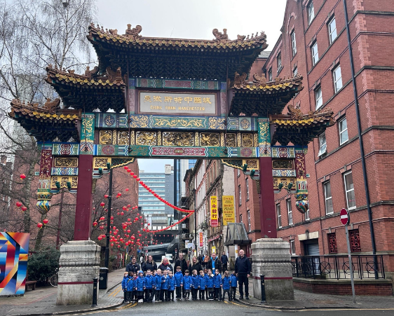
Payment and permission slips should be handed to a member of staff in a named envelope.
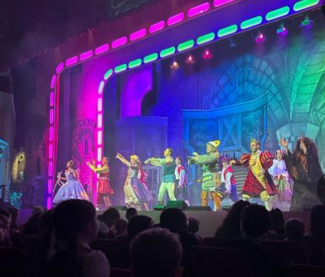

China Town
Pantomime
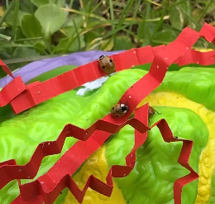
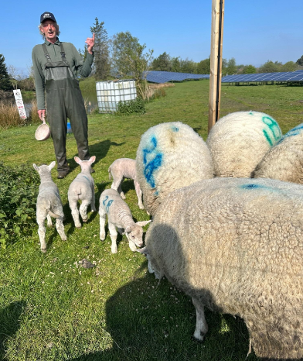
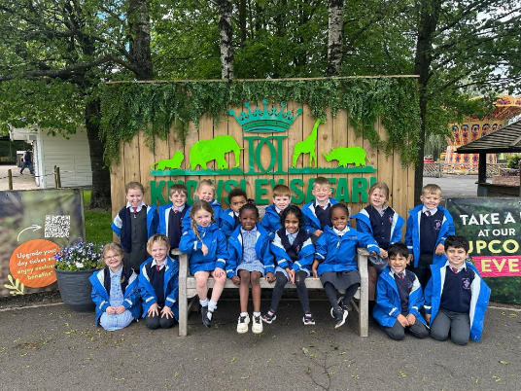
Visiting our local farm
Safari Park / Zoo
Looking after Ladybirds
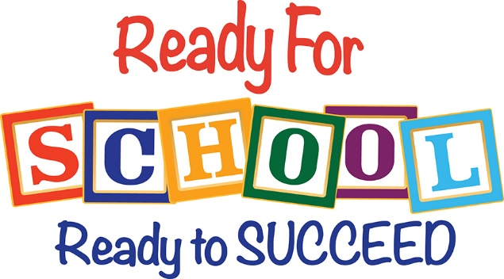
Getting Ready for School
Visiting our local farm
What you will need...
- Uniform – all pieces labelled please
- Coat – with a loop for hanging and identifiable tag on the zip. Always send a coat into school, even when the weather is warm as the Reception outdoor area is in the shade
- Book Bag (Velcro fastening) – just for reading book, blue book and home link activities – no water bottles to be put inside bags.
- Identifiable tag/key ring of your choice for your child’s book bag
- PE kit, including tracksuit. Your child will come to school dressed in their PE kit on PE days.
- Named Lunch Boxes – cubes or cuboids shapes are best if possible
- Named wellies – to be kept on our welly rack for outdoor play
- Spare clothes (if your child needs) – this can be kept in a draw string bag, spare underwear, socks, bottoms, in case of an accident.
- A water bottle - with your child’s name clearly labelled (we get lots of the same bottle).
5 Things to Practise Before September
- Taking shoes off and putting them back on the correct way around – velco shoes only please.
- Zips and buttons on coats/cardigans.
- Using a knife and fork, drinking with a cup.
- Going to the toilet, wiping and then washing hands – your child should be independent using the toilet as much as possible. However, we understand accidents happen from time to time.
- Encourage your children and show them how to do things, rather than doing things for them.

Learning at Home
We expect our children to read regularly at home and for them to complete their ‘Busy Book’ tasks weekly.
Busy Books
These activities generally coincide with our topic learning. Therefore, it is important the activities are completed and returned to school on time.
The Busy Book is sent home on Friday and needs to be returned on the following Thursday and placed in the box provided outside the Reception gate.



My Busy Book
Library Books
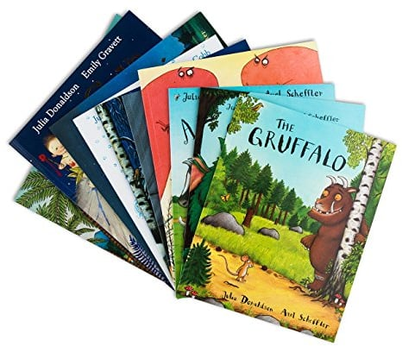
As part of our Library Lending service children will be able to borrow a book. This is usually done during time spent with their Buddy.
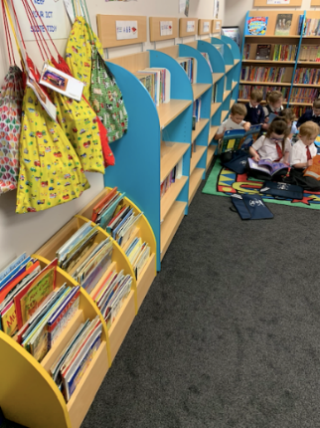
Please note, if you do not return your book on the specified day, your child may have to wait until the next week to change their book.

Reading
Reading Record Book
This book is an important record of your child’s progress at home and school. It must be signed and dated whenever your child has attempted to read.
We will check and change books at least once a week.
If you have any queries, please do not hesitate to write in the Reading Record Book or come into class.

Remarkable Readers
We take part in a whole school ‘Love of Reading’ scheme, whereby children earn a raffle ticket for reading three or more times each week. This is entered into our termly competition where the chosen ticket winners receive a cash prize to spend on quality language rich books.

When is the Best Time to Read with my Child?
- There is no set time or place
- It is important this is a quiet time for you to share with your child
- Choose a time when there aren’t other things your child wants to do
- Give lots of praise, don’t nag or the experience will not be enjoyable
- Encourage other adults to read with your child, or even older siblings who have enough phonic knowledge to help
- Don’t expect your child to read the full book – a few pages at a time is the best way to learn

Wellcomm
Wellcomm is a toolkit designed to help early years settings identify children from six months to six years old who may be experiencing delays with speech and language. It can then be used to put immediate interventions into place while waiting for a more formal assessment.
During the first four weeks we will assess your child using the Wellcomm tool kit.


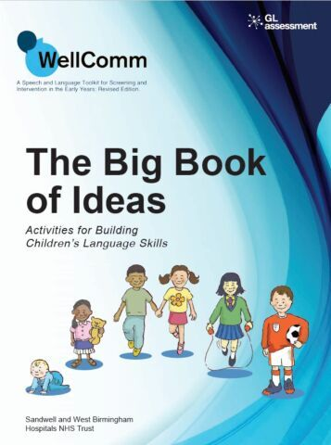
This gives us a good understanding of your child’s communication and language skills. It will allow us to tailor activities to your child’s individual needs if required.

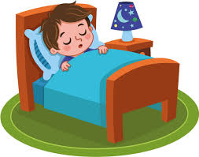
Sleep & Routines
According to a new study, children of all ages fall asleep faster if they have not been staring at a screen in the two hours prior to bedtime – and this adds up to an extra hour of sleep during a school week.

Children need significantly more sleep than adults to support their rapid mental and physical development.

“Sleep is so important in order to ensure that children can meet their full potential in every aspect of their lives”

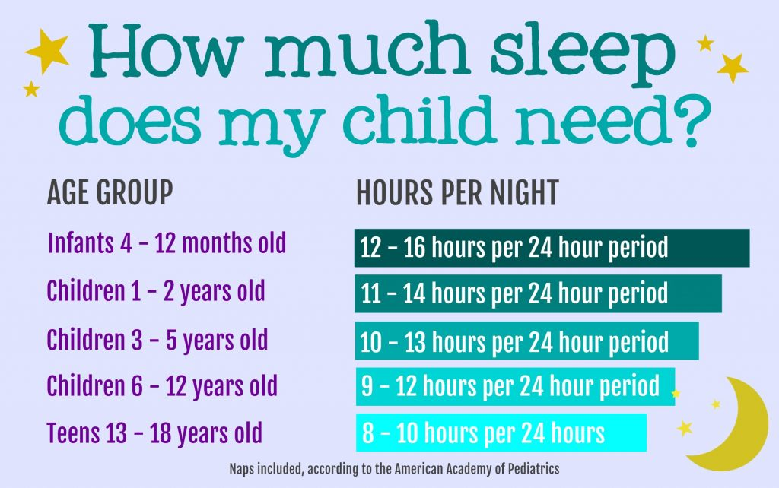
Vicky Dawson – Children’s Sleep Charity.

Welcome to the

St Stephen’s Family

The Early Years Team look forward to welcoming you and your child into our setting in September. We hope this booklet provides you with all the necessary information you require and gives you and your child a glimpse of our setting in preparation for a smooth transition.

In the meantime, if you have any queries, please feel free to contact us via the School Office and we will endeavour to help you.

