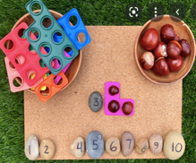 | Count objects, actions and sounds. | 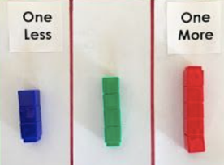 | Understand ‘one more than/one less than’ relationship between consecutive numbers.
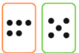  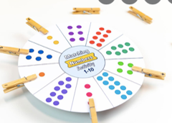 | Subitise. | 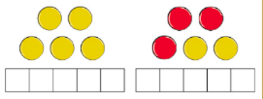 | Explore the composition of numbers to 10.
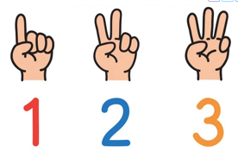 | Link the number symbol (numeral) with its cardinal number value. | 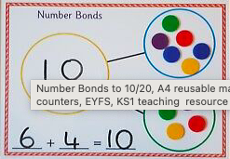 | Automatically recall number bond 0-5 and some to 10.
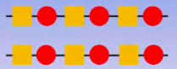 | Continue, copy and create repeating patterns. |  | Select, rotate and manipulate shapes, to develop spatial reasoning skills.
 | Compare Numbers. | 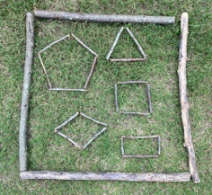 | Compose to decompose shapes so that they recognise a shape can have other shapes within it, just as numbers can.
 | Count beyond ten. | 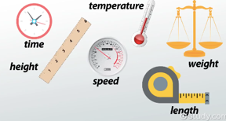 | Compare length, weight and capacity.

