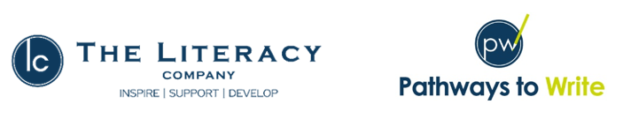

We follow a Mastery approach to English through the programme ‘Pathways to Write.’ Units of work are delivered using high quality texts and children in all year groups are given varied opportunities for writing. Skills are built up through repetition within the units, and children apply these skills in the writing activities provided. Many opportunities for widening children’s vocabulary are given through the Pathways to Write approach and this builds on the extensive work we do in school to provide our children with a rich and varied vocabulary.

You will find the end of year expectations for writing, reading and spoken language for each of our year groups in the attached documents. For further detail on the skills that your children are learning on a termly basis, please contact your class teacher.

