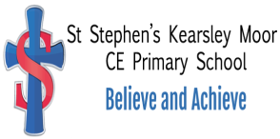

Religious Education

St Stephen’s (Kearsley Moor)
Church of England Primary School

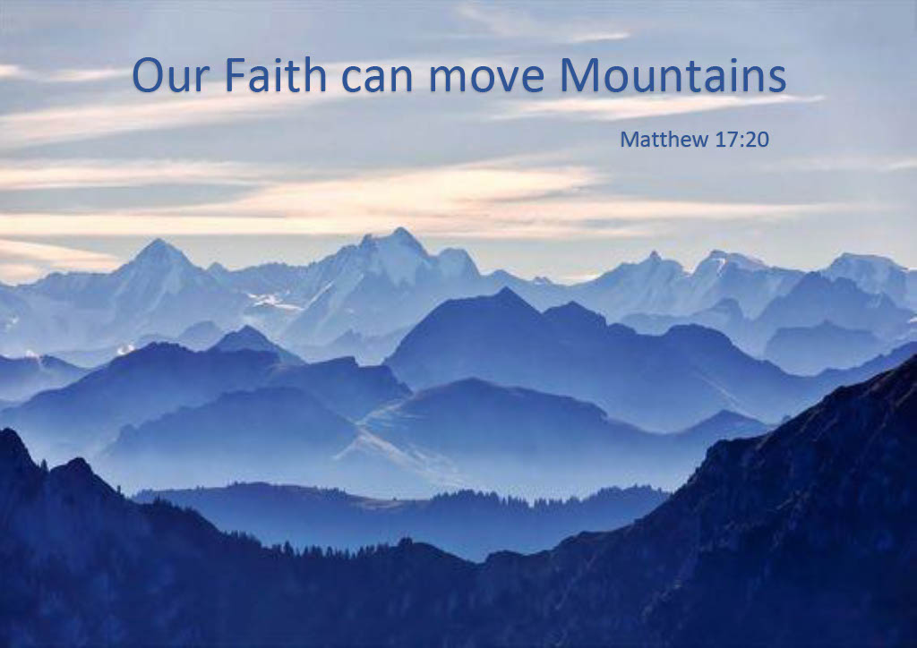

Context
- St Stephen’s (Kearsley Moor) Church of England Primary School is a one form entry primary school, serving children in the age range of 4-11 years.
- We deliver Religious Education (RE) in line with the Manchester Diocesan Syllabus.
- St Stephens’s (Kearsley Moor) Church of England Primary School recognises and values the religious backgrounds and non-religious backgrounds of each of our pupils. We intend to be sensitive to the home background of all and therefore work to ensure that RE is accessible to all pupils and teachers of any religious persuasion or none.
- We have a strong understanding of how RE can play a leading role in pupils’ spiritual, moral, social and cultural development.
- At St Stephen’s (Kearsley Moor) we know how relationships with members of local communities and local faith communities can enrich pupils’ experiences in RE and we strive to cultivate and maintain these relationships.

Legal requirements
RE at St Stephen’s (Kearsley Moor) CE Primary School will meet legal requirements by:
- its inclusion in the curriculum of all registered pupils. In primary school, this is a requirement for all pupils in Reception to Year 6.
- reflecting the fact that religious traditions in Great Britain are in the main Christian, while taking account of the teaching and practices of the other principal religious traditions represented in Great Britain.
- teaching RE in accordance with the Manchester Diocesan guidelines.

Aims

Our aims of RE are that pupils will:

Making Sense of beliefs (Know about and understand a range of religions and worldviews) so that they can:
- describe, explain and analyse beliefs and practices, recognising the diversity which exists within and between communities and among individuals
- identify, investigate and respond to questions posed and responses offered by some of the sources of wisdom found in religions and worldviews
- appreciate and appraise the nature, significance and impact of different ways of life and ways of expressing meaning.

Making Connections (Express ideas and insights about the nature, significance and impact of religions and worldviews) so that they can:
- explain reasonably their ideas about how beliefs, practices and forms of expression influence individuals and communities
- express with increasing discernment their personal reflections and critical responses to questions and teachings about identity, diversity, meaning and value, including ethical issues
- appreciate and appraise varied dimensions of religion or a worldview.

Understanding the concept (Gain and deploy the skills needed to engage seriously with religions and worldviews) so that they can:
- find out about and investigate key concepts and questions of belonging, meaning, purpose and truth, responding creatively
- enquire into what enables different individuals and communities to live together respectfully for the wellbeing of all
- articulate beliefs, values and commitments clearly in order to explain why they may be important in their own and other people’s lives.

Place in the curriculum
The National Curriculum states the legal requirement that:
All state schools ... must teach religious education to pupils at every key stage ... All schools must publish their curriculum by subject and academic year online.
(DfE, The National Curriculum in England: Framework Document, July 2013, p.4)
The Curriculum Framework for RE (2013) is the latest in a chain of documents to recognise RE as a core subject and it is regarded as such at St Stephen’s
We make cross-curricular links with other subjects where those links are beneficial for pupils’ learning and progress in RE. On occasions when strong cross-curricular links cannot be forged with other subjects, RE is taught as a discrete subject.
As a Church of England Primary School we recognise that RE can make a positive contribution to much of pupils’ life in school. It can be linked especially well to Spiritual, Moral, Social and Cultural development, Citizenship (including social cohesion) and Personal, Social, Health and Economic education and we strive to make good links where we can.
In order to maximise the impact of RE sessions and pupils’ progress in this subject, we teach RE in designated regular RE lessons at St Stephen’s.

Timing
At St Stephen’s we follow the Manchester Diocese RE syllabus that recommends that RE should be taught for approx. 50 mins, weekly in the Early Years Foundation Stage (EYFS), one hour weekly in Key Stage 1 (KS1) and a 75 mins session each week in Key Stage 2 (KS2).
Across an academic year EYFS and KS1 will have experienced approx. 36 hours of RE teaching whilst KS2 will have been involved in over 45 hours of RE tuition.

Learning and teaching in RE

The teaching and learning approach at St Stephen’s has three core elements which are woven together to provide breath and balance within the teaching and learning about religions and beliefs, underpinning the aims of RE. The teaching and learning in the classroom will encompass all three elements allowing for overlap of elements as suits the religion, concept and question being explored. The three elements set the context for open exploration of religion and belief.
A wide range of imaginative teaching methods and pupil groupings should be used in effective RE sessions.
St Stephen’s recognises that ‘enquiry’ can be instrumental to good learning in RE as referenced in recent Ofsted RE subject reports, and we aim to help pupils develop skills to enquire independently. Pupils should be given time to generate pertinent questions where appropriate and teachers of RE should ensure that the atmosphere in an RE session is conducive to question raising and reflective thought whenever appropriate.
We appreciate the positive impact that local communities and local faith communities can have on pupils’ experiences in RE. St Stephen’s caters for this by having a visit to a place of worship in each year across our key stages (eg use of local Faith Trails incorporating the Schoenstatt Shrine, Manchester Jewish Museum and Synagogue, St John’s Methodist Church, Wat Sriratanaram Monastery and by inviting visitors from faith communities into RE lessons. We have also forged strong links with the diocese and work closely with the Changing Places Project.
It is vitally important that teachers demonstrate respectful attitudes towards all faiths, modelling the attitudes and responses we would expect from our pupils.

Religions and worldviews
St Stephen’s has followed the Manchester Diocesan guidelines and has selected the following religions and worldviews for focused study in each key stage. Consideration of other religions and non religious worldviews can occur at any key stage, as appropriate to do so.
Reception: Christianity and other faiths as part of their growing sense of self, their own community and place within it.
KS1: Christians, Jews and Muslims.
KS2: Christians, Muslims, Jews and Hindus.

Planning
St Stephen’s uses the Manchester Diocese syllabus to form the basis of its schemes of work. In accordance with this syllabus, pupils will study the following questions/units at each key stage:
All aims of RE are planned for throughout the units of work.

Inclusion
Our whole school inclusion, English as an Additional Language (EAL) and Special Educational Needs and Disabilities (SEND) policies apply to RE.
Teachers are aware that pupils who have barriers to learning in other areas may have a strong interest in and aptitude for RE. All pupils should be encouraged to progress to their full potential and a variety of teaching methods (e.g. use of art, drama, ICT) should be employed to ensure that this is possible.
Pupils who are Gifted and Talented in RE are given opportunities to demonstrate and develop their strengths.
Some pupils have positive and deep experiences of religion from their lives outside of school. While there is no doubt that these experiences should be valued, they do not necessarily relate to pupils’ ability in RE.

Assessment
In RE, by the end of each key stage, pupils are expected to know, understand and apply the concepts, skills and processes specified in the relevant Programme of Study, as in all subjects of the curriculum. The expectation is that pupils’ achievements will be weighed up by teachers using criteria arising from the Programmes of Study
Pupils’ attainment in RE throughout the school will be tracked by the Subject Leader in order to ensure that RE provision at St Stephen’s is successful.
As required by law, we report pupils’ attainment in RE in written form to parents once a year.

Right of withdrawal
Pupils’ families and faith communities have the right to encourage religious nurture of the children, fostering their faith. It is the responsibility of the school to provide Religious Education for all its pupils.
Parents have the right to withdraw their children either partly or wholly from RE. In addition, teachers have the right not to teach the subject. Our approach to RE, however, has been constructed in the hope that parents and teachers will rarely, if ever, wish to exercise their right of withdrawal.
As stated in our school prospectus and on our school website, those parents who wish to withdraw their child from RE lessons should inform the Headteacher in writing/contact the school office at their earliest convenience.
This policy has been adopted by the governors in consultation with the RE Subject Leader and teaching staff.
Date of approval by Governing Body …
Date of review …

