Many people in the world belong to a **faith community.** A faith community is a group of people who believe the same things as each other about God or the religion they follow.

People within the faith community will often have special events to welcome people such as an **aqiqah** in Islam or a **baptism** in Christianity.

Faith communities will also have many symbols and items which show they belong to that religion, for example in Christianity you may often see the **ichthus,** this is a symbol known around the world to represent Christianity. Christians will also use a **parable** from the Bible to show how important people are.

In Judaism you will often see a mezuzah or a seder plate to recognize that a person belongs to a Jewish faith community and there are special rules about what can cannot be done on **Shabbat.**

In Islam the faith community will show what they believe about **Allah** and about **Muhammad** by what they wear and what they do, for example many Muslims will have calligraphy pictures at home to show they are Muslims.

People will often show they belong to each other to having a wedding ceremony which each faith community will celebrate in a different way.

Community:a group of people who have something in common

Muhammad: Mesenger or the Prophet of Allah

Allah: God

Shabbat: a day of rest for Jewish people, the seventh day of the week

Ichthus: a Greek symbol of a fish used by Christians to show their faith

Faith: a belief in God or the teachings of a belief system

Wedding: a marriage ceremony as a legal union of two people

Baptism: a ceremony that welcomes someone into the Christian Church

Aqiqah: a ceremony to welcome a baby into the world in Islam

Parable: a story Jesus told that has a special meaning

Wonderful words

Important information

So how does it all work?

Year One – Knowledge Organiser

What does it mean to belong to a faith community?

Year One  
**Knowledge  
Organiser**

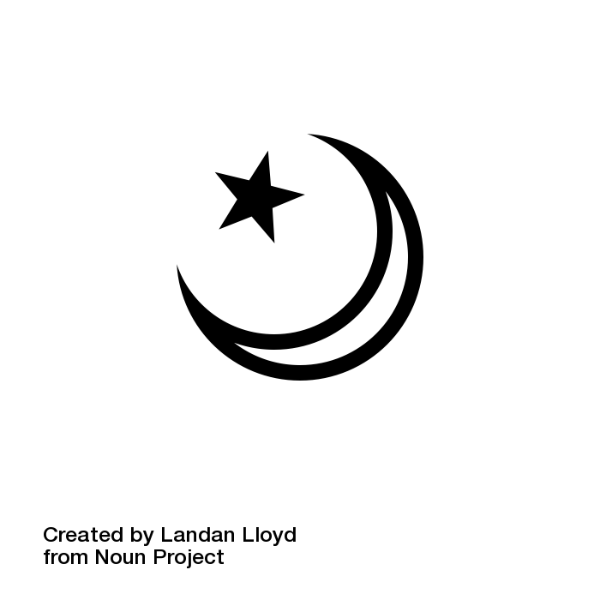

**Faith Community**

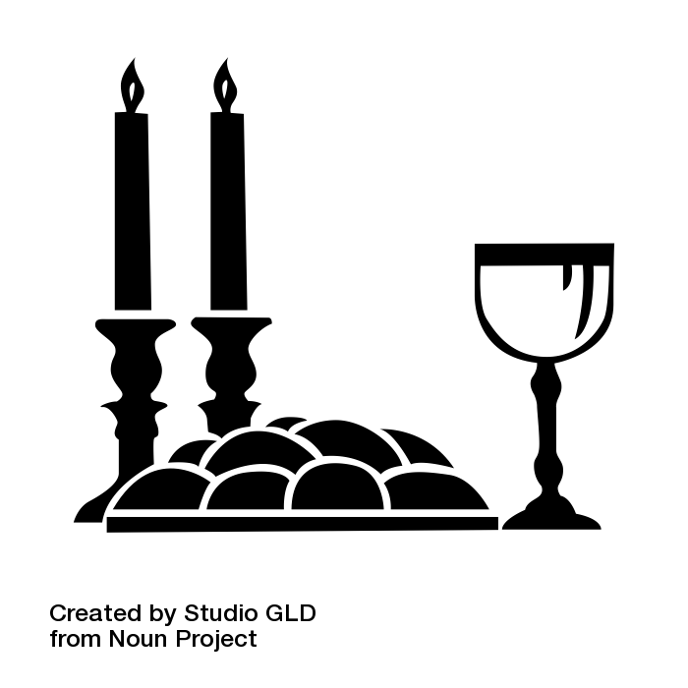



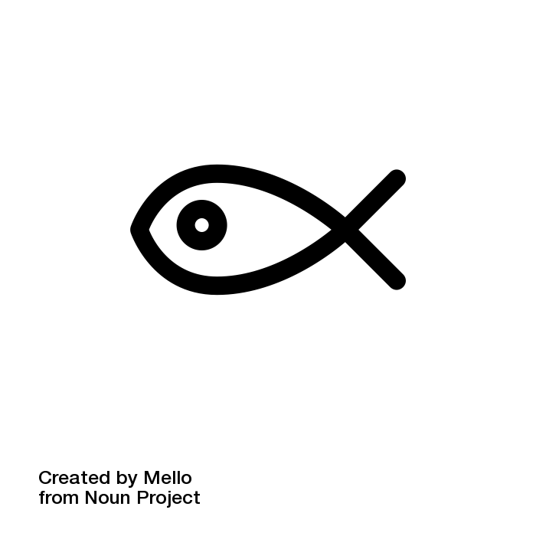

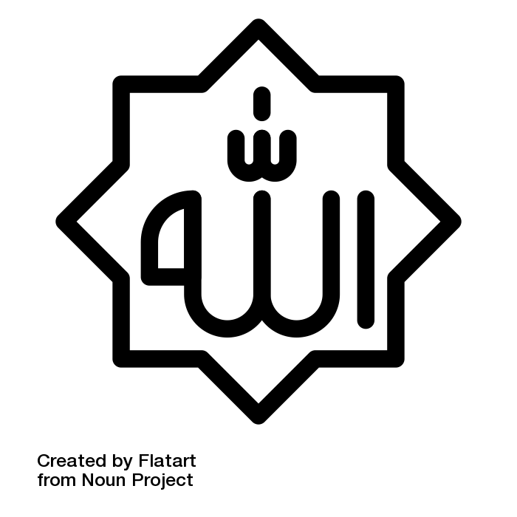

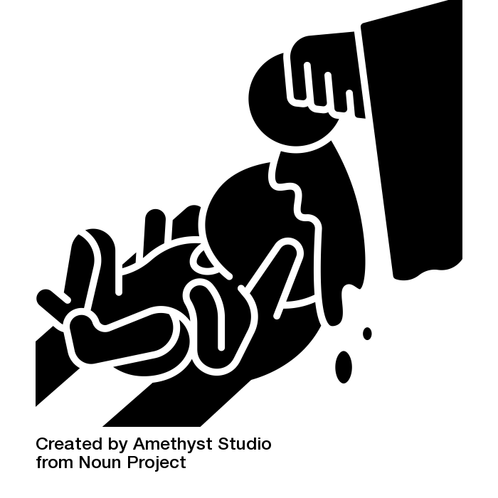

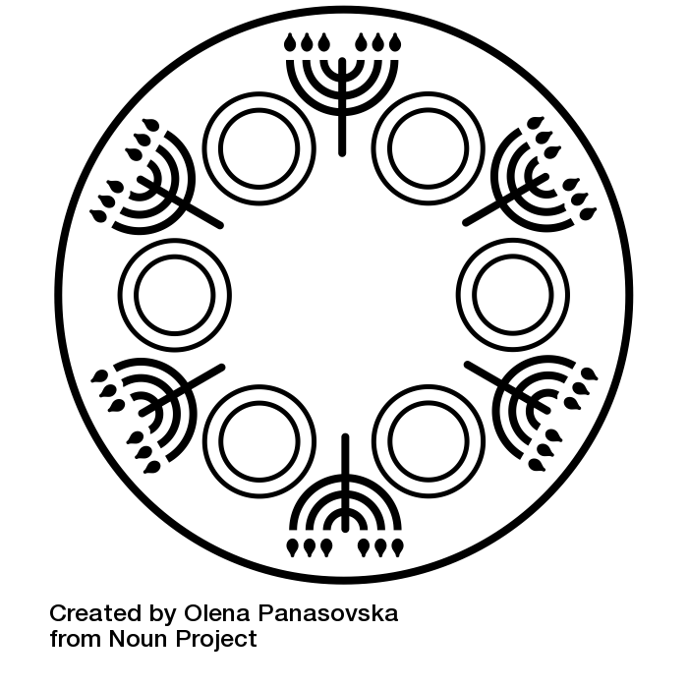

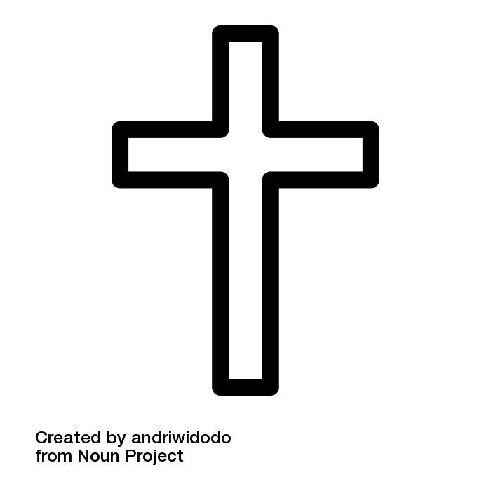

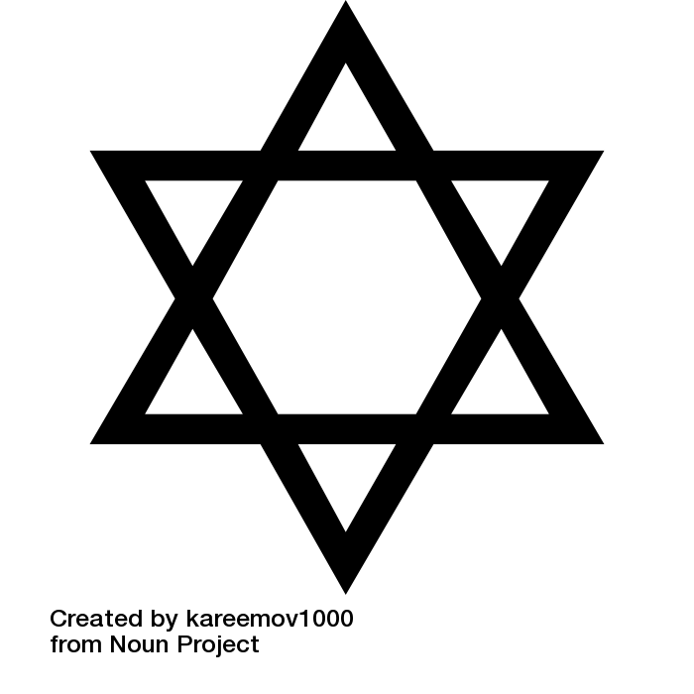

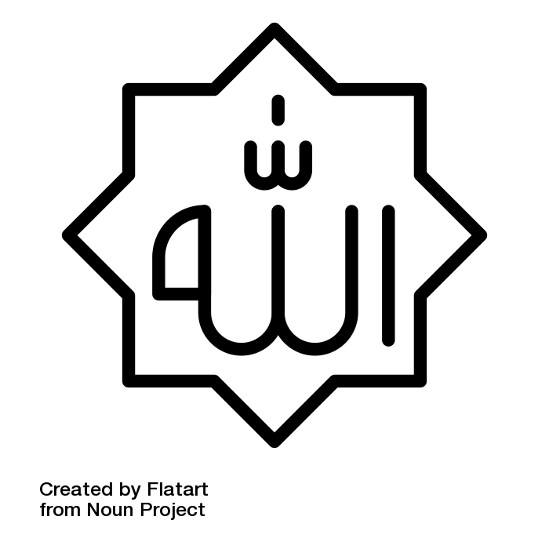

**Belonging**

UNIT  
**11**