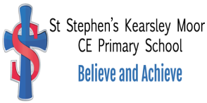
Results 2024 / 2025

 | School | Bolton | National
% of pupils reaching Good Level of Development (GLD | 60% | 64% | 68%
EYFS

Phonics
 | School | Bolton | National
% of pupils reaching Phonics threshold in Y1 | 100% | 80% | 80%
% of pupils reaching Phonics threshold end of KS1 | 96% | 86% | N/A

Key Stage 2 Data
 | School | Bolton | National | Ave. Scale Score
% of pupils reaching EXPECTED STANDARD in
Reading | 60% | 75% | 75% | 106
Writing (moderated) | 77% | 74% | 72% | /
Maths | 73% | 77% | 74% | 105
Combined | 53% | 64% | 62% | /

 | School | Bolton | National
% of pupils reaching HIGHER STANDARD in
Reading | 23% | 30% | 33%
Writing (moderated) | 3% | 16% | N/A
Maths | 23% | 28% | 26%
Combined | 3% | 10% | 8%

